4048 error

Npm cache clean --force

Product component

<!DOCTYPE html>

<html>

<h1 [ngClass]="effects">

product details

</h1 >

<fieldset>

<legend>Type effects</legend>

<input [(ngModel)]="effects" type="text" size="40px" placeholder="backEffects, textEffects,bordeEffects">

</fieldset>

<dl>

<input #pname name="textname" id="textname" value="{{prodname}}" type="text">

{{pname.value}}

<dt>name</dt>

<!-- attribute binding -->

<dd>{{product.name}} </dd>

<dt>price</dt>

<dd>"{{product.price}}"</dd>

<dt>quantity</dt>

<dd>{{product.quantity}} </dd>

<dt>manufactured</dt>

<dd>{{product.mfd.toLocaleDateString()}} </dd>

<dt>preview</dt>

<dd> <img src= "{{product.photo}}" width="300" height="300"> </dd>

<dt>Total amount</dt>

<dd>{{product.quantity * product.price }}

<!-- ONE way Binding change in view No change in Model -->

<dt>name</dt>

<dd>

<input #txtName value="tv" type="text">

</dd>

<dt>shippedto</dt>

<dd>

<select #shippedto>

<option>delhi</option>

<option>hyderabad</option>

</select>

</dd>

<br>

names:{{txtName.value}} <br> <!-- ONE way Binding change in view No change in Model -->

city:{{shippedto.value}}

<!-- TWo way Binding change in view change in Model -->

<dt>productName</dt>

<dd>

<input [(ngModel)]="productName" value="tv" type="text">

</dd>

<dt>shippedto</dt>

<dd>

<select [(ngModel)]="shippedTo">

<option>delhi</option>

<option>hyderabad</option>

</select>

</dd>

<br>

<!-- what ever we change below will be updated -->

names:{{productName}} <br>

city:{{shippedTo}}

</dl>

<!-- not exicuted public isNotAvailable=false; -->

<button value="Exist" name="Exist" [disabled]="isNotAvailable">exist</button>

</html>

Ts-file

public effects='';

public prodname="samsung Tv";

public product={ //Json format

name: "mobile Tv",

price: 34000.53,

quantity:2,

mfd: new Date('2019/02/15'),

photo:'assets/mobiletv.jpg'

};

public isNotAvailable=true;

}

CSS

.backEffects{

background-color: red;

}

.textEffects{

color: yellow;

text-align: center;

}

.bordeEffects{

border-style: dotted;

border-width: 2px;

}

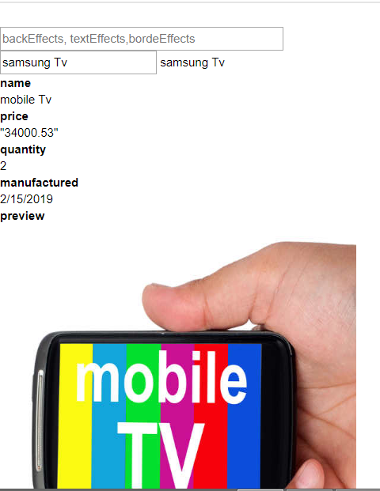

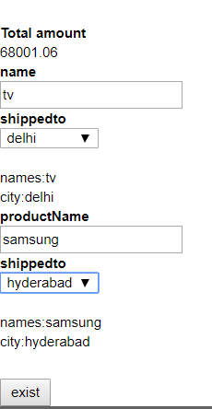

**Two-way** Binding---Twowaybinding.component

<html>

<dl>

<dt>Product Name</dt>

<dd> <input [(ngModel)]="productName" type="text"> </dd>

<dt> shipped TO</dt>

<dd>

<select [(ngModel)]="shippedTo" >

<option>delhi</option>

<option>hyd</option>

</select>

</dd>

</dl>

<br><br>

Name:{{productName}} <br>

shippedto:{{shippedTo}}

</html>

Ts-file

import { Component, OnInit } from '@angular/core';

@Component({

selector: 'app-twowaybinding',

templateUrl: './twowaybinding.component.html',

styleUrls: ['./twowaybinding.component.css']

})

export class TwowaybindingComponent {

public productName="samsung tv";

public shippedTo="Delhi";

}

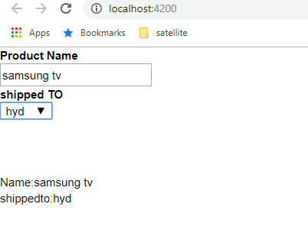

Class Binding Dynamically-Angular-19-03-- Twowaybinding.component

When you Type like backgroundeffects,bordereffects

<html>

<h2 [(ngClass)]="effects">Product details</h2>

<fieldset>

<legend>

Type effect

</legend>

<input [(ngModel)]="effects" type="text" sige=40 placeholder="backeffects,texteffects,borderEffects">

</fieldset>

</html>

import { Component, OnInit } from '@angular/core';

@Component({

selector: 'app-twowaybinding',

templateUrl: './twowaybinding.component.html',

styleUrls: ['./twowaybinding.component.css']

})

export class TwowaybindingComponent {

public effects='';//header part coloring dynamically 19-03

}

Css

/* class binding 19-03 */

.backeffects{

background-color: red;

}

.texteffects{

color:yellow;

text-align: center;

}

.bordereffects{

color:green;

border-style: dotted;

border-width: 3px;

}

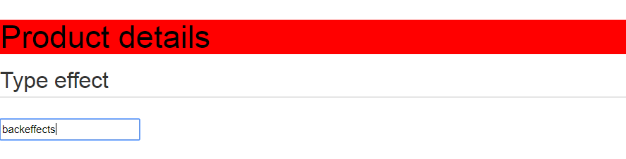

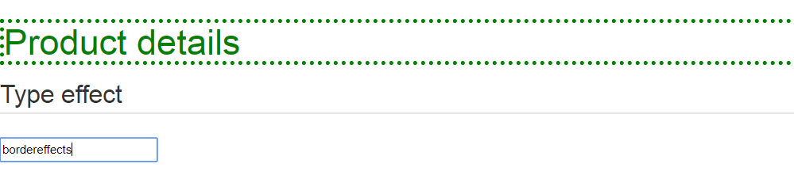

When check boxes click it get operated

<!-- class binding object Refernce -->

<html>

<!-- All Classes are defined at [ngClass] -->

<h2 [ngClass]="{bordereffects:enableBorder,texteffects:enabletext,backeffects:enableBackground }" > product details </h2>

<fieldset>

<legend> select effects </legend>

<ol>

<li> <input [(ngModel)]= "enableBorder" type= "checkbox"> Bordereffects </li>

<li> <input [(ngModel)]= "enabletext" type= "checkbox"> texteffects </li>

<li> <input [(ngModel)]= "enableBackground" type= "checkbox"> Background effects </li>

</ol>

</fieldset>

</html>

Ts-file

import { Component, OnInit } from '@angular/core';

@Component({

selector: 'app-twowaybinding',

templateUrl: './twowaybinding.component.html',

styleUrls: ['./twowaybinding.component.css']

})

export class TwowaybindingComponent {

/*class binding object Refernce */

public enableBorder=true;

public enabletext=true;

public enableBackground=true;

}

Css

/* class binding 19-03 */

.backeffects{

background-color: red;

}

.texteffects{

color:yellow;

text-align: center;

}

.bordereffects{

color:green;

border-style: dotted;

border-width: 3px;

}

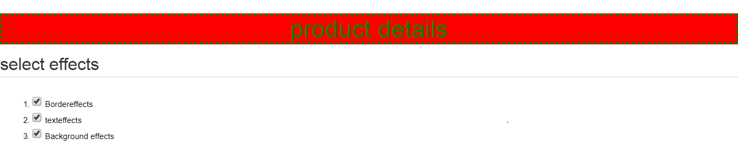

**Event-Binding—event.component**

**html**

EVENT BINGING

<fieldset>

<legend>

REcord action

</legend>

<button (click)='insert()'>Insert</button>

<button (click)='delete()'>Delete</button>

</fieldset>

<br>

{{msg}}

import { Component, OnInit } from '@angular/core';

@Component({

selector: 'app-event',

templateUrl: './event.component.html',

styleUrls: ['./event.component.css']

})

export class EVENTComponent {

// EVENT BINGING

public msg="";

public insert(){

this.msg=("record inserted");

}

public delete(){

this.msg=("record deleted");

}

}

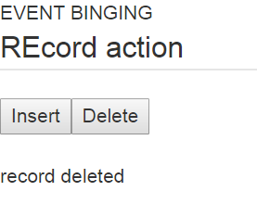 **when click on insert-record inserted**

**X-Y POSITION CLICK-EVENT**

<html>

<img (click)="GetStatus($event)"

src="assets/mobiletv.jpg" width="200" height="200">

<br>

<br>

{{msg}}

</html>

**TS-FILE**

import { Component, OnInit } from '@angular/core';

@Component({

selector: 'app-event',

templateUrl: './event.component.html',

styleUrls: ['./event.component.css']

})

export class EVENTComponent {

public msgX="";

public msgY="";

public GetStatus(event){

this.msgY="Y"+event.clientY;

this.msgX="X"+event.clientX;

}

// Event Arguments where we click ON MOBILE or HAND

public msg="";

public GetStatus(event){

if (event.clintX<=90 && event.clintY>=41){

if(event.clintX>=41 && event.clintY<=87 ){

this.msg="you clicked on Mobile";

}

}

else{

this.msg="you clicked on HAND";

}

}

}

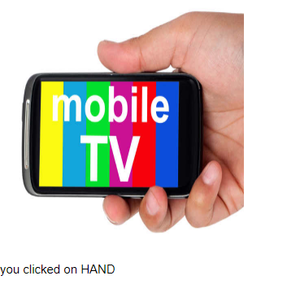

**EVENT.COMPONENT**

**handling Objet and event One function f1()**

<html>

<fieldset>

<legend> Data Base </legend>

<button #sendInsert value="insert" (click)="Action(sendInsert.value)" >Insert</button>

<button #sendUpdate value="update" (click)="Action(sendUpdate.value)">Update</button>

<button #sendDelete value="delete" (click)="Action(sendDelete.value)">Delete</button>

</fieldset>

<br>

<h1 align="center"> {{msg}} </h1>

</html>

**Ts-file**

public msg="";

public Action (val){

switch(val){

case 'insert':

this.msg='Record Inserted';

break;

}

switch(val){

case 'update':

this.msg='Record Updated';

break;

}

switch(val){

case 'delete':

this.msg='Record Deleted';

break;

}

}

}

**Css**

h1

{

text-align: center;

background-color: brown;

}

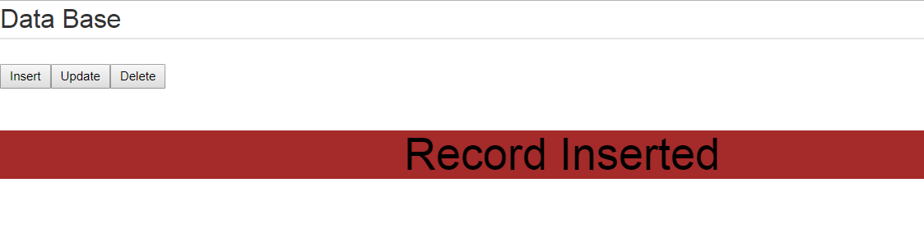

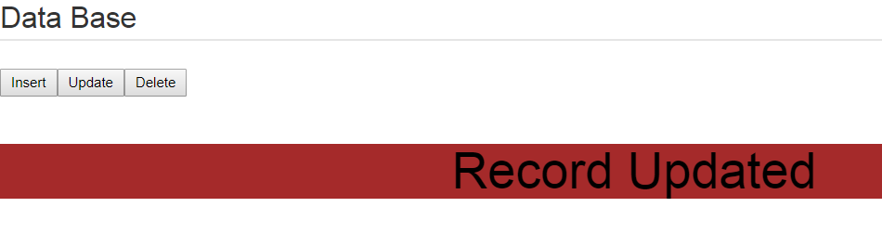

**Conditions-angular—22-03**

**Html**

<h2>product details</h2>

<table width="500" border='1' >

<tr>

<td>

<dl>

<!-- related to product Details -->

<dt>name</dt>

<dd>

{{product.name}}

</dd>

<dt>price</dt>

<dd>

{{product.price}}

</dd>

<dt>Mfd</dt>

<dd>

<!-- see how date has written -->

{{product.mfd.toLocaleDateString()}}

</dd>

<!-- Relaed to ShowHide() method -->

<dt>

<button (click)="ShowHide()" > {{isVisible? 'Hide':'Show'}} Preview </button>

</dt>

</dl>

</td>

<td *ngIf="isVisible">

<img [src]="product.photo" width="100" height="100">

</td>

</tr>

</table>

**Ts file**

import { Component, OnInit } from '@angular/core';

@Component({

selector: 'app-conditions',

templateUrl: './conditions.component.html',

styleUrls: ['./conditions.component.css']

})

export class ConditionsComponent {

public product={

name :"mobile tv",

price:25000,

mfd: new Date('2019/03/22'),

photo:"assets/mobiletv.jpg "

}

public isVisible= false ;

public ShowHide()

{

//learn how to write

this.isVisible = (this.isVisible==false)? true:false;

}

}

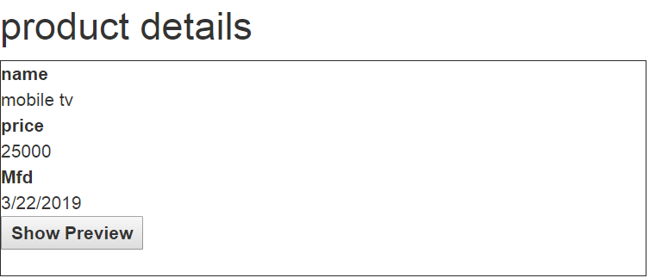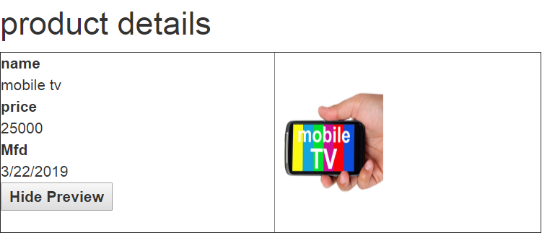

**Iterations-Angular**

<h2>Product list</h2>

<ol>

<!-- products moved to items so item binded to display -->

<li *ngFor='let item of products' >{{item}}</li>

</ol>

<!-- products moved to items so item binded to display on Table -->

<table border="1">

<tr *ngFor='let item of products' width='50' height='50'>{{item}}</tr>

</table>

import { Component, OnInit } from '@angular/core';

@Component({

selector: 'app-iteration',

templateUrl: './iteration.component.html',

styleUrls: ['./iteration.component.css']

})

export class IterationComponent {

public products=[

'samsung tv',

'mobile',

'electronic-mobile'

]

}

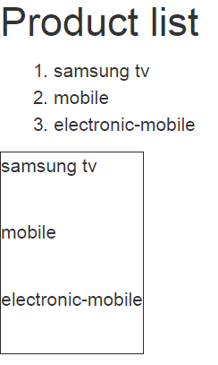

**Nested-loop-iterations**

<!-- nested loop -->

<ol>

<!-- data moved to products -->

<li *ngFor="let product of data">

<!-- 1st print categories -->

{{product.category}}

<ol>

<!-- After categories enter in devices -->

<li *ngFor='let item of product.devices'>

{{item}}

</li>

<table border="1">

<tr *ngFor='let item of product.devices' width='500' height='50'>{{item}}</tr>

</table>

</ol>

</li>

</ol>

**Tss**

import { Component, OnInit } from '@angular/core';

@Component({

selector: 'app-iteration',

templateUrl: './iteration.component.html',

styleUrls: ['./iteration.component.css']

})

export class IterationComponent {

public data=[

{category:'electronics',

devices:['mobile','tv','laptop']},

{category:'shoe' ,

devices:['nike','lee']}

]

}

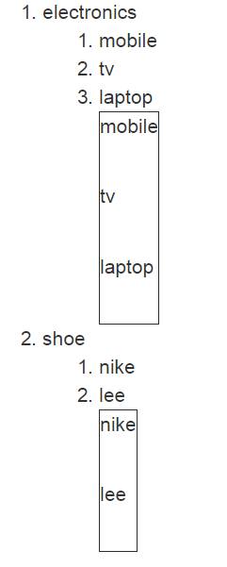

**Iteration adding-delete the content**

**Iteration-table**

<h2>product Details</h2>

<table border="1" width='500'>

<th>Name </th>

<th>Price </th>

<th>index </th>

<th>is Even </th>

<th>Is odd </th>

<th>if first </th>

<th>is Last </th>

<tr *ngFor='let item of products;

let index=index;

let even=even;

let odd=odd;

let first=first;

let last=last' >

<td>{{item.name}}</td>

<td>{{item.price}}</td>

<td>{{index}}</td>

<td>{{even}}</td>

<td>{{odd}}</td>

<td>{{first}}</td>

<td>{{last}}</td>

</tr>

</table>

<fieldset>

<legend align="center"> Add and remove products</legend>

<dl>

<dt>Name</dt>

<dd><input [(ngModel)]="devices.name" type="text"> </dd>

<dt>price</dt>

<dd><input [(ngModel)]="devices.price" type="text"> </dd>

</dl>

<button (click)='Addproducts(devices)' >Add Products</button>

</fieldset>

<table border="1" width='500'>

<th>Name </th>

<th align=center >Price </th>

<th align=center>Action</th>

<tr [class.odd]='odd' [class.even]='even'

*ngFor='let item of products;

let index=index;

let odd=odd;

let even=even'>

<td>{{item.name}}</td>

<td>{{item.price}}</td>

<td><button (click)='DeleteProducts(index)'>Dleteproduct</button> </td>

</tr>

</table>

**Ts**

import { Component, OnInit } from '@angular/core';

@Component({

selector: 'app-iterationtable',

templateUrl: './iterationtable.component.html',

styleUrls: ['./iterationtable.component.css']

})

export class IterationtableComponent {

public products=[

{name:'samsung Tv',price:30000},

{name:'nike shoe',price:4000},

{name:'mobile',price:7000}

]

// Cleaning up the text

public devices={

name:'',

price:0

}

// receving the New text

public NewDevices={

name:'',

price:0

}

// To be add in the Table

public Addproducts(obj){

this.NewDevices={

name:obj.name,

price:obj.price

}

this.products.push( this.NewDevices);

this.devices.name='';

this.devices.price=0

}

// for Delete the row

public DeleteProducts(index){

let msg= confirm('are you shure you want to delete')

if(msg==true){

this.products.splice(index,1);

}

}

}

**Css**

.odd{

background-color: darkcyan;

color: white;

}

.even{

background-color: blue;

color: white

}

th{

background-color:red;

color: white;

}

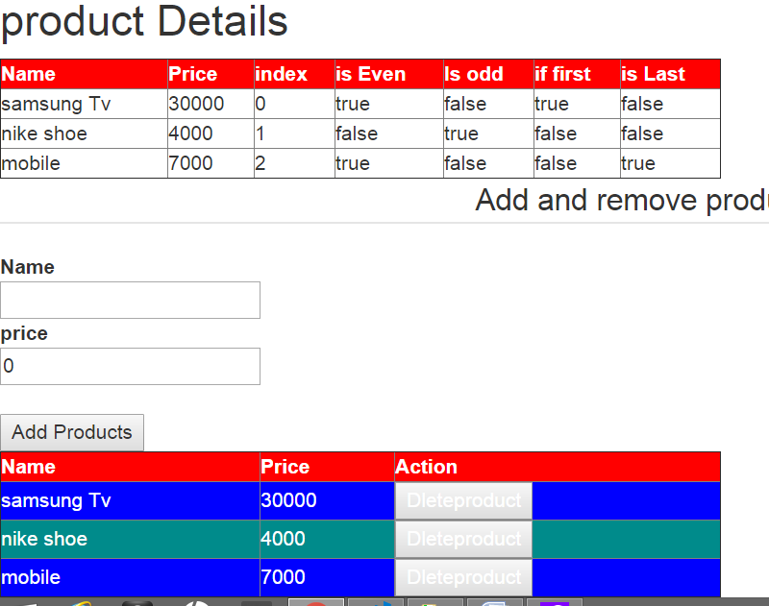

**Handling iteration by passing object properties into function-25-03**

**i.e without INDEX**

**facebook.compo**

<div *ngFor="let car of cars" align="center">

<h2> {{car.carName}}</h2>

<img [src]='car.photo' width='200' height='200'>

<br>

{{car.likes}} <span>| </span>

{{car.dislikes}}

<br>

<a href='#' (click)="likes(car)" >

<img src='assets/7.png' width='50' height='50' >

</a>

<span> | </span>

<a href='#' (click)="dislikes(car)" >

<img src='assets/8.jpe' width='50' height='50'>

</a>

</div>

**Ts**

import { Component, OnInit } from '@angular/core';

@Component({

selector: 'app-facebook',

templateUrl: './facebook.component.html',

styleUrls: ['./facebook.component.css']

})

export class FacebookComponent {

public cars=[

{

carName:"audi-car", photo:"assets/2.jpg", likes:0, dislikes:0

},

{

carName:"Range-rower", photo:"assets/3.jpe", likes:0, dislikes:0

},

{

carName:"ferrari-car", photo:"assets/4.jpe", likes:0, dislikes:0

}

];

public likes(car){

car.likes ++;

};

public dislikes(car){

car.dislikes ++;

}

}

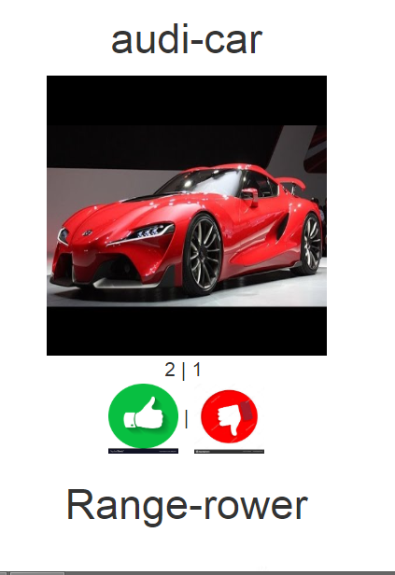

**Style Binding**

<fieldset>

<legend>

selsect effects

</legend>

<dl>

<dt>

background color

</dt>

<dd>

<!-- two way binding user options use [(ngModel)] -->

<select [(ngModel)]="backcolor">

<option>Red</option>

<option>green</option>

</select>

</dd>

<dt> text align</dt>

<dd>

<!-- two way binding user options use [(ngModel)] -->

<input type='radio' [(ngModel)]="alignment" name='align' value='left'>left

<input type='radio' [(ngModel)]="alignment" name='align' value='center'>center

<input type='radio' [(ngModel)]="alignment" name='align' value='right'>right

</dd>

</dl>

</fieldset>

<!-- dynamically styles to be applied so use [ngStyle] -->

<h2 [ngStyle]="getEffects()"> welcome to style binding</h2>

import { Component, OnInit } from '@angular/core';

import { preserveWhitespacesDefault } from '@angular/compiler';

@Component({

selector: 'app-stylebinding',

templateUrl: './stylebinding.component.html',

styleUrls: ['./stylebinding.component.css']

})

export class StylebindingComponent {

public backcolor="red";

public alignment="center";

public getEffects(){

const effects={

'background-color':this.backcolor,

'color':'black',

'text-align': this.alignment

};

return effects;

}

}

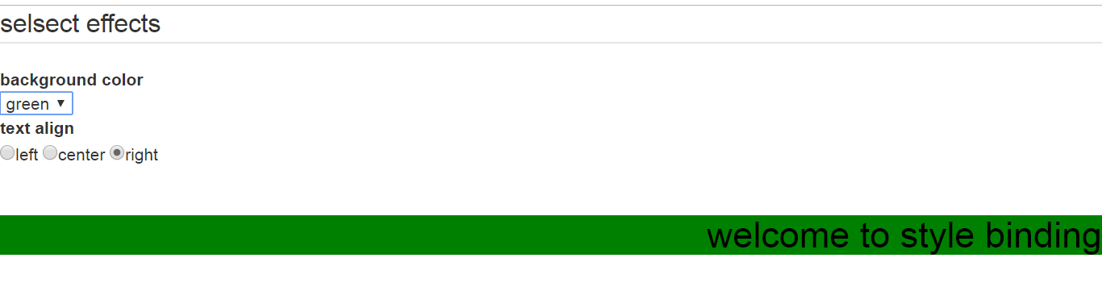

**MouseMoments**

<body (mousemove)="ApplyEffects($event)" >

<div style="height:1000px"></div>

<img [ngStyle]= "imageEffects()" src="assets/flag.jpe">

</body>

import { Component, OnInit } from '@angular/core';

@Component({

selector: 'app-mousemovement',

templateUrl: './mousemovement.component.html',

styleUrls: ['./mousemovement.component.css']

})

export class MousemovementComponent {

public xPosition=''

public yPosition =''

public absPosition="fixed"

public ApplyEffects(event){

this.xPosition=event.clientX,

this.yPosition=event.clientY

}

public imageEffects(){

const effects={

'left':this.xPosition+'px',

'top':this.yPosition+'px',

'position':this.absPosition

}

return effects;

}

}

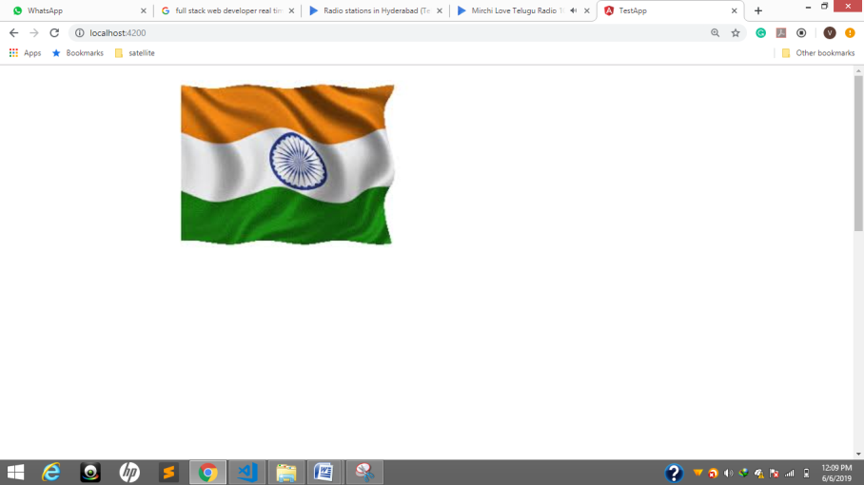

<marquee scrollamount="10" behavior="alternate">

<!--

name is given same pic two images one name -->

<img [src]="pic" (mouseover)="Ad1()" (mouseout)="Ad2()" width='300' height='100'>

</marquee>

<p>move thye mouse pointer onto Ad</p>

<!-- name is given same Bulb two pic one name -->

<img [src]="bulb" (mousedown)="down()" (mouseup)="up()" width='300' height='100'>

<p>press hold down the mouse button to ON bulb</p>

import { Component, OnInit } from '@angular/core';

@Component({

selector: 'app-mousemovement',

templateUrl: './mousemovement.component.html',

styleUrls: ['./mousemovement.component.css']

})

export class MousemovementComponent {

//initially what the images to present

public pic="assets/pepsi.jpg" //add jpg or png

public bulb="assets/bulboff.jpe"

//name is given same Bulb two pic one name

public down(){

this.bulb="assets/bulbon.jpe" ;

}

public up(){

this.bulb="assets/bulboff.jpe" ;

}

//name is given same pic two images one name

public Ad1(){

this.pic="assets/reliance.png" ;

}

public Ad2(){

this.pic="assets/pepsi.jpg" ;

}

}

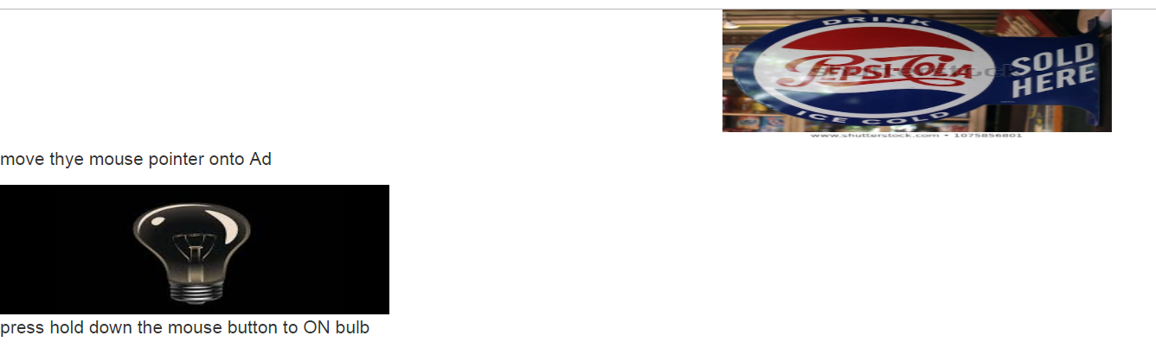

**Events**

**Shopping Component**

<table align="center" width='400' border="1" cellspacing='4' celpadding='4'>

<tr>

<td><h2>Amazon shoping</h2></td>

</tr>

<tr>

<td>

select a category <br>

<select [(ngModel)]="lstcategories" (change)='selectCategory()'>

<option *ngFor="let category of categories">{{category}}</option>

</select>

</td>

</tr>

<tr>

<td>

select a products <br>

<select [(ngModel)]="lstProducts" (change)='selectProduct()'>

<option *ngFor="let Product of Products">{{category}}</option>

</select>

</td>

</tr>

<tr>

<td>

<h3>{{prodName}}</h3>

<img [src]='prodPhoto' width='200' height='150' border='1'>

<br>

cost :{{prodPrice| currency:'INR'}}

<br>

<input [(ngModel)]='quantity' type='number' min='1' max='4'>quantity<br> <br>

Total Amount:{{quantity*prodPrice}}

</td>

</tr>

</table>

import { Component, OnInit } from '@angular/core';

@Component({

selector: 'app-shopping',

templateUrl: './shopping.component.html',

styleUrls: ['./shopping.component.css']

})

export class ShoppingComponent {

public categories=['selectCategory','electronics','shoes'];

public electronics=['select elecatronic products','samsung tv','mobile'];

public shoes=['select shoe products','nike shoe','lee cooper boot'];

public data=[

{Name:'samsung tv',price:50000.45,photo:'assets/tv.jpe'},

{Name:'mobile',price:31400.45,photo:'assets/mobiletv.jpg'},

{Name:'nike shoe',price:5000.45,photo:'assets/shoe.jpe'}

];

public products=[];

public lstcategories;

public lstProducts;

public prodName;

public prodPrice;

public prodPhoto;

public quantity=1;

public selectCategory(){

switch(this.lstcategories){

case 'electronics':

this.products=this.electronics;

break;

case 'shoes':

this.products=this.shoes;

break;

}

}

public getDetails(index){

this.prodName=this.data[index].Name;

this.prodPrice=this.data[index].price;

this.prodPhoto=this.data[index].photo;

}

public selectProduct(){

switch(this.lstcategories){

case 'samsung tv':

this.getDetails(0);

break;

case 'mobile':

this.getDetails(1);

break;

case 'nike shoe':

this.getDetails(2);

break;

case 'lee cooper boot':

this.getDetails(3);

break;

}

}

}

**404 error**

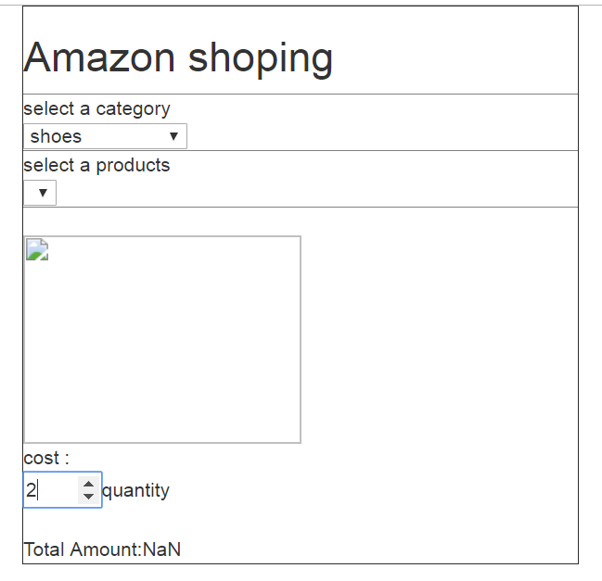

**Bootstrap**

**Login.comp**

<div class='container'>

<form name='frmLogin'>

<h2 class="text-center">

login here</h2>

<!-- for user name -->

<div class="form-group" [ngClass]="{'has-error':true}">

<label class="control-label" for="txtName">User name</label>

</div>

<input class="form-control" type="text" name="txtName" required>

<span class="text-danger">Name Require</span>

<!-- for password -->

<div class='form-group'>

<label class="control-label" for="txtPwd">password</label>

</div>

<div> <input class="form-control" type="password" name="txtPwd"></div>

<!-- BLOCK level Buttons -->

<div class='form-group'>

<button class="btn btn-block btn-primary">login</button>

</div>

</form>

</div>

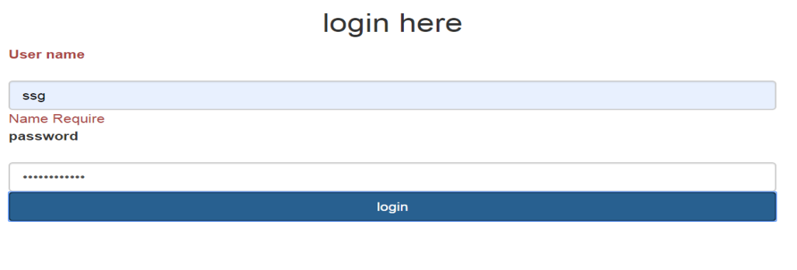

**Angular pipes**

**senteceComponent sentencepipe**

**NO-output**

**Accessing the parent-component into child-component**

**@input @output**

<h2>

parent component

</h2>

<div>

<app-child [count]="getCount()"

[electronicsCount]="getElectronincsCount()"

[shoeCount]="getShoeCount()" >

</app-child>

</div>

import { Component, OnInit } from '@angular/core';

@Component({

selector: 'app-parent',

templateUrl: './parent.component.html',

styleUrls: ['./parent.component.css']

})

export class ParentComponent {

public products=[

{id:1 ,name:"samsung tv" ,price:50000.45 ,category:"electronics"},

{id:2 ,name:"nike shoe" ,price:7000.45 ,category:"shoe"},

{id:1 ,name:"mobile" ,price:10000.45 ,category:"electronics"}

];

public getCount(){

return this.products.length;

}

public getElectronincsCount(){

return this.products.filter(x=>x.category=='electronics').length;

}

public getShoeCount(){

return this.products.filter(x=>x.category=='shoe').length;

}

}

**Now Child**

**Html**

<h2>

child component

</h2>

<div >

total no of products:{{count}} <br>

total no of electronics products:{{electronicsCount}}<br>

total no of shoe products:{{shoeCount}}

</div>

import { Component,Input,Output, OnInit } from '@angular/core';

@Component({

selector: 'app-child',

templateUrl: './child.component.html',

styleUrls: ['./child.component.css']

})

export class ChildComponent {

@Input() public count=0;

@Input() public electronicsCount=0;

@Input() public shoeCount=0;

}

**For output in bootstrap use parent.component**

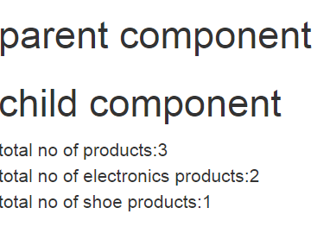

**Nested component & custom Events**

**For output use**  <app-data></app-data>

**DATA.component**

<div class="container">

<app-filter (selectionChanged)="onSelectionChanged($event)"

[all]='getAllCount()'

[electronics]="getElectronicsCount()"

[shoe]="getShoeCount()">

</app-filter>

<br><br>

<table width='400' border='1'>

<th>name</th>

<th>price</th>

<th>category</th>

<ng-container *ngFor='let item of products'>

<tr *ngIf="selectedvalue=='all' || selectedvalue=='item.category' ">

<td>{{item.name}}</td>

<td>{{item.price}}</td>

<td>{{item.category}}</td>

</tr>

</ng-container>

</table>

</div>

import { Component, OnInit } from '@angular/core';

@Component({

selector: 'app-data',

templateUrl: './data.component.html',

styleUrls: ['./data.component.css']

})

export class DataComponent {

public products=[

{name:'samsung Tv',price:53000.45,category:'electronics'},

{name:'shoe',price:3000.45,category:'shoe'},

{name:'mobile',price:5000.45,category:'electronics'},

];

public selectedvalue='all';

public getAllCount(){

return this.products.length;

}

public getElectronicsCount(){

return this.products.filter(x=>x.category=='electronics').length;

}

public getShoeCount(){

return this.products.filter(x=>x.category=='shoe').length;

}

onSelectionChanged(val){

this.selectedvalue=val;

}

}

**Filter @output @input**

<fieldset>

<legend>filter products</legend>

<select (change)="onSelectionChanged()"

[(ngModel)]="selectedCategoryValue" >

<option value="all">All</option>

<option value="electronics">Electronics</option>

<option value="shoe">Shoe</option>

</select>

</fieldset>

import { Component,EventEmitter,Input,Output } from '@angular/core';

@Component({

selector: 'app-filter',

templateUrl: './filter.component.html',

styleUrls: ['./filter.component.css']

})

export class FilterComponent {

@Input() public all=0;

@Input() public electronics=0;

@Input() public shoe=0;

public selectedCategoryValue='all';

@Output() public selectionChanged:

EventEmitter <string>= new EventEmitter<string>();

onSelectionChanged(){

this.selectionChanged.emit

(this.selectedCategoryValue);

}

}

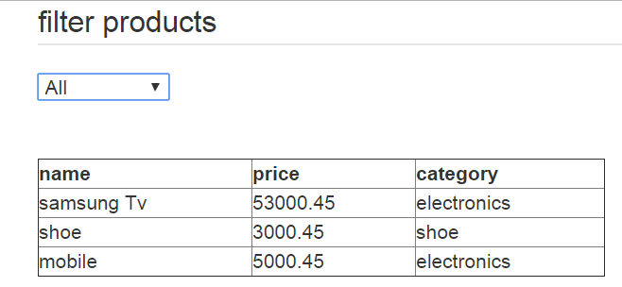

**Category is not working**

**Services-Angular**

**Productsdata.services**

import { Injectable } from '@angular/core';

@Injectable()

export class ProductsdataService {

constructor() { }

getproducts(){

let products=[ {name:'tv', price:45000.23},

{name:'nike shoe', price:45000}];

return products;

}

}

**Html**

<ol>

<li *ngFor="let item of products">

{{item.name}}

{{item.price}}

</li>

</ol>

**Ts-file**

import { Component, OnInit } from '@angular/core';

import {ProductsdataService} from '../productsdata.service';

@Component({

selector: 'app-productslist',

templateUrl: './productslist.component.html',

styleUrls: ['./productslist.component.css']

})

export class ProductslistComponent implements OnInit {

//Data is collected from service with file name ProductsdataService

constructor(private prodsDataService:ProductsdataService) { }

public products;

ngOnInit() {

//from ProductsdataService go to getproducts() object collect data and give to products

this.products=this.prodsDataService.getproducts()

}

}

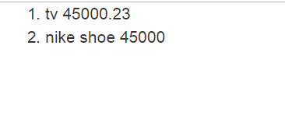

**Captcha---service**

**Service file**

import { Injectable } from '@angular/core';

@Injectable()

export class CaptchaService {

constructor() { }

generateCode(){

let a=Math.random()*10;

let b=Math.random()*10;

let c=Math.random()*10;

let d=Math.random()*10;

let e=Math.random()*10;

let f=Math.random()*10;

let code= 'Math.random(a)'+' '+

'Math.random(b)'+' '+

'Math.random(c)'+' '+

'Math.random(d)'+' '+

'Math.random(e)'+' '+

'Math.random(f)';

return code;

}

}

**Html**

<div class="container">

<h2>login here</h2>

<dl>

<dt>User Name</dt>

<dd><input type='text'></dd>

<dt>password</dt>

<dd><input type="password"></dd>

<dt>verify code</dt>

<dd>

{{code}}

<button (click)="NewCaptcha()">Refresh</button>

<br> <br>

<input type="text" size='6'>

</dd>

</dl>

<button class="btn btn-primary">Login</button>

</div>

**Ts file**

import { Component, OnInit } from '@angular/core';

import { CaptcherdService } from '../captcherd.service';

@Component({

selector: 'app-logincaptcha',

templateUrl: './logincaptcha.component.html',

styleUrls: ['./logincaptcha.component.css']

})

export class LogincaptchaComponent implements OnInit {

constructor(private Captcha:CaptcherdService) { }

public code;

ngOnInit() {

this.code=this.Captcha.generateCode();

}

NewCaptcha() {

this.code=this.Captcha.generateCode()

}

}

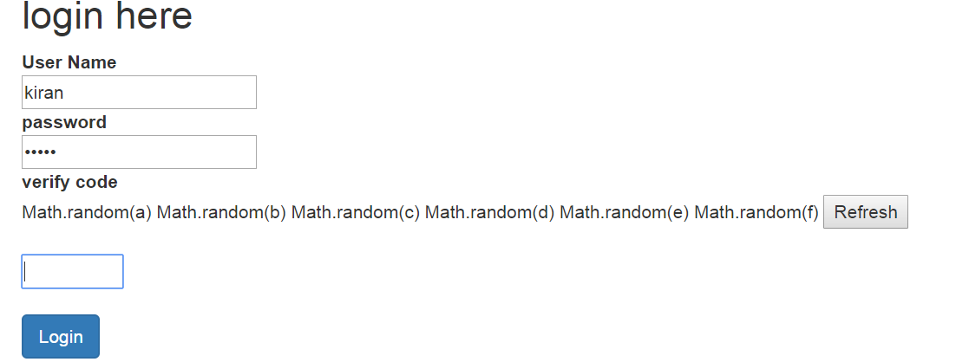

**Captch not-working**

**MEAN—files**

**Server-mongodb data to show**

**Mongodb information shown in SERVER side**

//import modules

var mongoClient=require("mongodb").MongoClient;

var express=require("express");

var bodyparser=require("body-parser");

//configure mongo connection

var url="mongodb://127.0.0.1/angular7proj";

//configure middileware

var app=express();

//configure parser

app.use(bodyparser.urlencoded({

extended:true

}));

app.use(bodyparser.json());

//create API rrequest

app.get("/",function(req,res){

res.send("API request sucessful");

})

//read products from mongodb

app.get("/getproducts", function(req,res){

mongoClient.connect(url,function(err,db){

if(!err){

var dbo=db.db("angular7proj");

dbo.collection("tableproducts").find({}).toArray(

function(err,document){

if (!err){

res.send(document);

}

} )

}

})

})

app.listen(8080);

console.log("server listening to 8080")

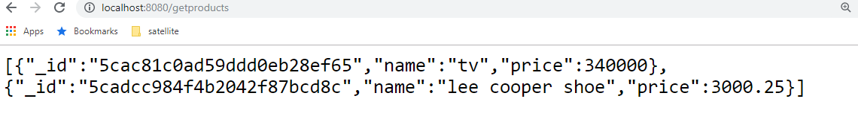

**Iproduct.ts**

interface IProducts{

//productID:number;

“name”:string;

“price”:number;

// Mfd:any;

}

**Products-get.Service.ts**

import { Injectable } from '@angular/core';

import { HttpClient} from '@angular/common/http';

import { Observable } from "rxjs";

@Injectable()

export class ProductsGetService {

public url="http//localhost:8080/getproducts";

constructor(private http:HttpClient) { }

getProducts():Observable <IProducts[]>{

return this.http.get<IProducts[]>(this.url)

}

}

**Pservice.component.ts**

import { Component, OnInit } from '@angular/core';

import {ProductsGetService} from './../products-get.service';

@Component({

selector: 'app-pservice',

templateUrl: './pservice.component.html',

styleUrls: ['./pservice.component.css']

})

export class PserviceComponent implements OnInit {

public products = [];

constructor(private data: ProductsGetService) { }

ngOnInit() {

this.data.getProducts().subscribe(data=>this.products=data);

}

}

**No front end output**

**Routing in angular**

**App-route.module.ts**

import { NgModule } from '@angular/core';

import { CommonModule } from '@angular/common';

import { RouterModule, Routes, ROUTES } from '@angular/router';

import { AboutComponent } from './about/about.component';

import { ContactComponent } from './contact/contact.component';

import { HomeComponent } from './home/home.component';

const Routes:Routes=[{path:"home", component:HomeComponent},

{path:"about",component:AboutComponent},

{path:"contact",component:ContactComponent},

{path:'',redirectTo:"home",pathMatch:'full'}];

@NgModule({

imports: [RouterModule.forRoot(Routes)],

exports:[RouterModule]

})

export class AppRouteModule { }

**app.component.html**

<table width="800" border="1" cellspacing='5' cellpadding='5'>

<tr class="rowStyle">

<td colspan="2" >NareshIT | Hyderabad</td>

</tr>

<tr heigh="300">

<td width="200" class="colStyle">

<ul>

<li><a routerLink="home">Home</a></li>

<li><a routerLink="about">About</a></li>

<li><a routerLink="content">Content</a></li>

</ul>

</td>

<!--split into two columns -->

<td width="600">

<router-outlet></router-outlet>

</td>

</tr>

<tr class="rowStyle">

<td colspan="2"> & copy; copyright 2019

<br>

Faculty|Courses|Development

</td>

</tr>

</table>

**Also we have to create 1.HOME.COMPONENT 2.ABOUT.component 3.CONTACT.component**

**o/p what eve we click it rout to that observe the PATH/HOME OR /ABOUT OR/COTACT**

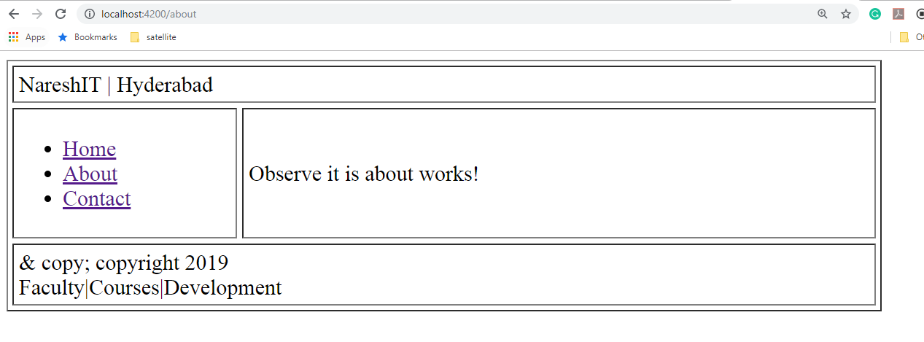

**Types of Directives**

Angular 2 categorizes directives into 3 parts:

1. Directives with templates known as **Components**
2. Directives that creates and **destroys DOM elements** known as **Structural Directives**

*[ngIf](https://angular.io/api/common/NgIf), *[ngFor](https://angular.io/api/common/NgForOf), [[ngSwitch](https://angular.io/api/common/NgSwitch)]

1. Directives that manipulate DOM by changing behavior and appearance known as **Attribute Directives**

**ngStyle**

1. Components—directives with a template.
2. Structural directives—change the DOM layout by adding and removing DOM elements.
3. Attribute directives—change the appearance or behavior of an element, component, or another directive.

Decorators in angular

@Component

@Injectable({

  providedIn: 'root'

})

**@Routes**.

@Input()

@output

@NgModule({

Lifecyclehooks

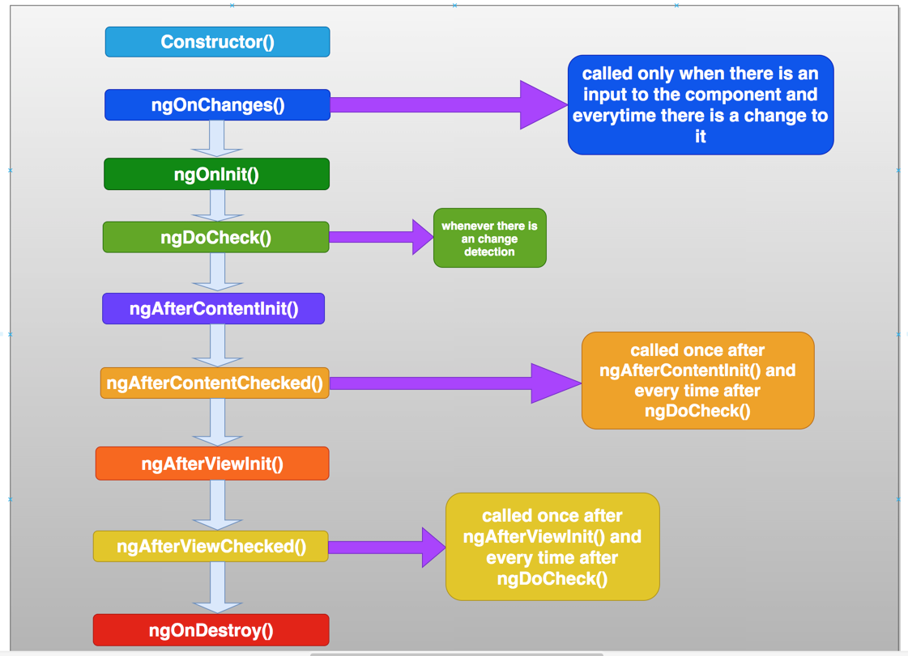

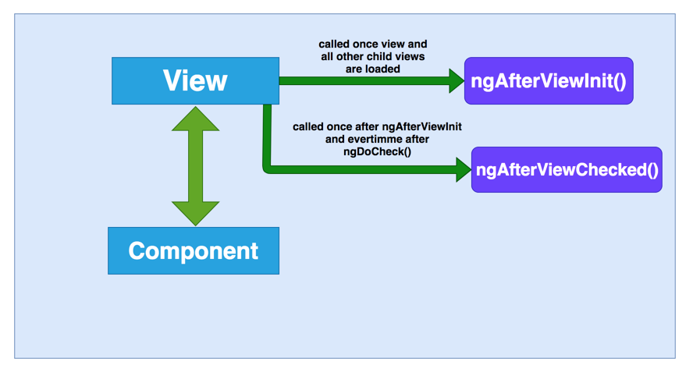

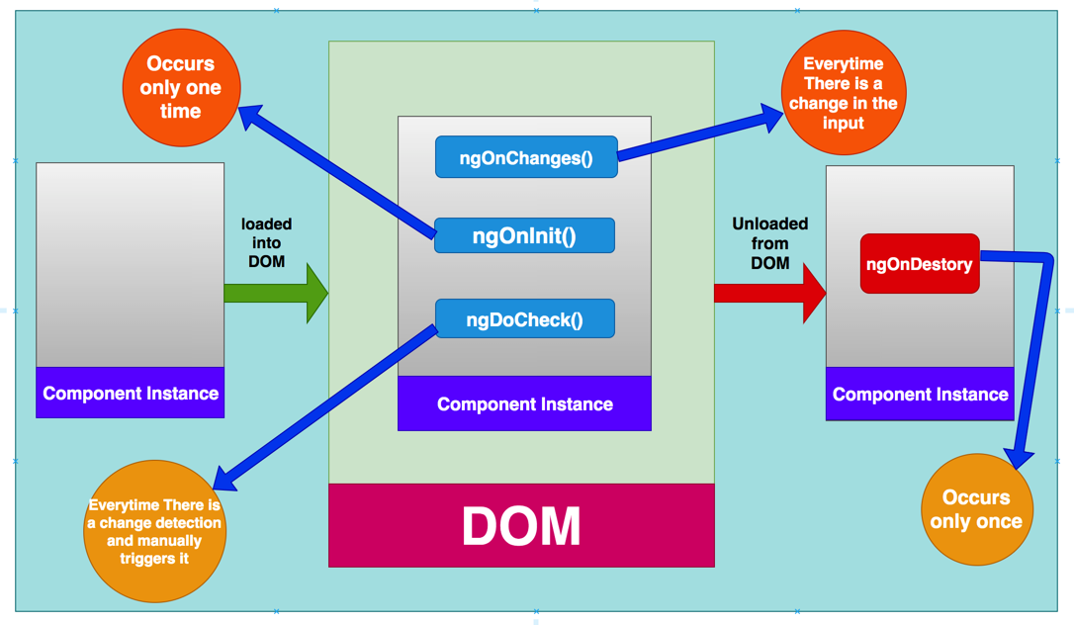

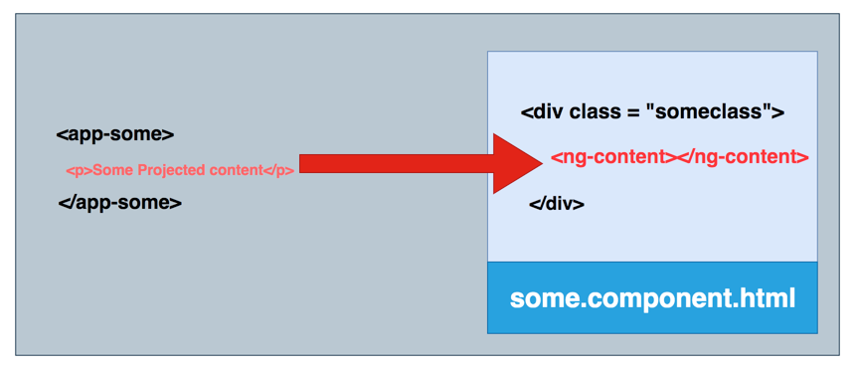

Must have  experience on REST API and Component binding and staffing.

Topics to include: data communication in components, services, reusable components, lazy loading, life cycle hooks, binding(one, two), JavaScript .

**Single Page Application**

Single page application (SPA) is a web application that fits on a single page. All your code (JS, HTML, CSS) is retrieved with a single page load. And navigation between pages performed without refreshing the whole page.

@Viewchild @viewcontent @viewchildern

<https://codecraft.tv/courses/angular/components/viewchildren-and-contentchildren/>

Viewchild()

<https://medium.com/@nishu0505/using-viewchild-in-angular-de1854a51872>

Lifecyclehooks

<https://medium.com/bb-tutorials-and-thoughts/angular-understanding-angular-lifecycle-hooks-with-a-sample-project-375a61882478>

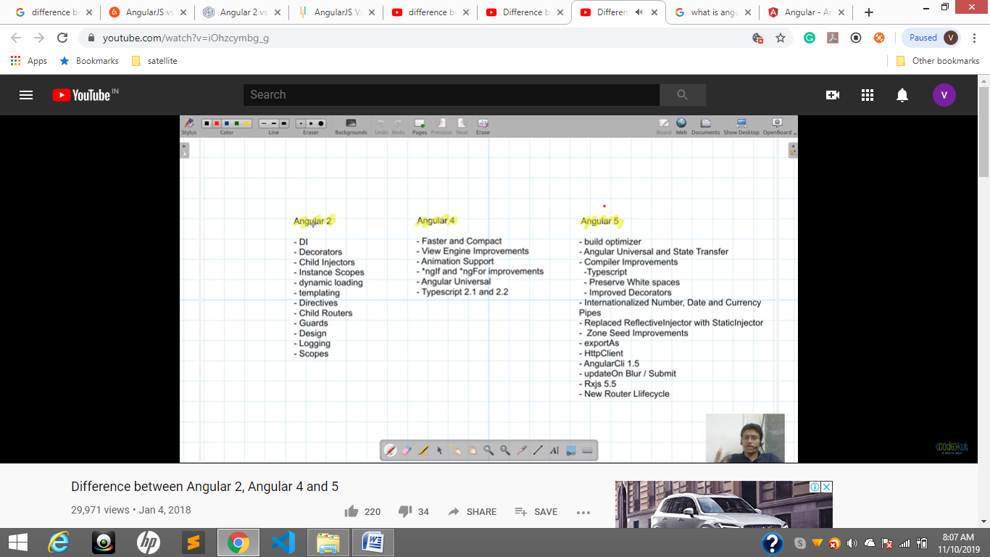

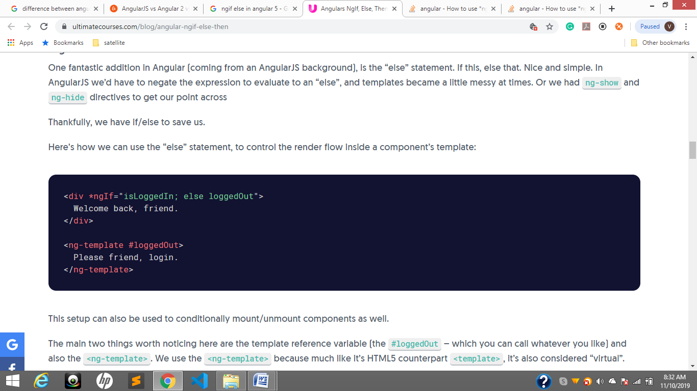

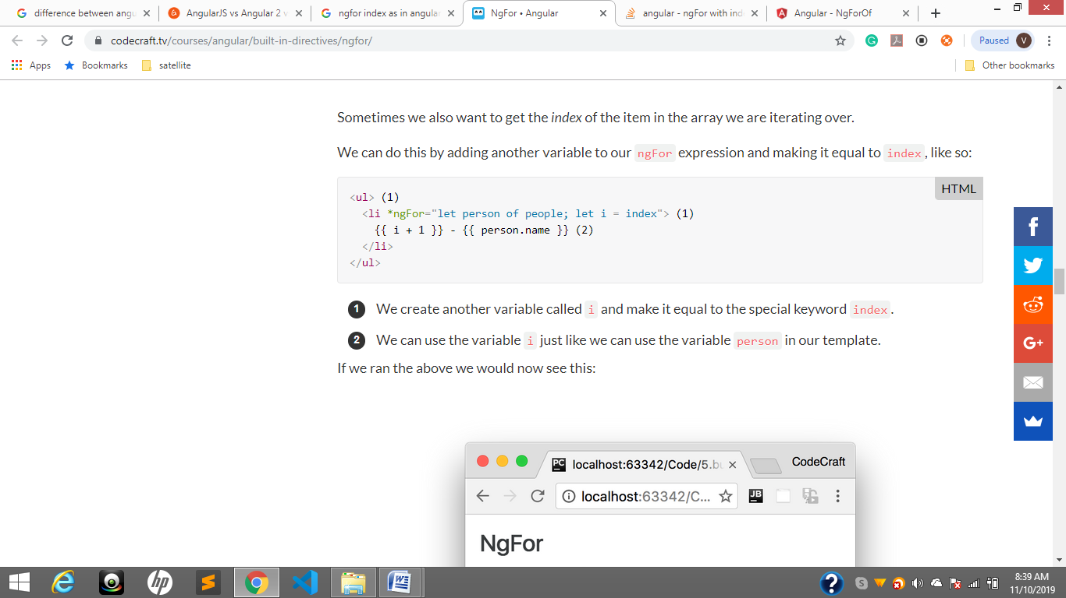

directives

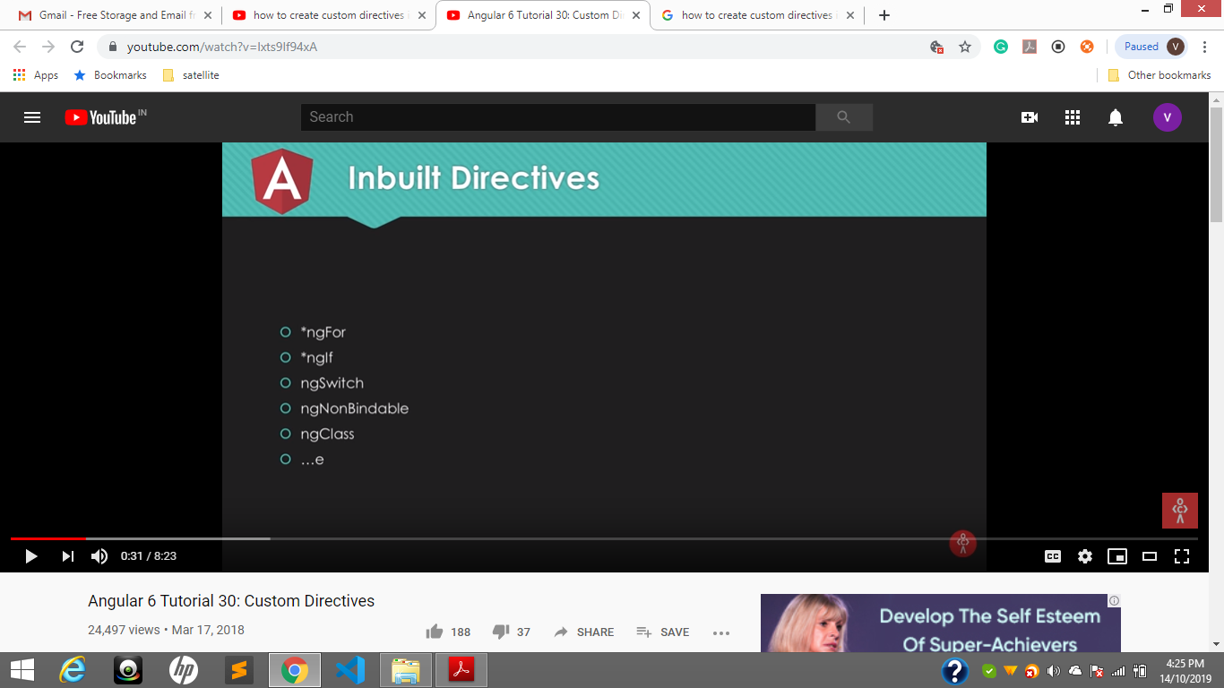

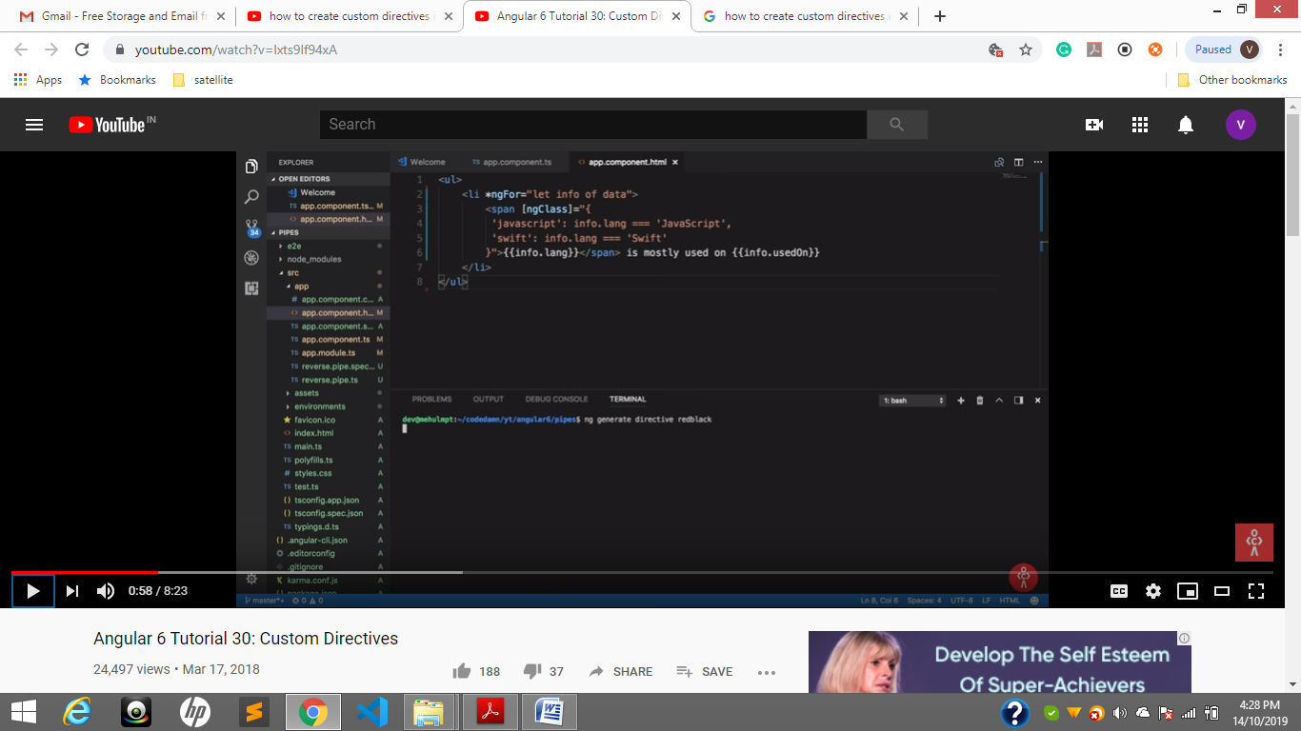

Ng g directive directiveName

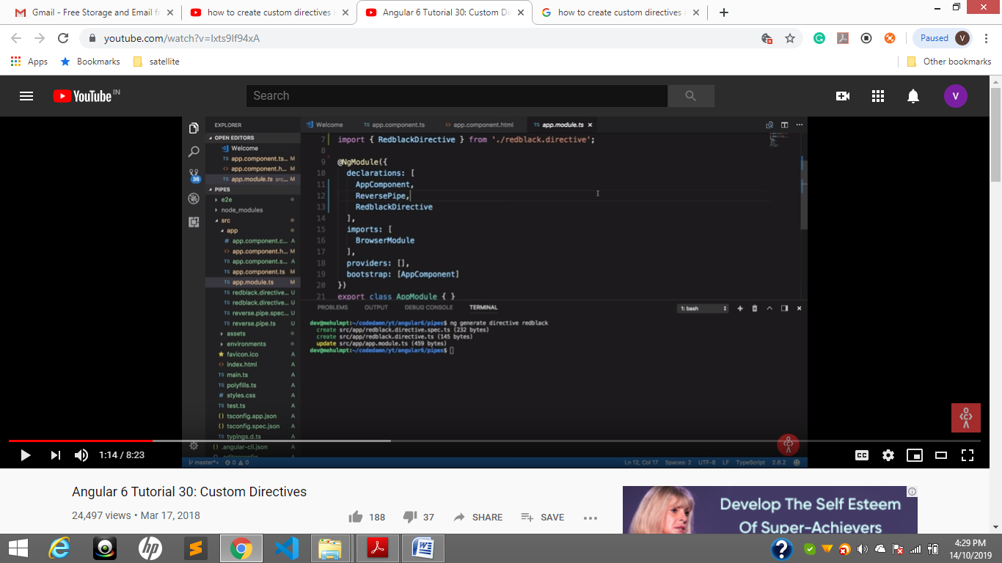

In declarations Directives /components/ pipes will add

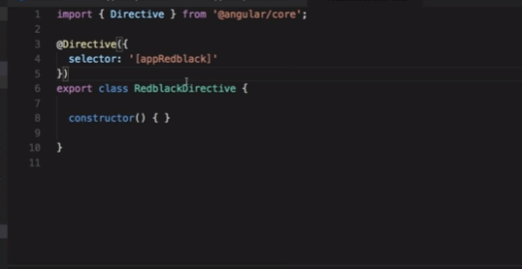

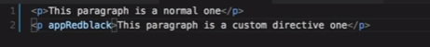

**AppRedblack directive is added to the element**

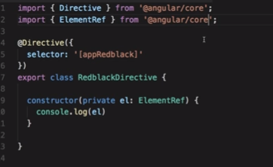

Created element reference using dependency injection object created.

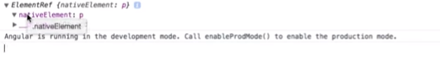

We get a nativeElement reference

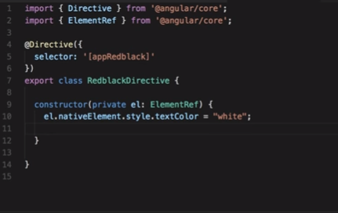

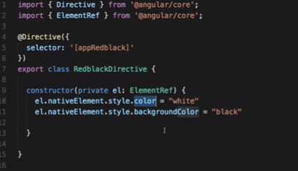

ElementRef contain NativeElemnt son ele.nativeElement.style.textColor=red

output



So we customized/ custom directive according to our Needs

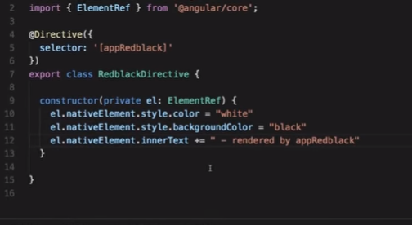

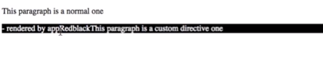

Text also added But added First that was wrong. So we have to use ngONinit

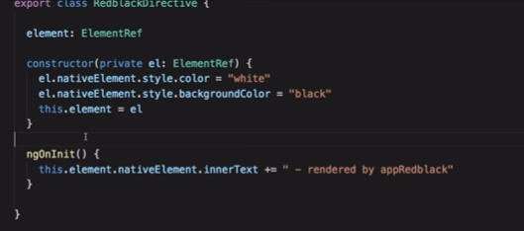

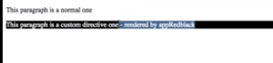

//o/p venkat kiran duggirala

<p **DirectiveRef**>venkat kiran<p>………app.component HTML

Constructor( ele:ElementRef){

Ele.nativeElemnt.style.innerText=”duggirala” // o/p …duggirala venkat kiran but expected is wrong

}

ele:ElementRef

ngOninit(){

this.ele.nativeElemnt.style.innerText=”duggirala” //o/p …venkat kiran duggirala…..it is correct

}

…………………………………………………………X

<https://www.youtube.com/watch?v=wWknX6eaWjg>

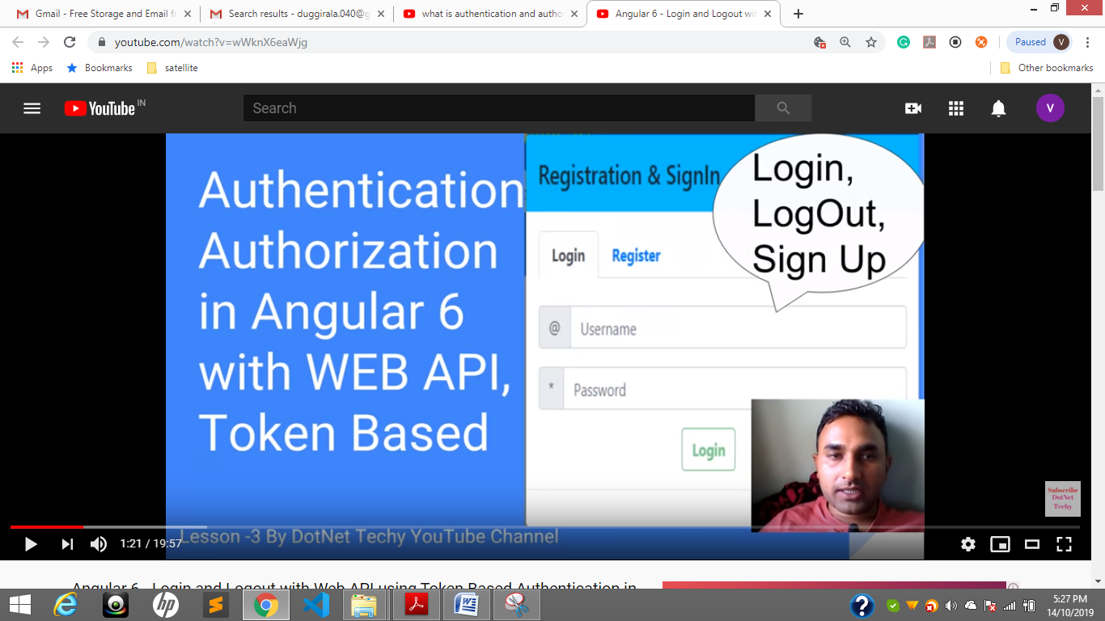

Authorozation is provided bye Auth gaurds

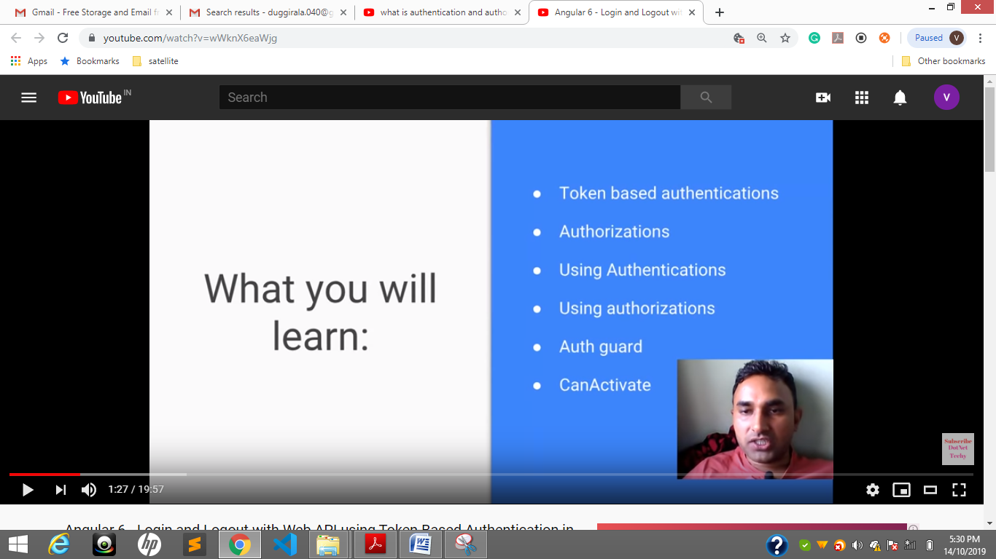

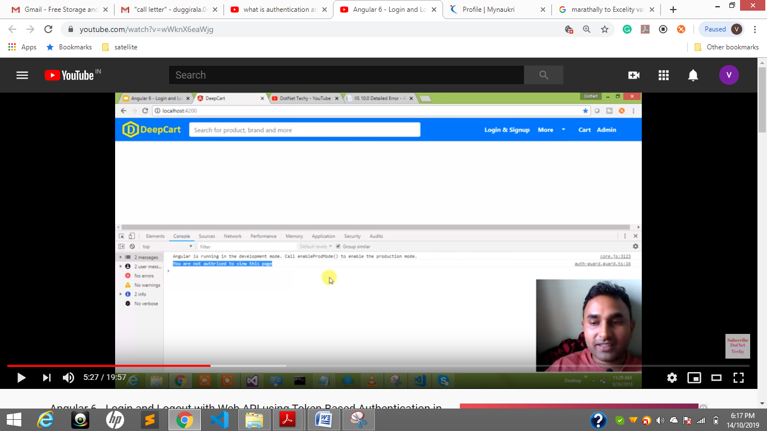



/admin if without login



Your are not authorized to view this page.

Back end check for **Authentication.Api calls**

Msg come from AUTH Guard

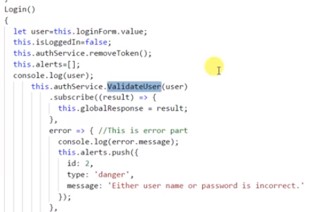

Created authService to validate

Observe headers

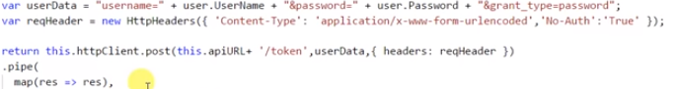

Localstorage

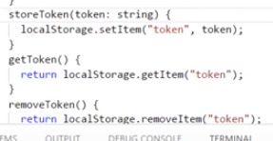

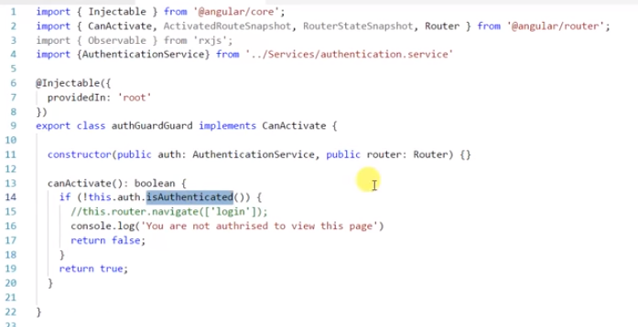

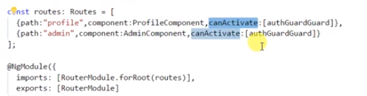

Here authGaurdGuard is .ts file contain authentication service

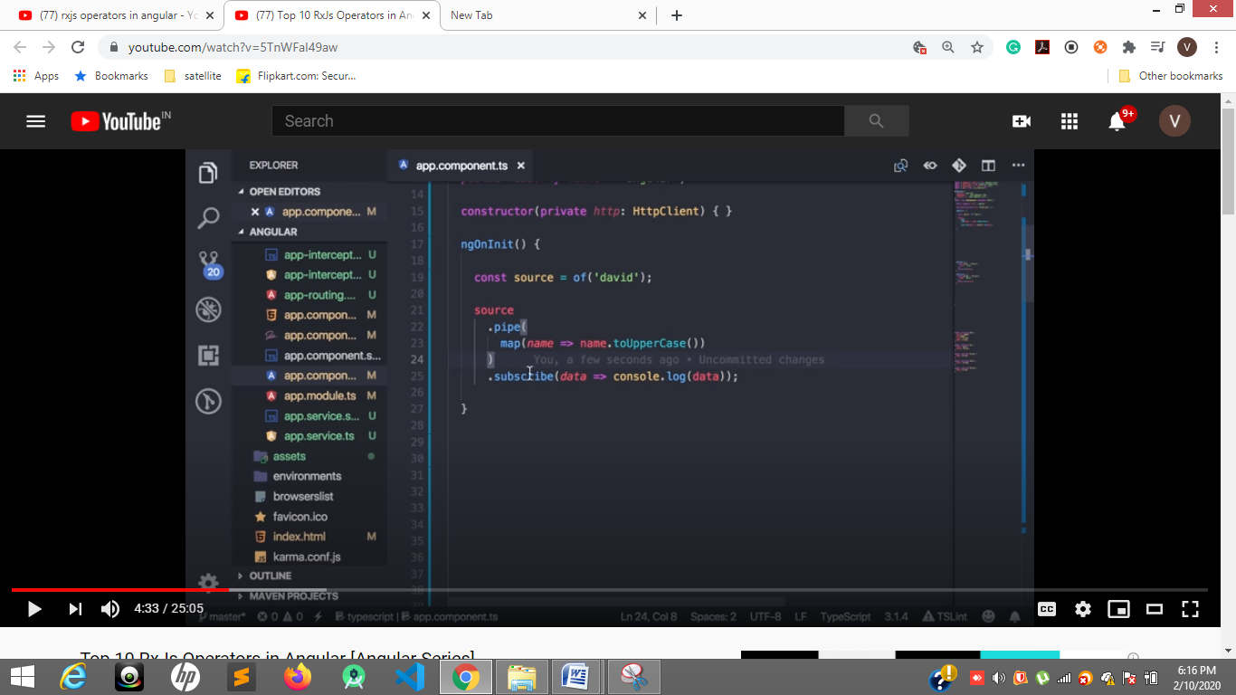

**Search functionality**

[**https://www.youtube.com/watch?v=5TnWFaI49aw**](https://www.youtube.com/watch?v=5TnWFaI49aw)

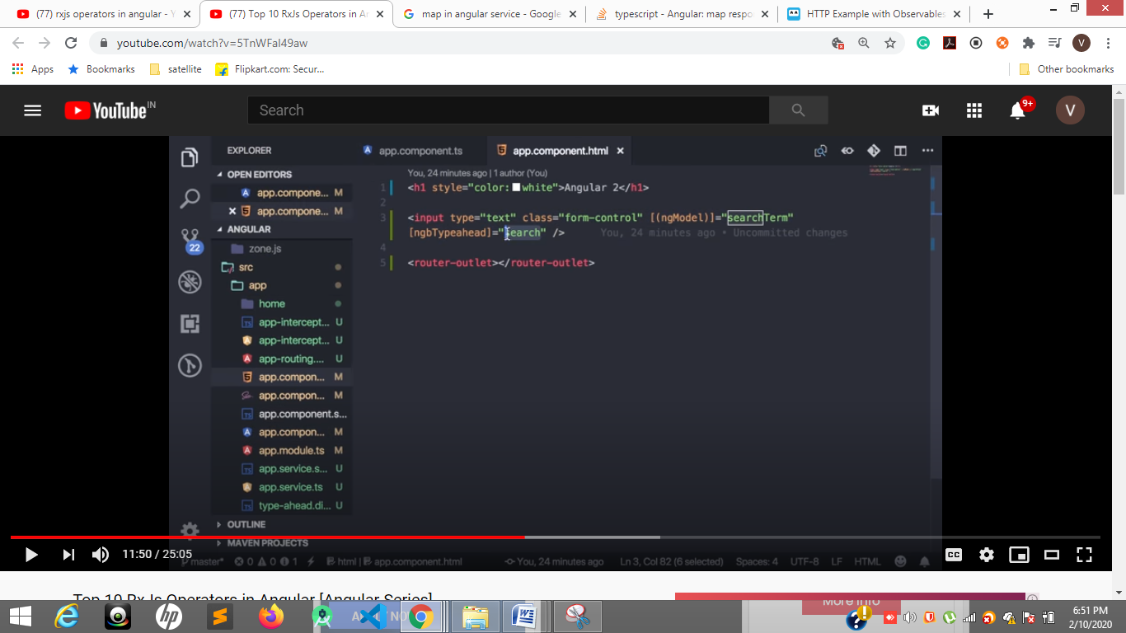

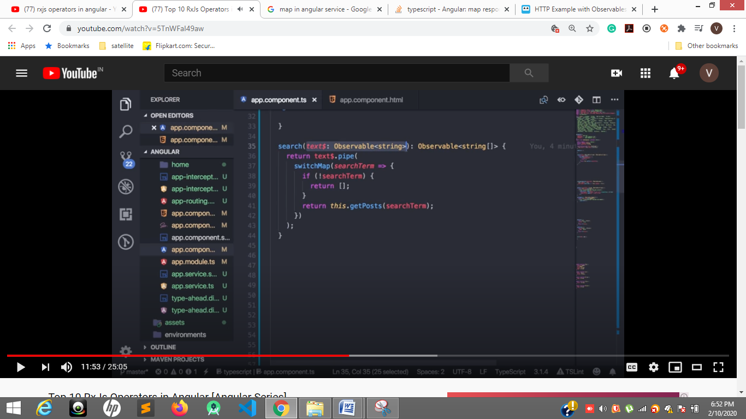

**DebounceTime not to call single letter but 500ms after to call server after typing**

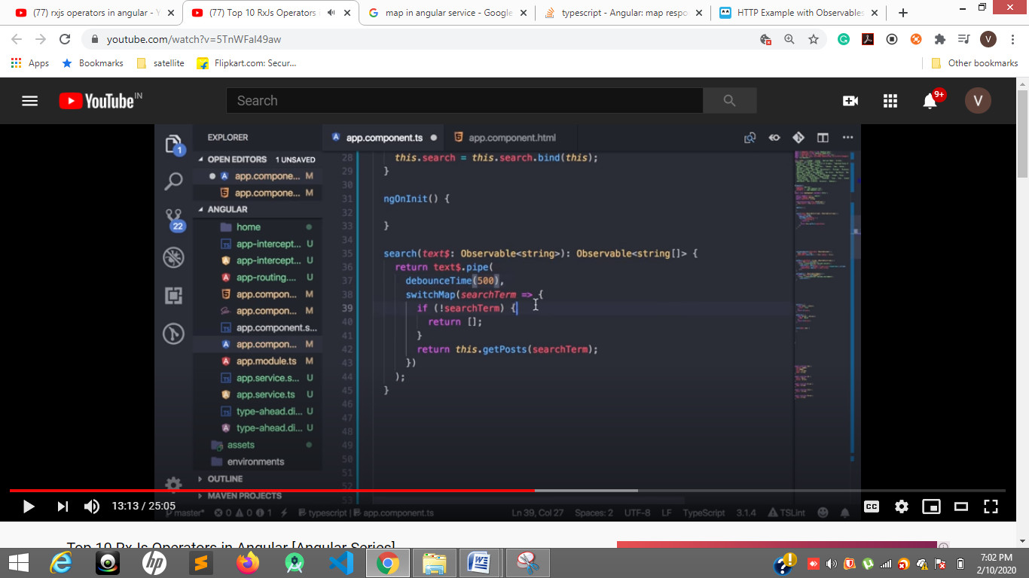

**Call api after changing letter**

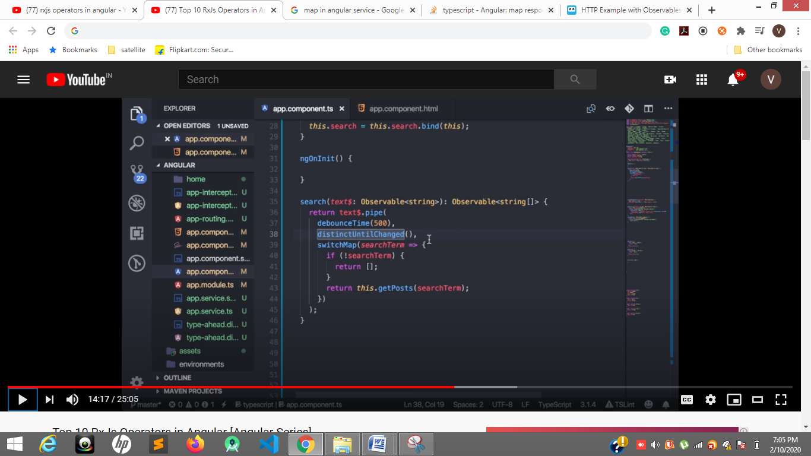

**distincUnitChanged()**

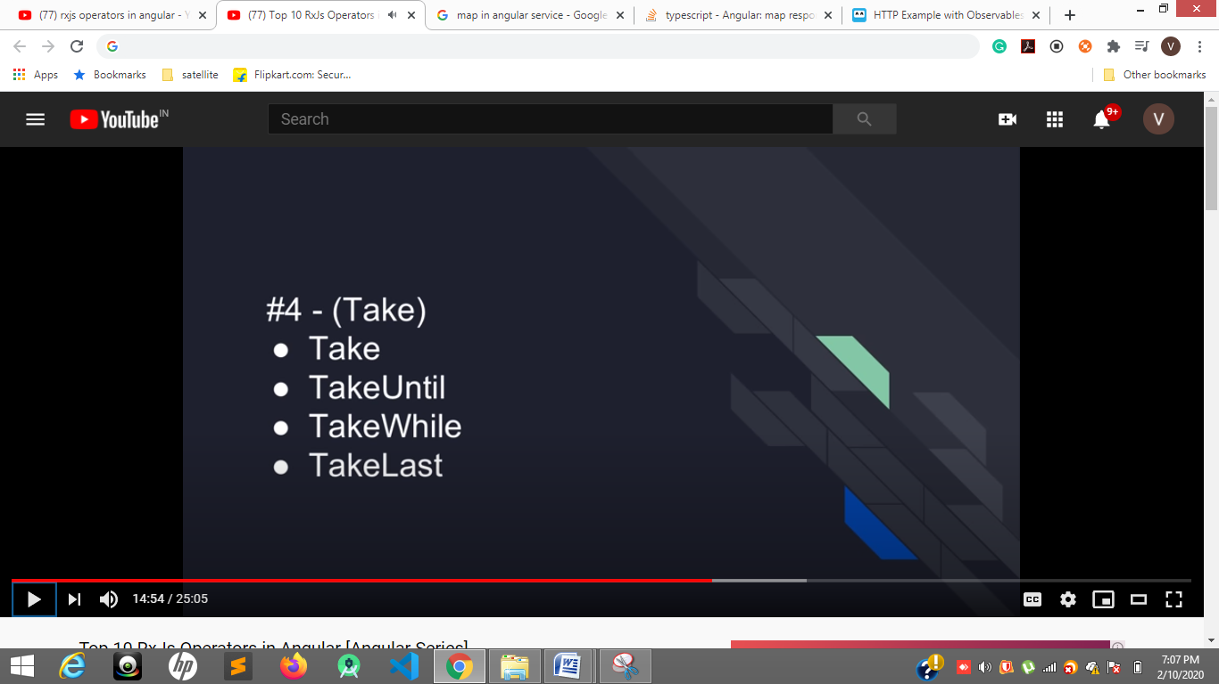

**Number of clicks to take and control on clicks**

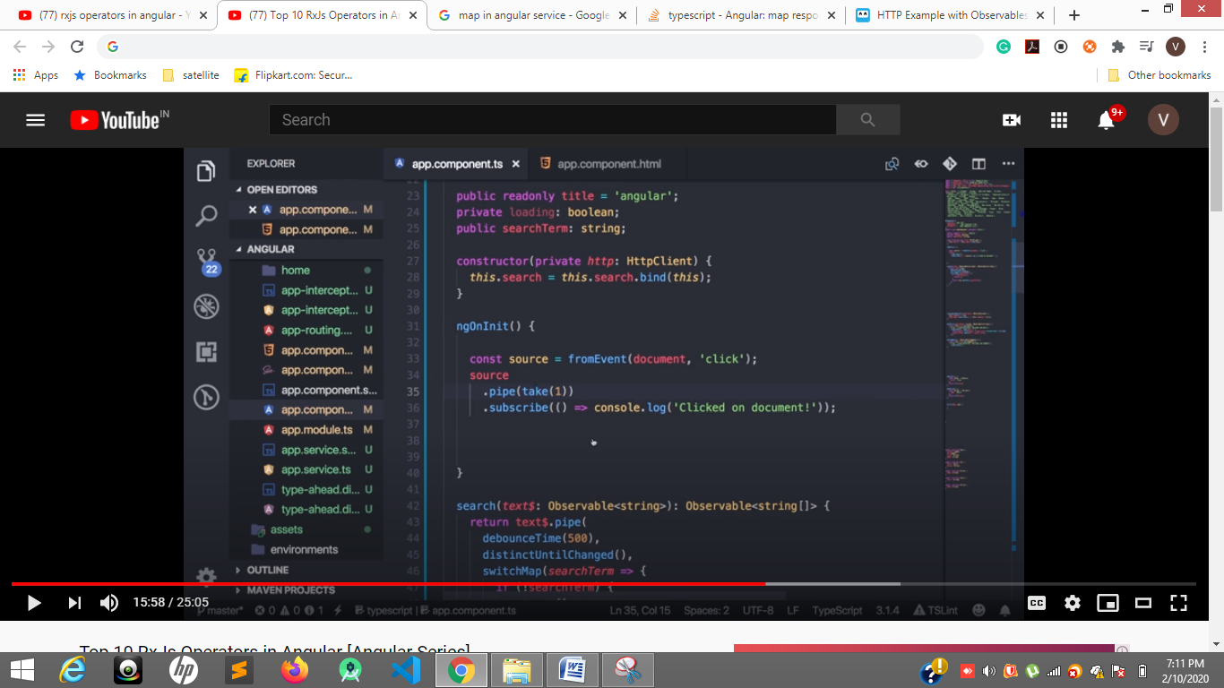**take(1)----------- one click\**

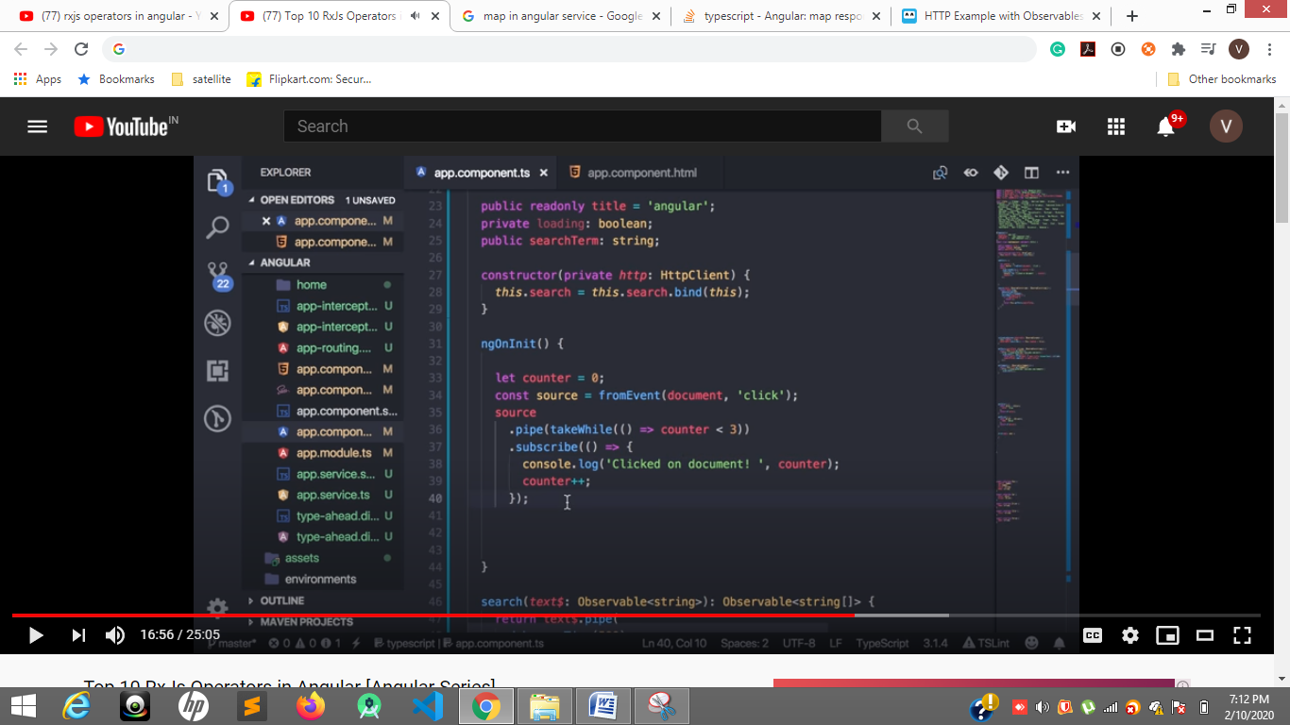**36 line**

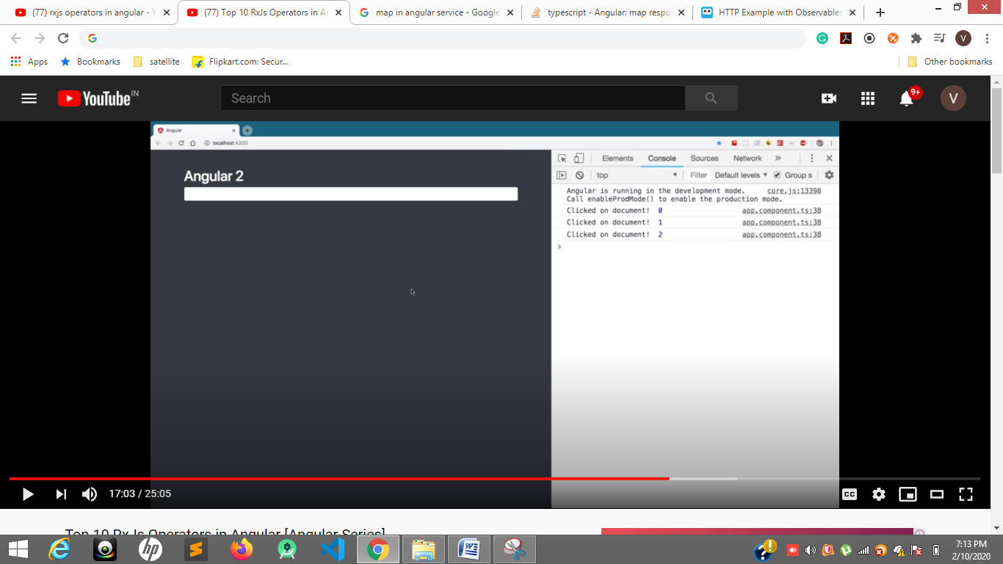

**TakeLast 2 or 3 in an array**

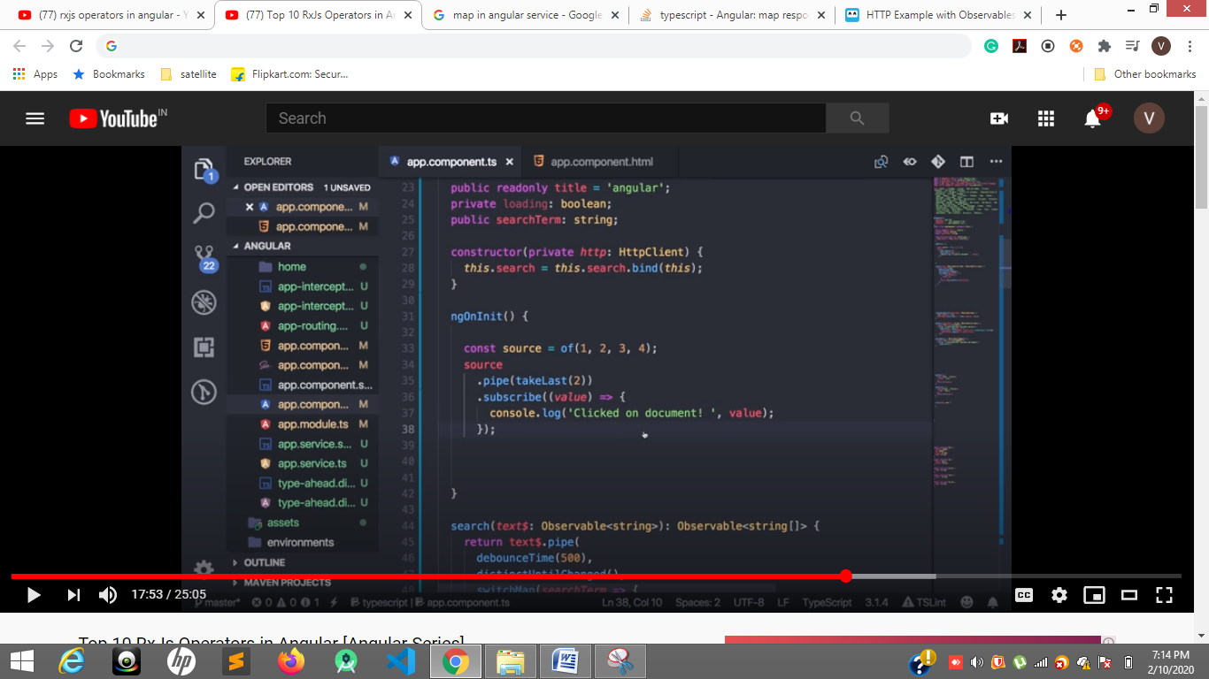

**35line**

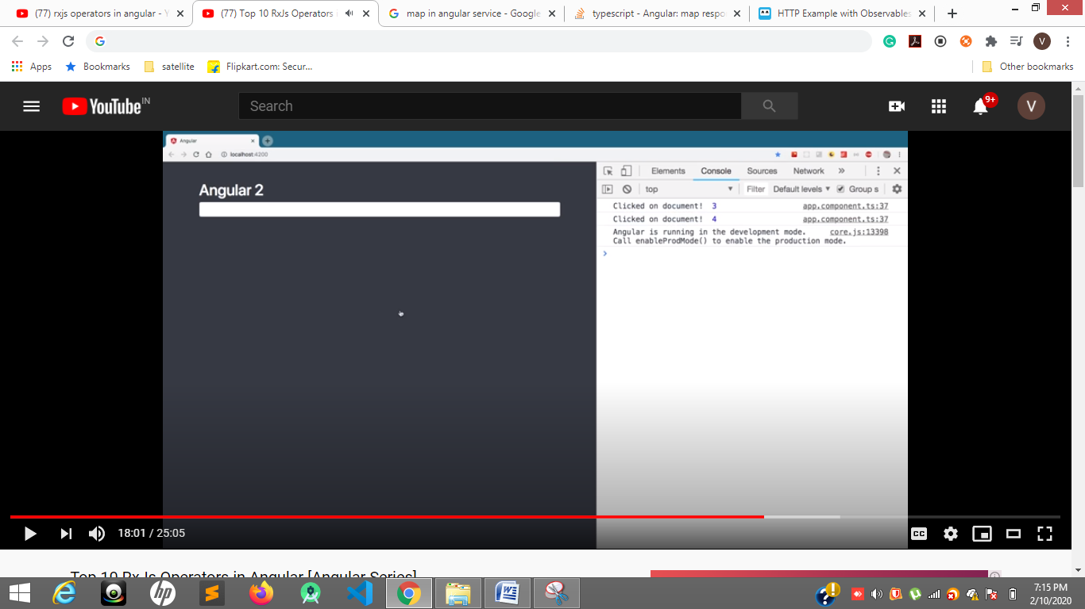

**Takeuntill**

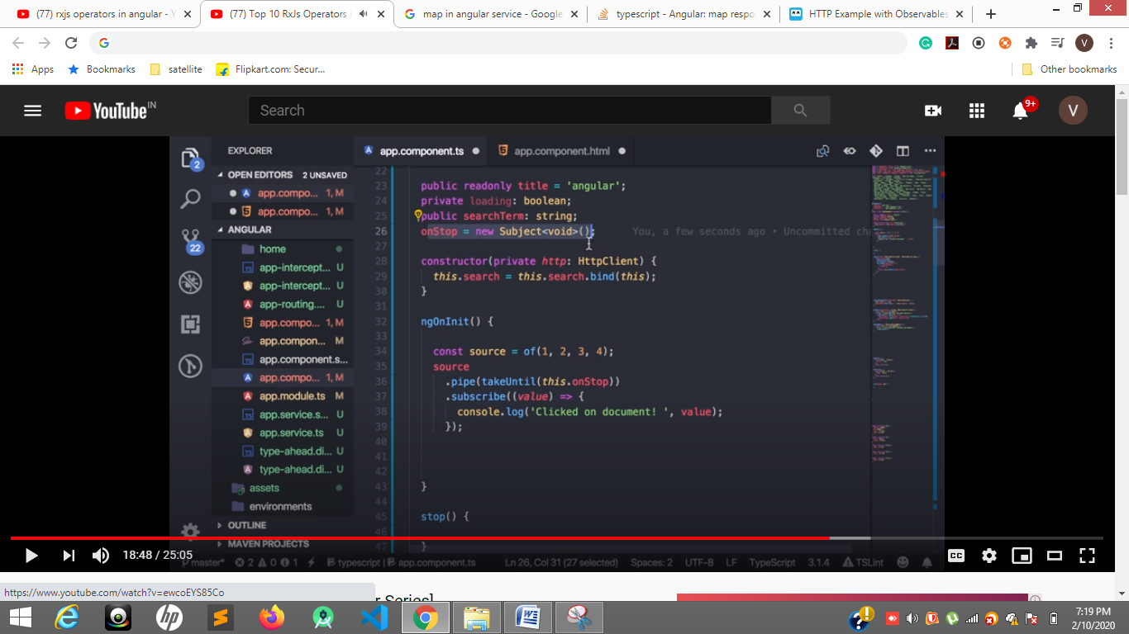

**26 nad 36**

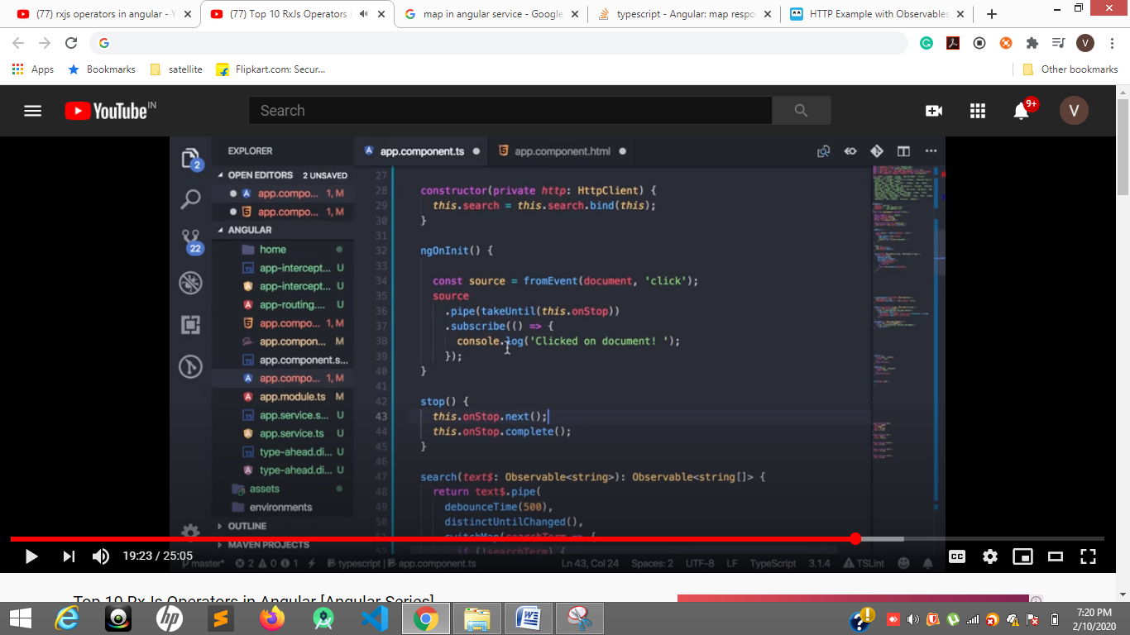

**42,43,44**

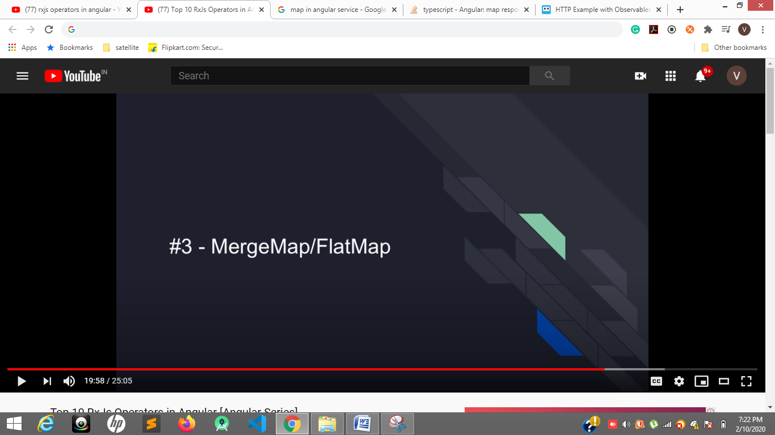

**How to merge two observable responses**

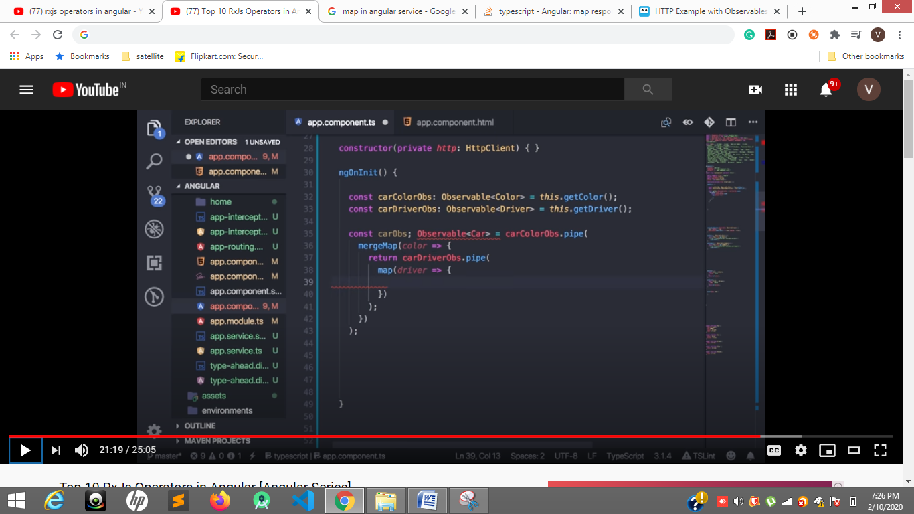**32,33,36,37,38**

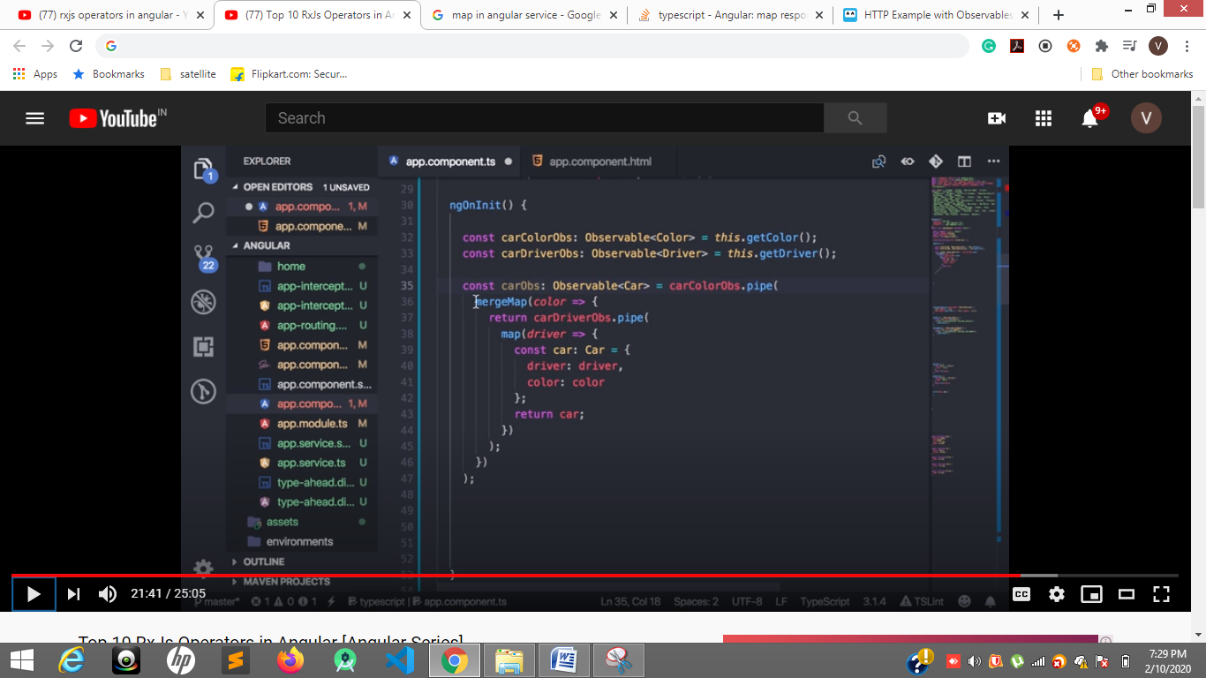

**36 to 43 lines**

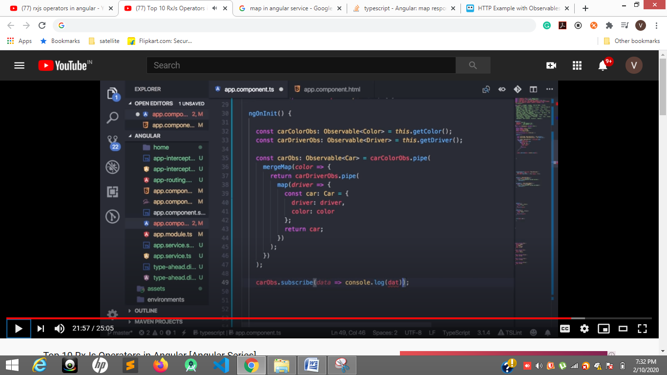

**49 line**

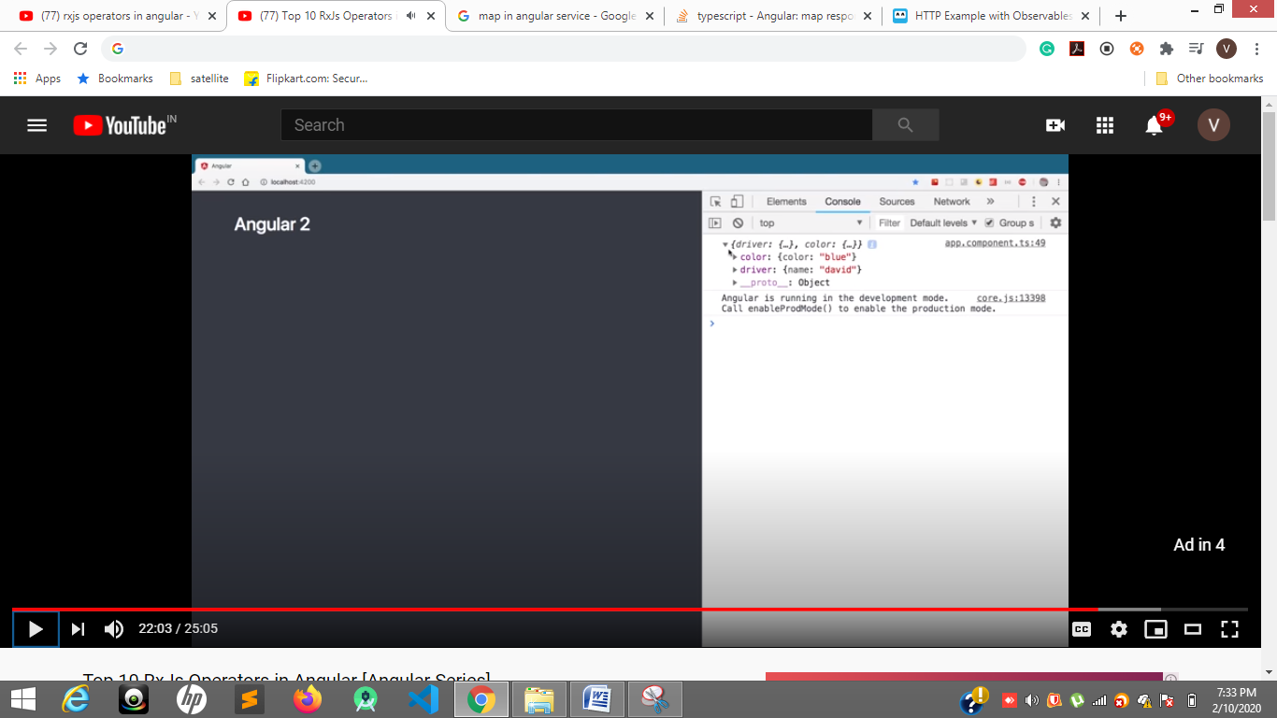

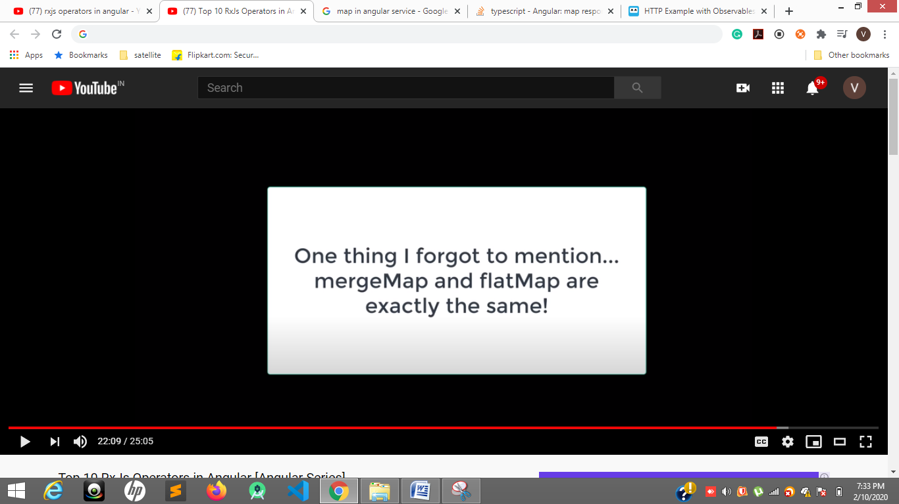

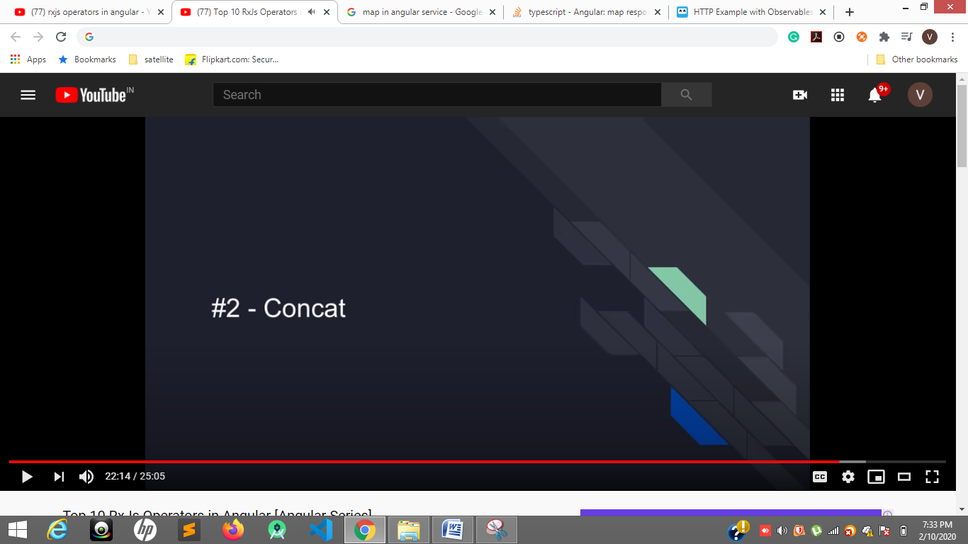

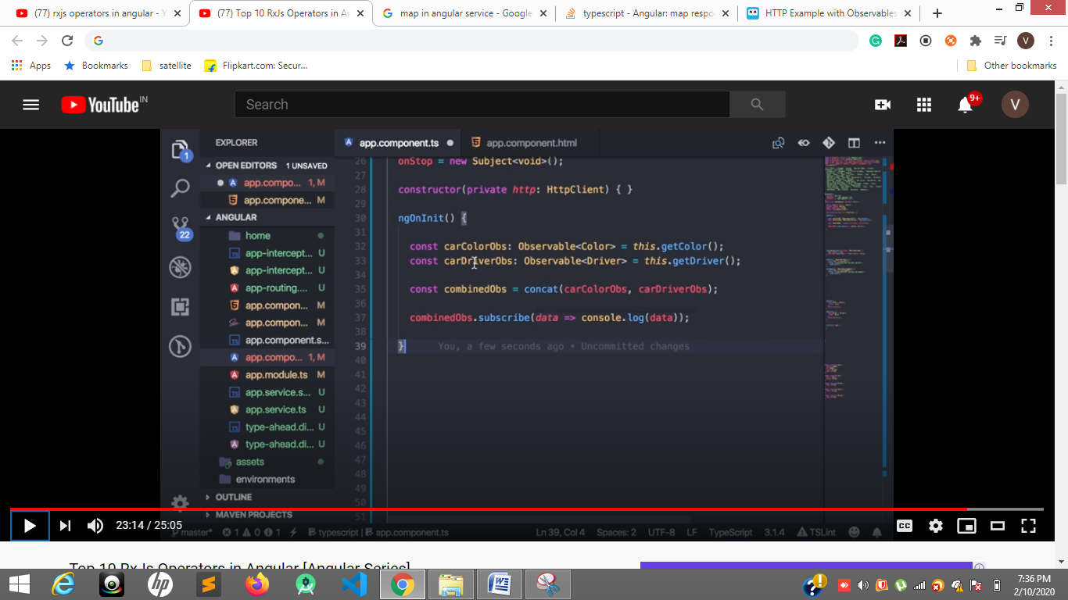

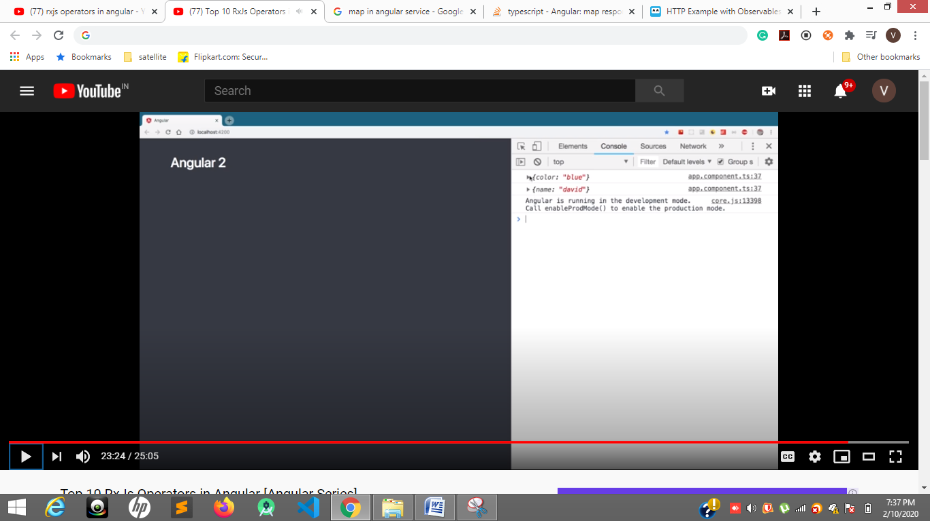

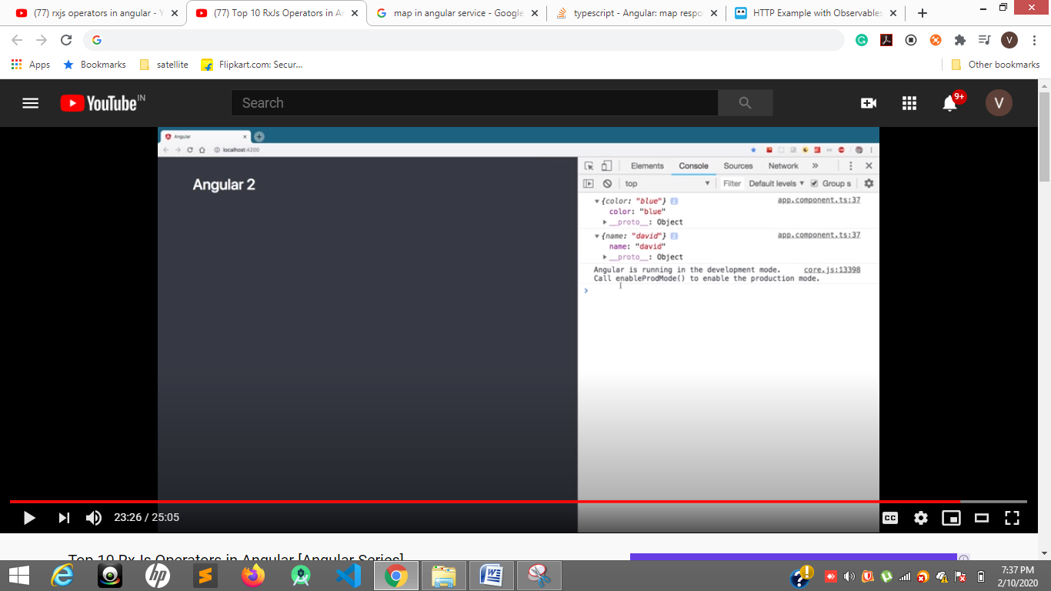

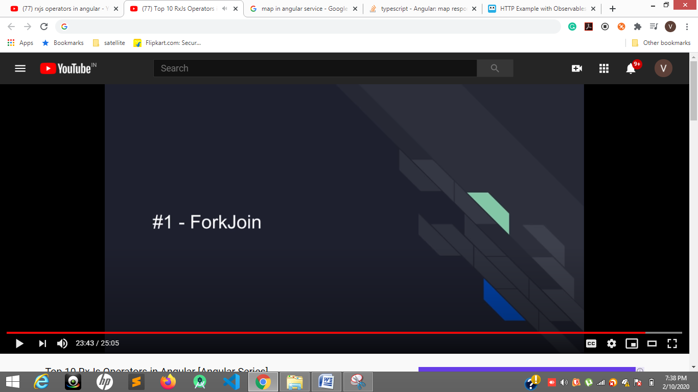

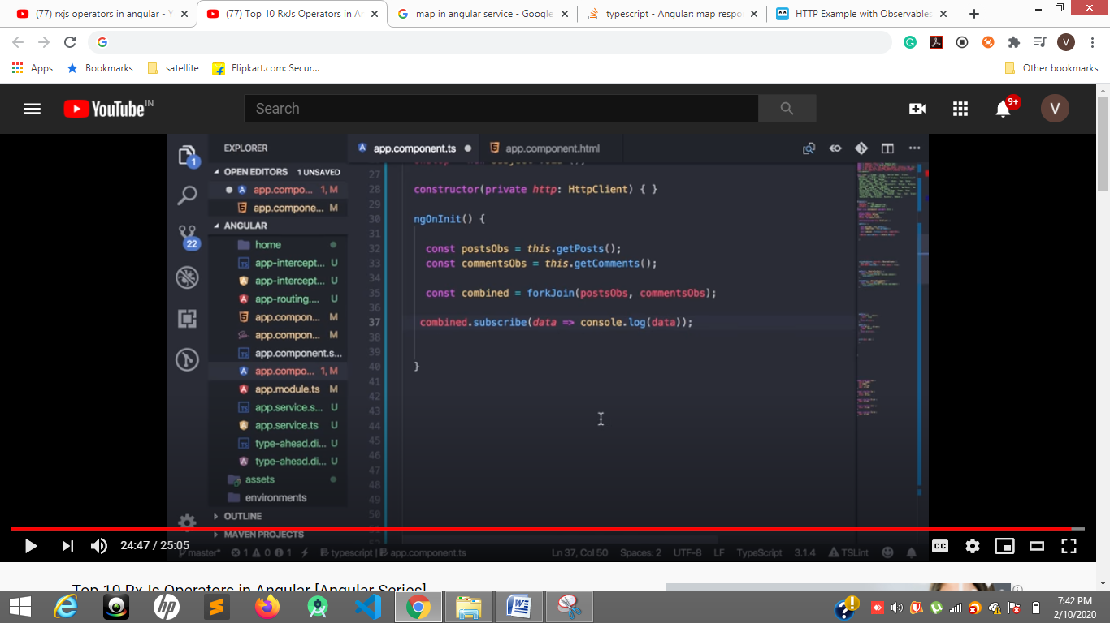

**Two array**

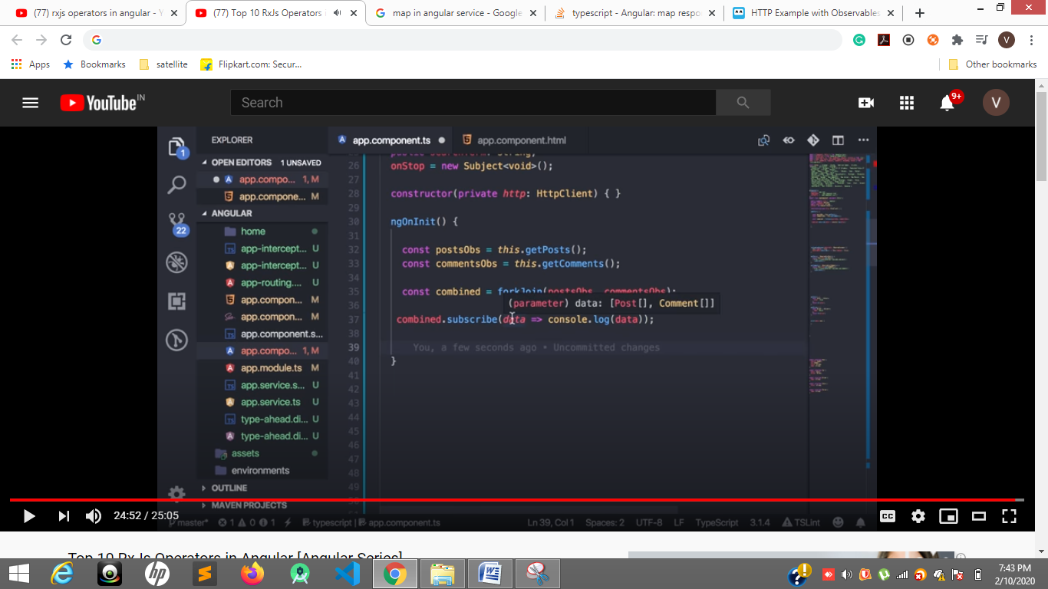

**Two api two observables into two arrays**

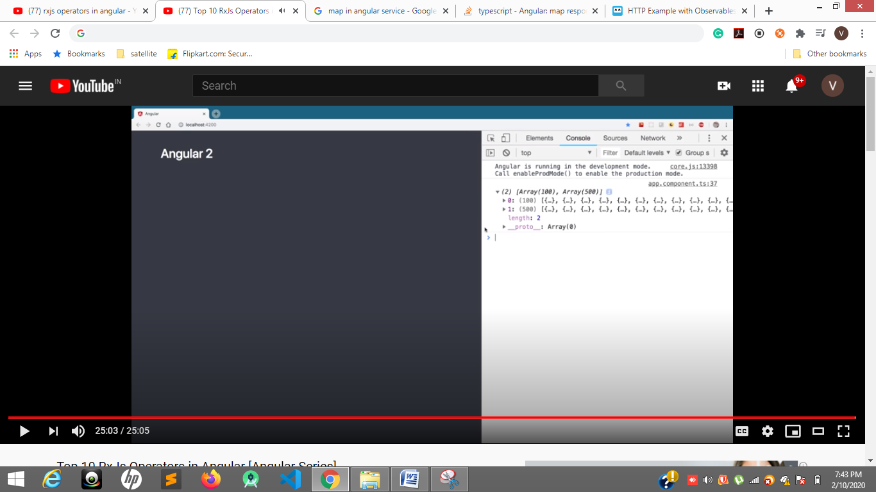

[**https://www.youtube.com/watch?v=VDEd4VGTchg**](https://www.youtube.com/watch?v=VDEd4VGTchg)

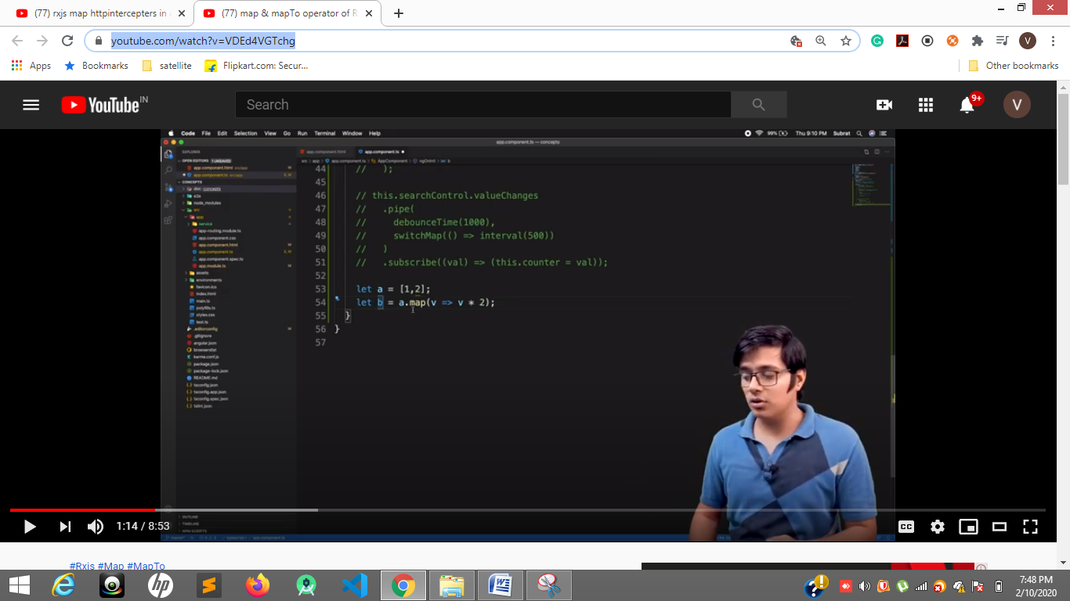

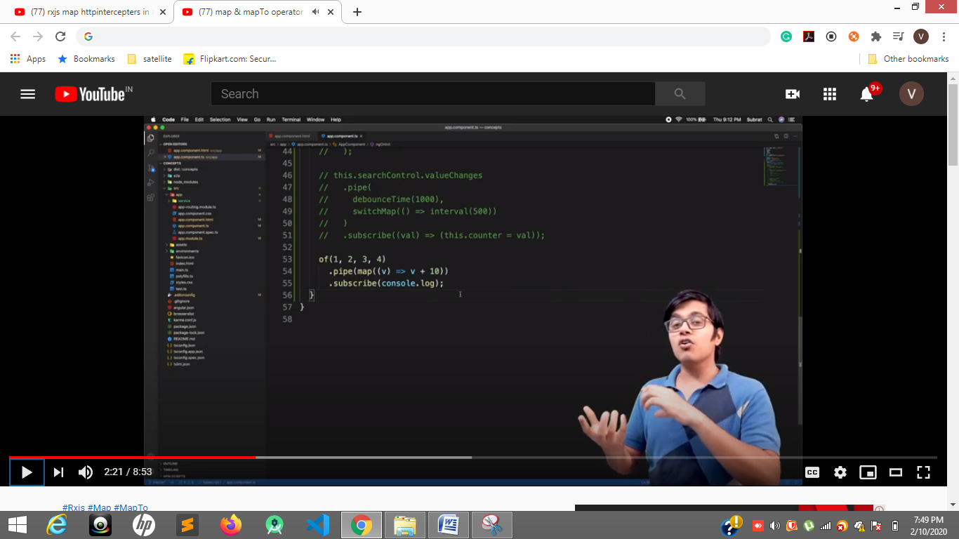

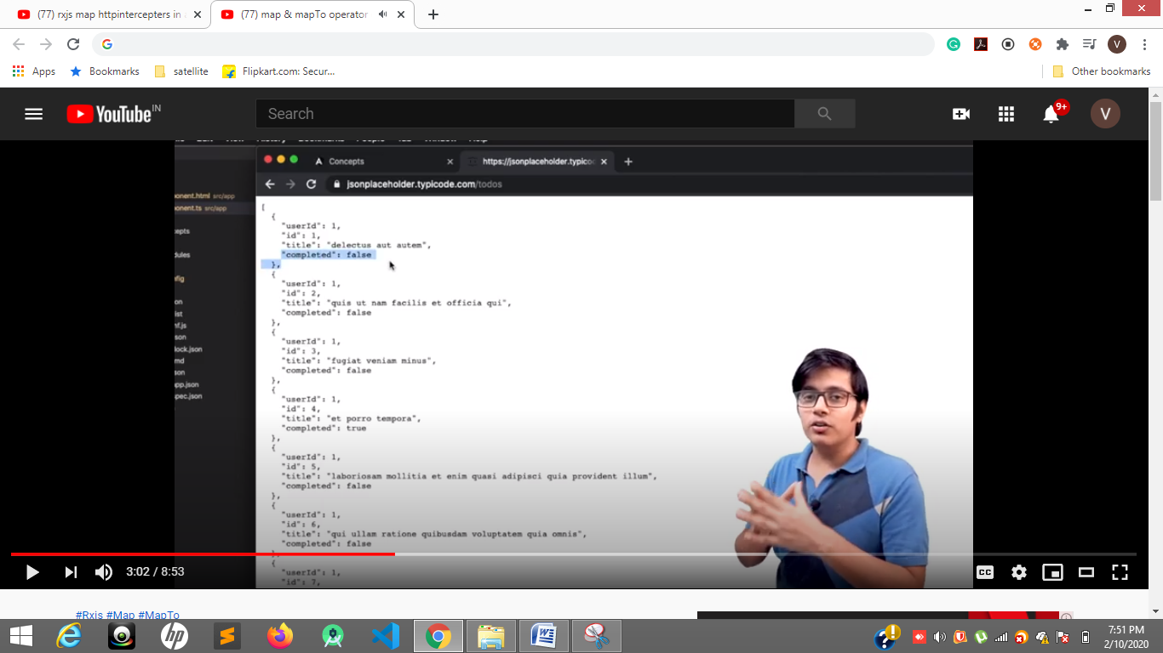

**Here if in Array of object 4 properties coming but I want only 2 properties so I can use**

**map (res=>res.map(data=>{**

**return {**

**only required properties**

**}**

**}))**

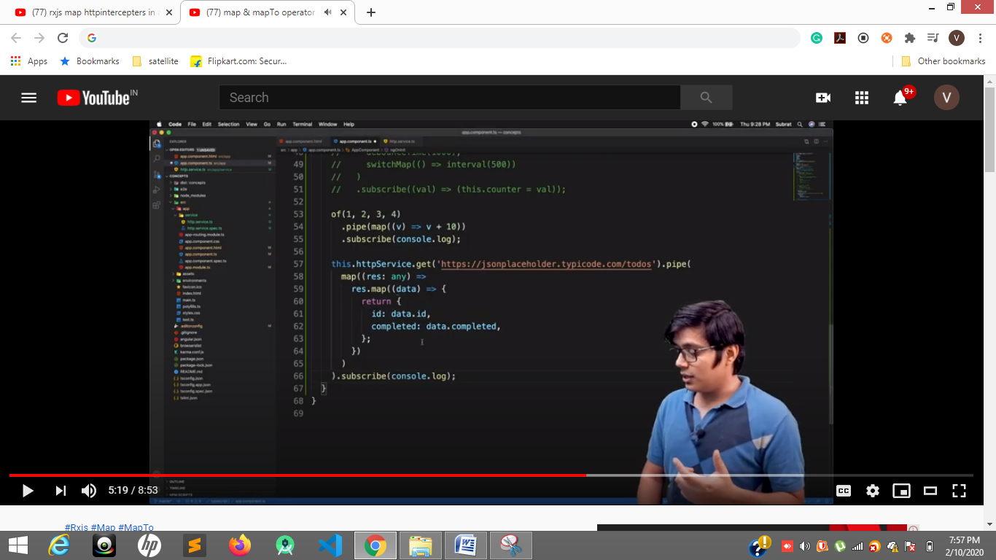

**35 to 61 , 66 lines**

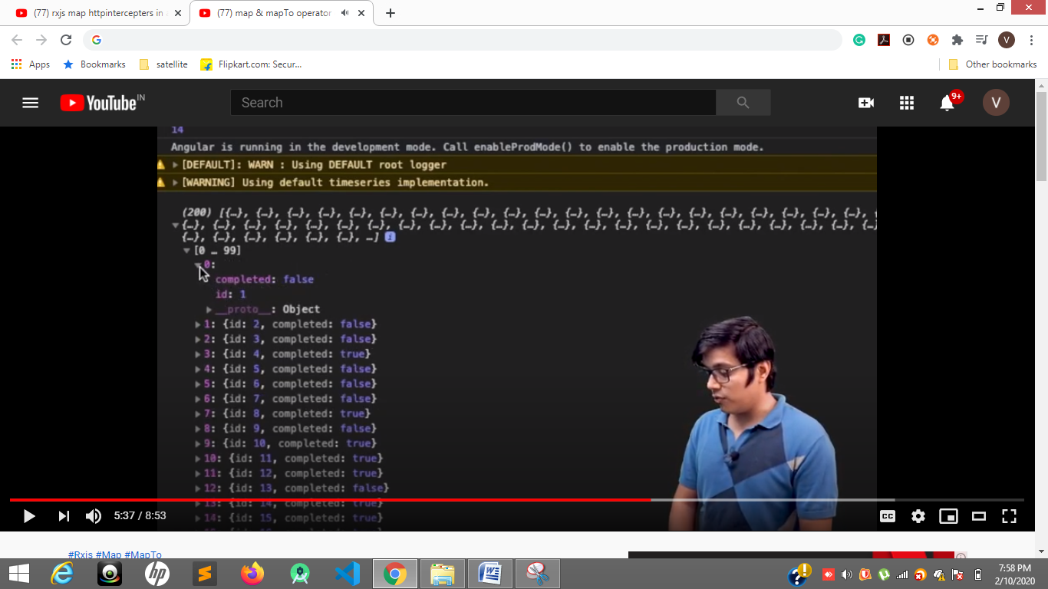

**Only two properties came**

**mapTo always return single value**

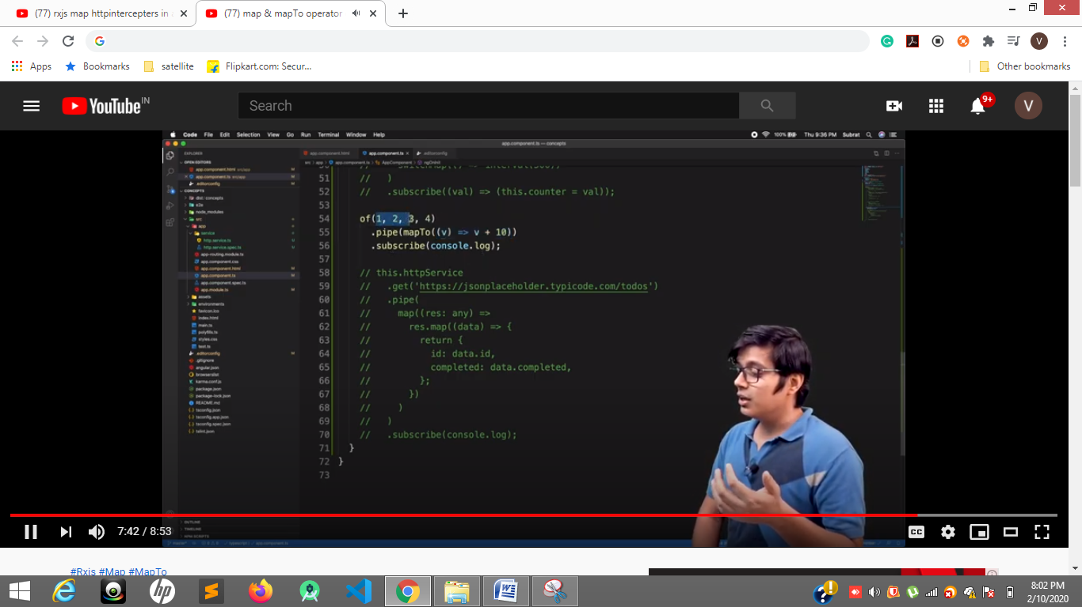

**Four times in console**

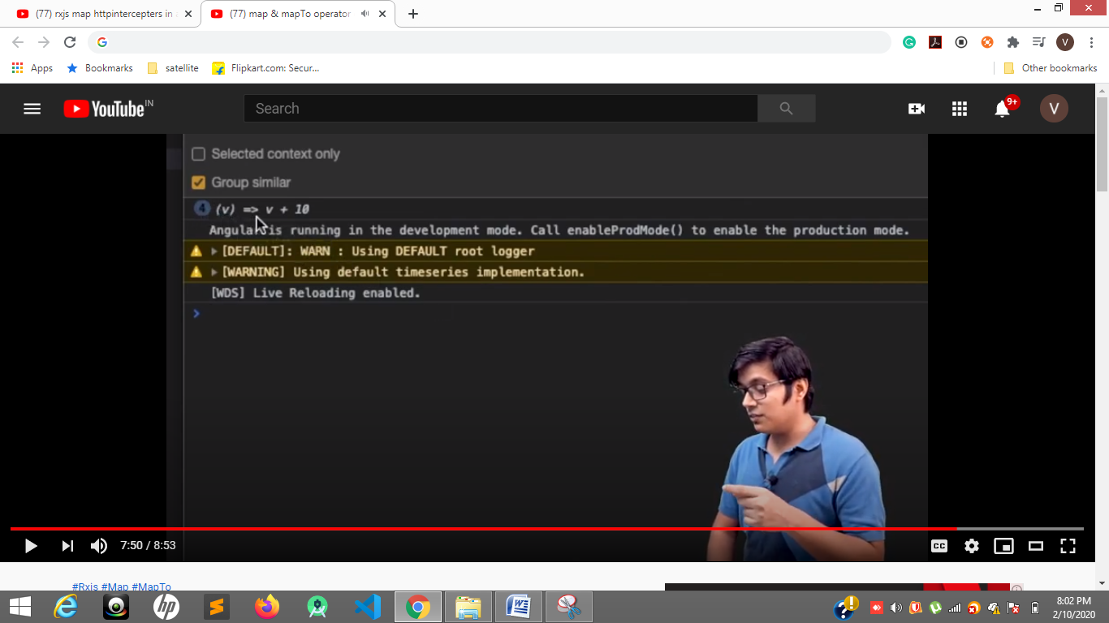

**mapTo is used to check number of times the values is emited**

[**https://www.youtube.com/watch?v=ahogOJEGIOM**](https://www.youtube.com/watch?v=ahogOJEGIOM)

**switchmap**

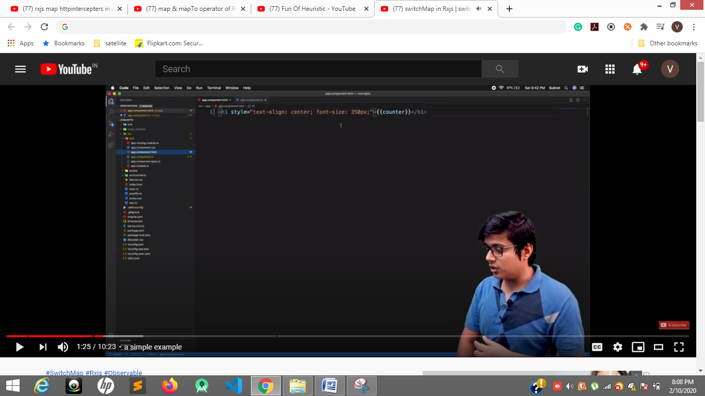

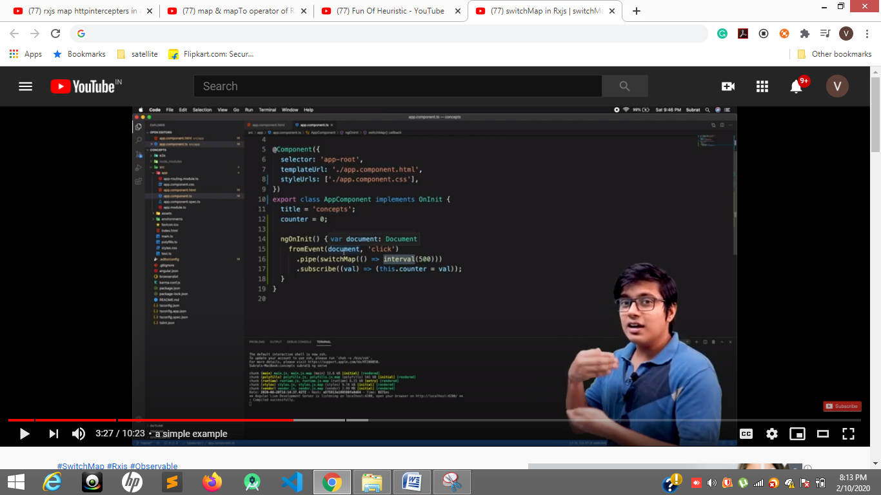

**For every click new subscription take place**

**Click start 0,1,2,3,4 after click again start from 0**

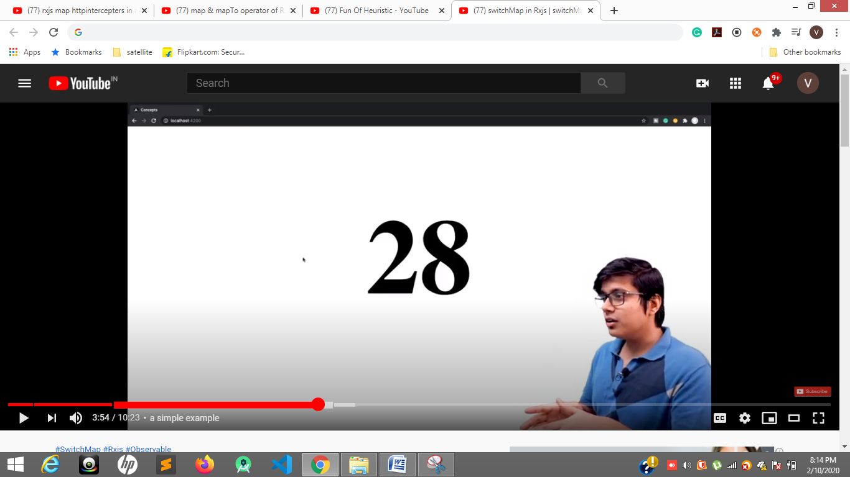

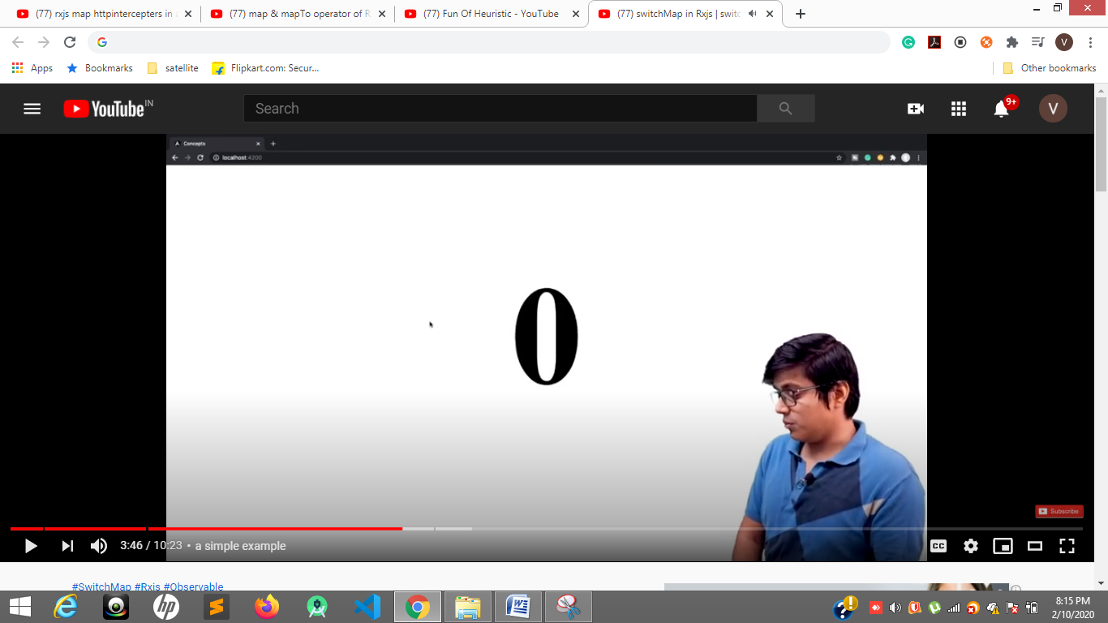

**Taking serach example real scenario**

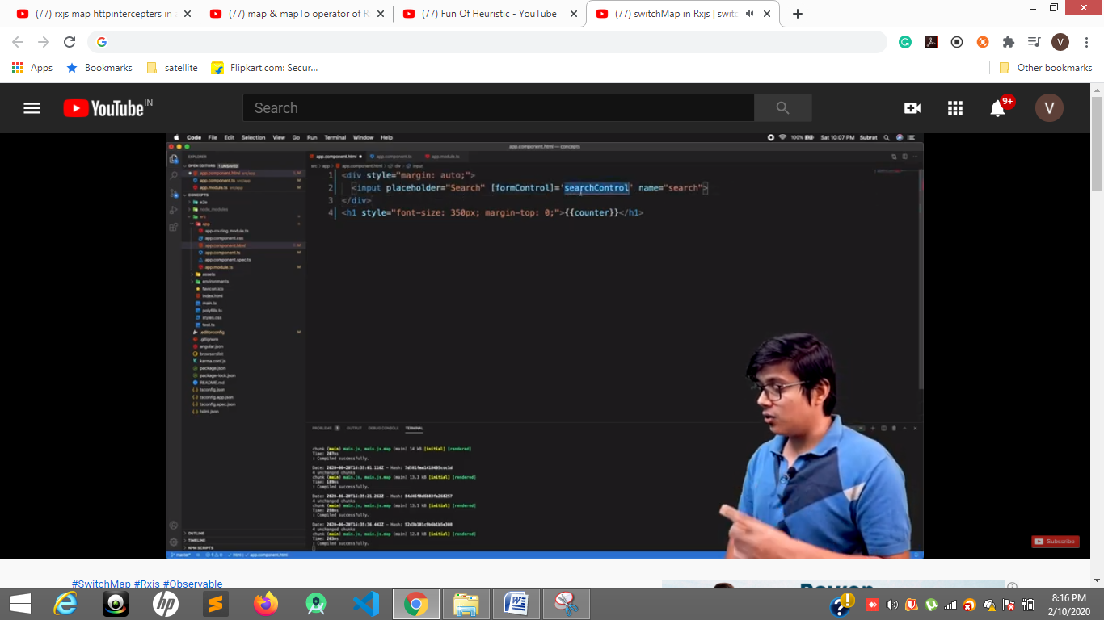

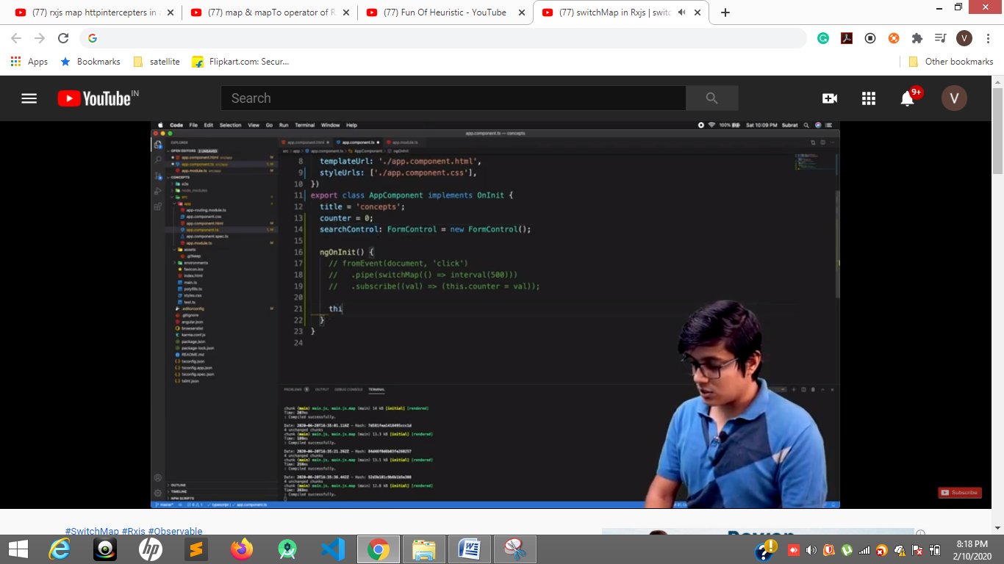

**14 line**

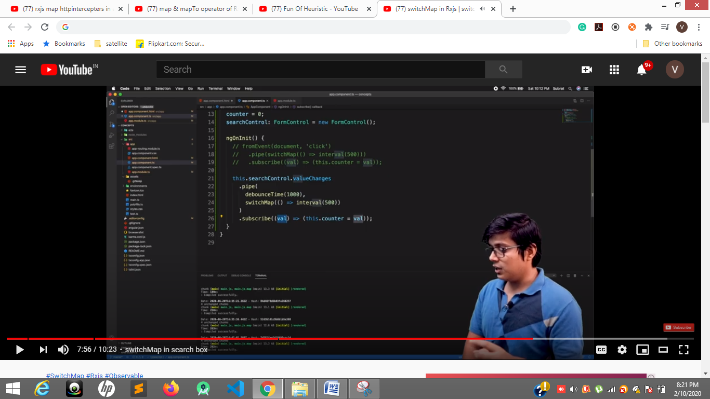

**24 line at interval(500) we need to call service all**

**--------------------------------------**

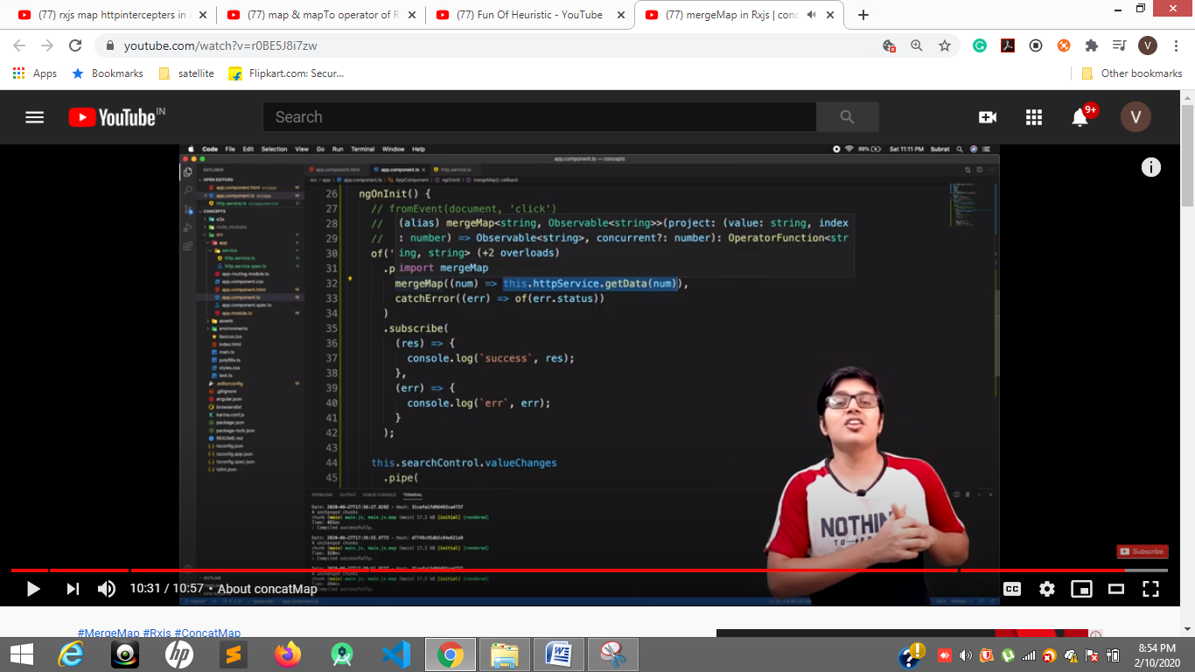

**mergeMap is asynchronous calls but concatMap is sycronous calls**

**33 error can be handled**

[**https://www.youtube.com/watch?v=X8hLraWnVhw**](https://www.youtube.com/watch?v=X8hLraWnVhw)

**Error s handling**

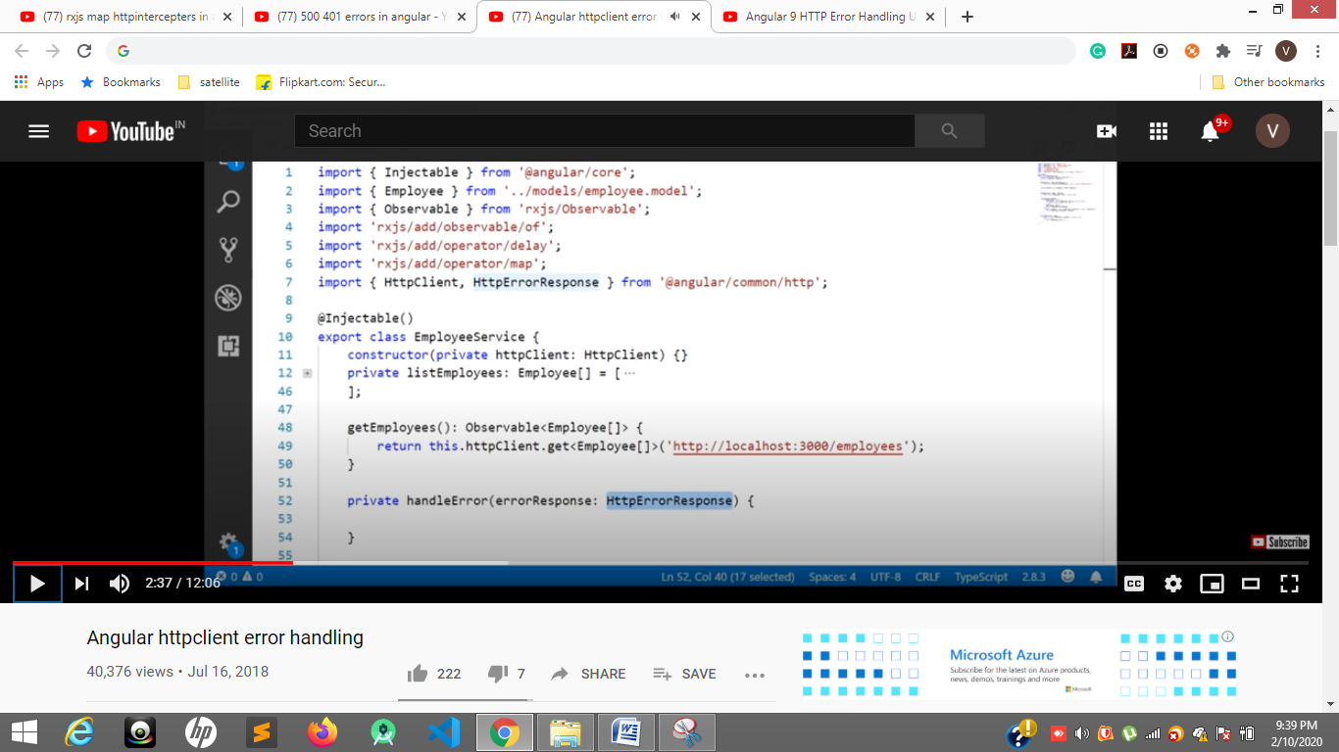

**7, 48 to50**

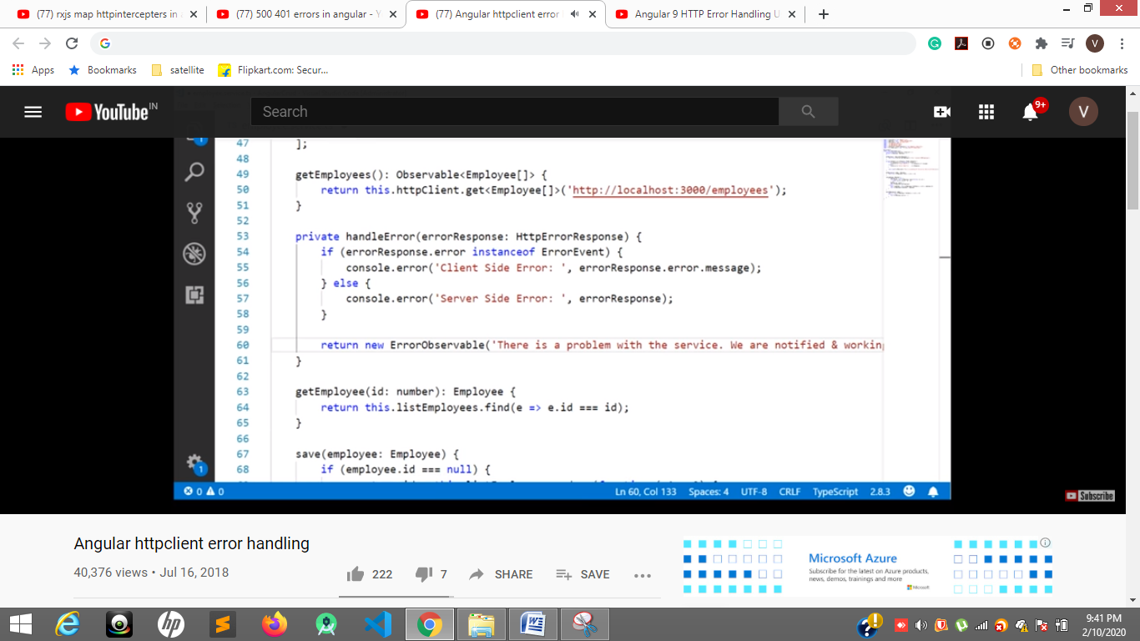

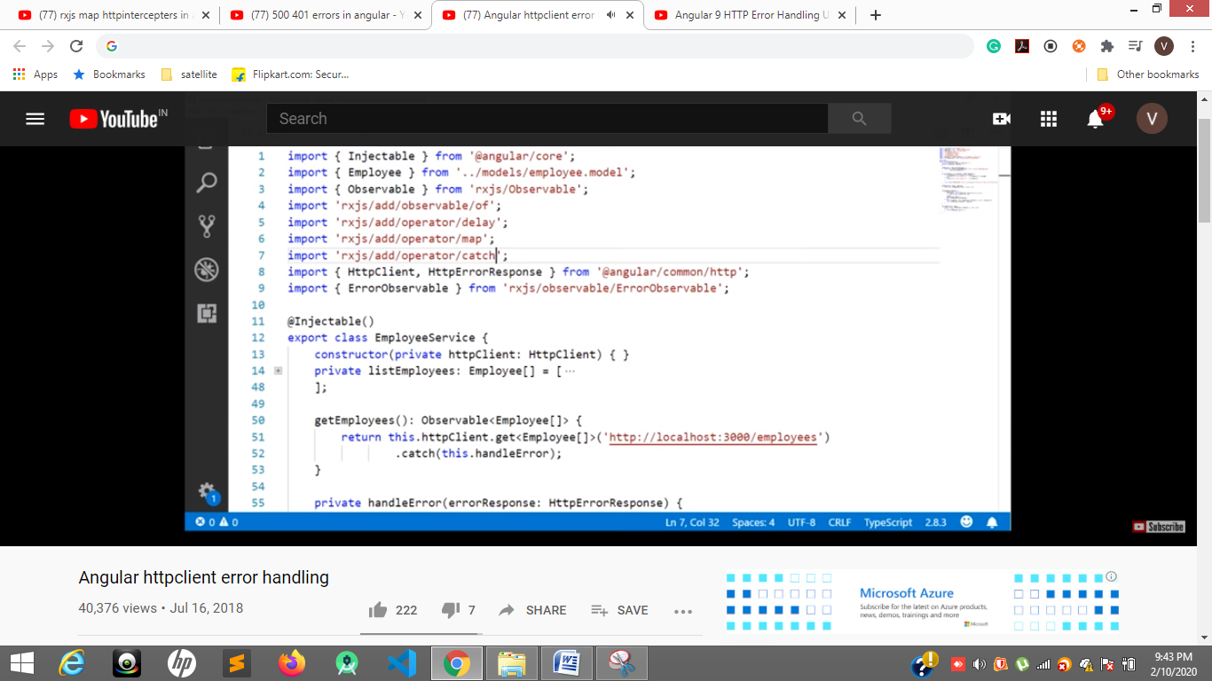

**7,52, 55 lines**

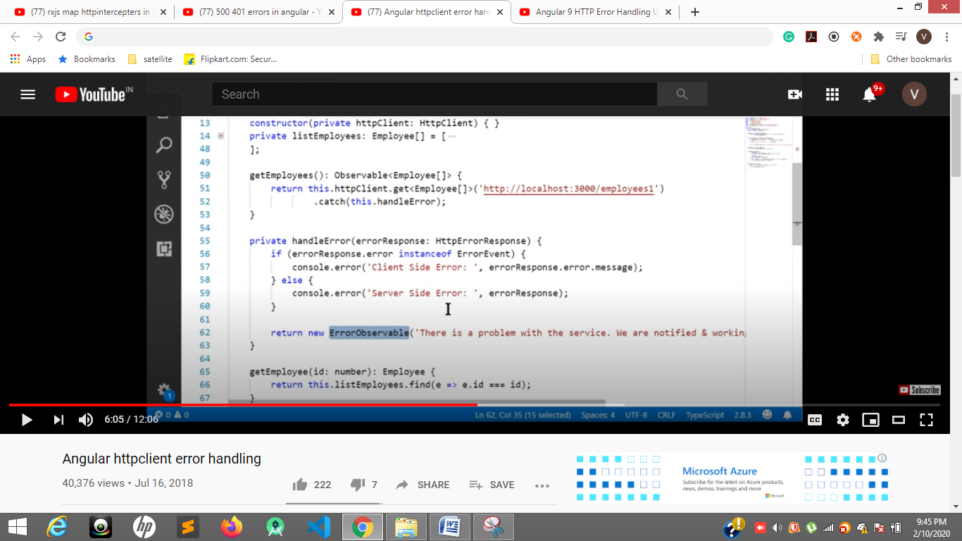

**51 line api made error so**

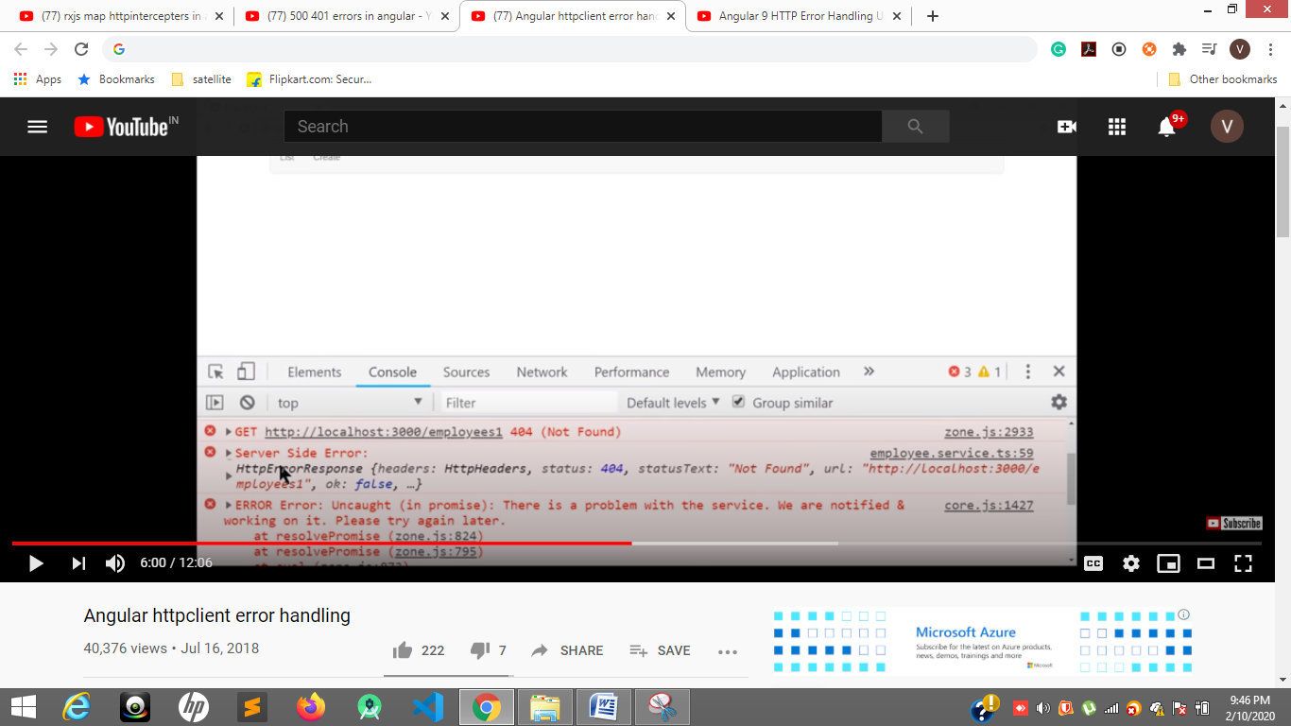

**404 error**



**2nd error for friendly error to show user**

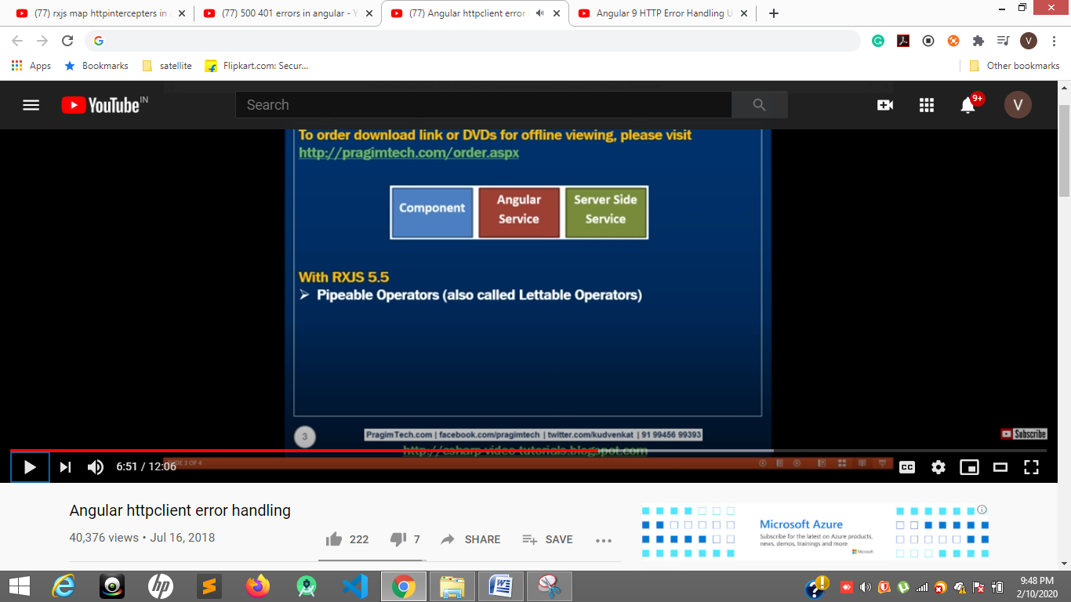

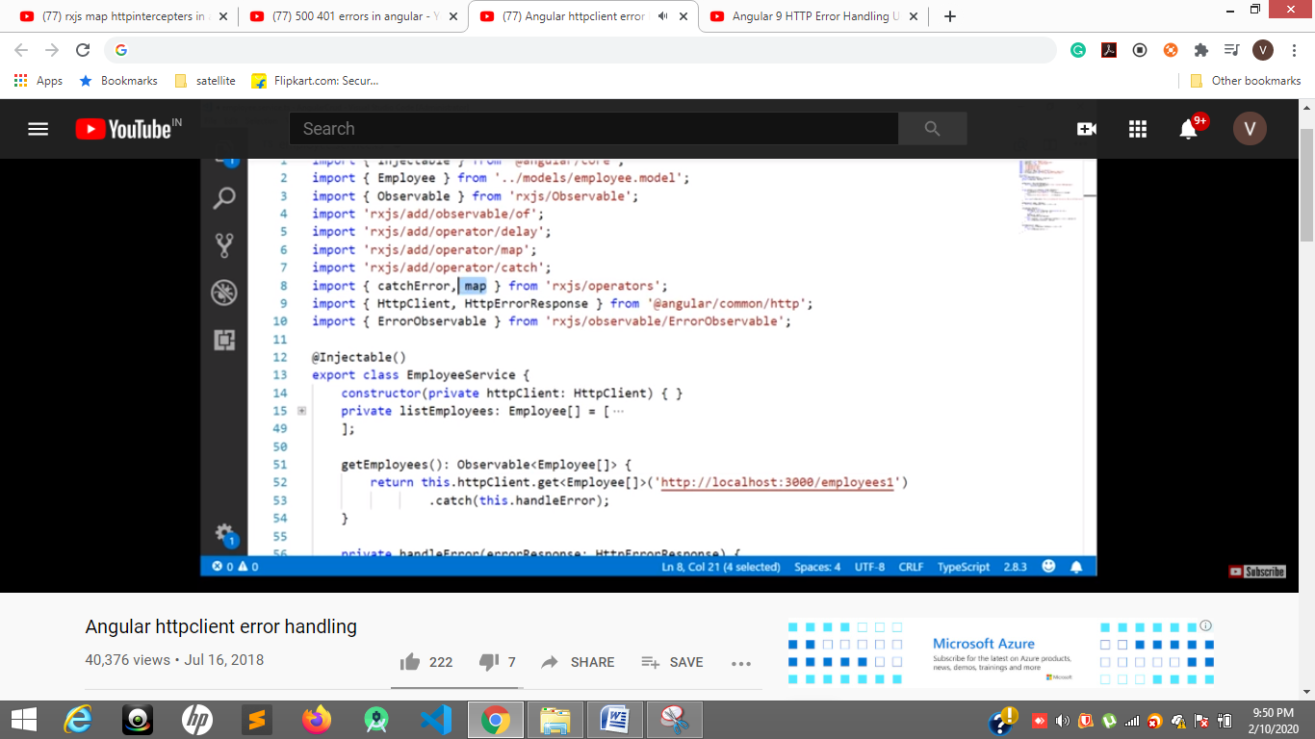

**7 pipable operatior**

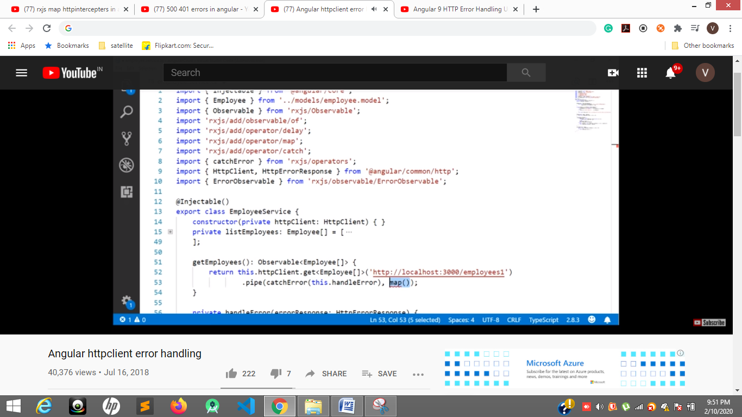

[**https://www.youtube.com/watch?v=d5bkiNebYWk**](https://www.youtube.com/watch?v=d5bkiNebYWk)

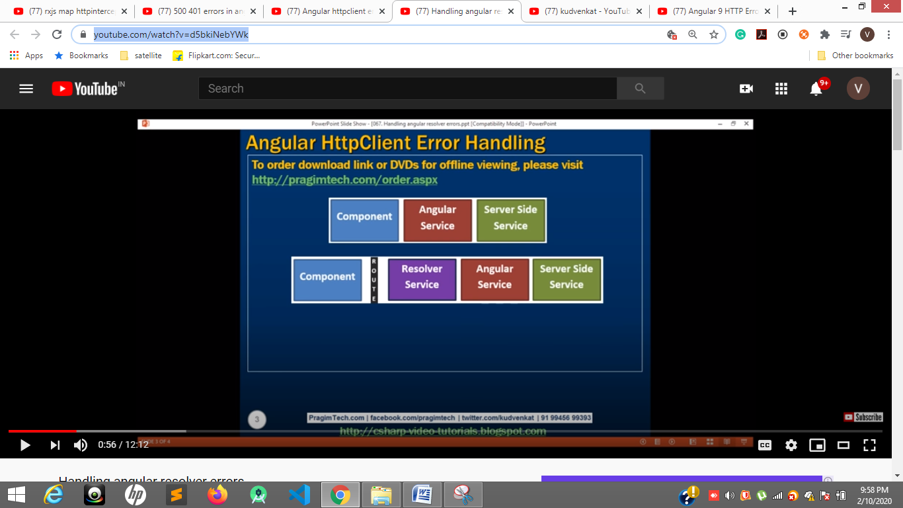

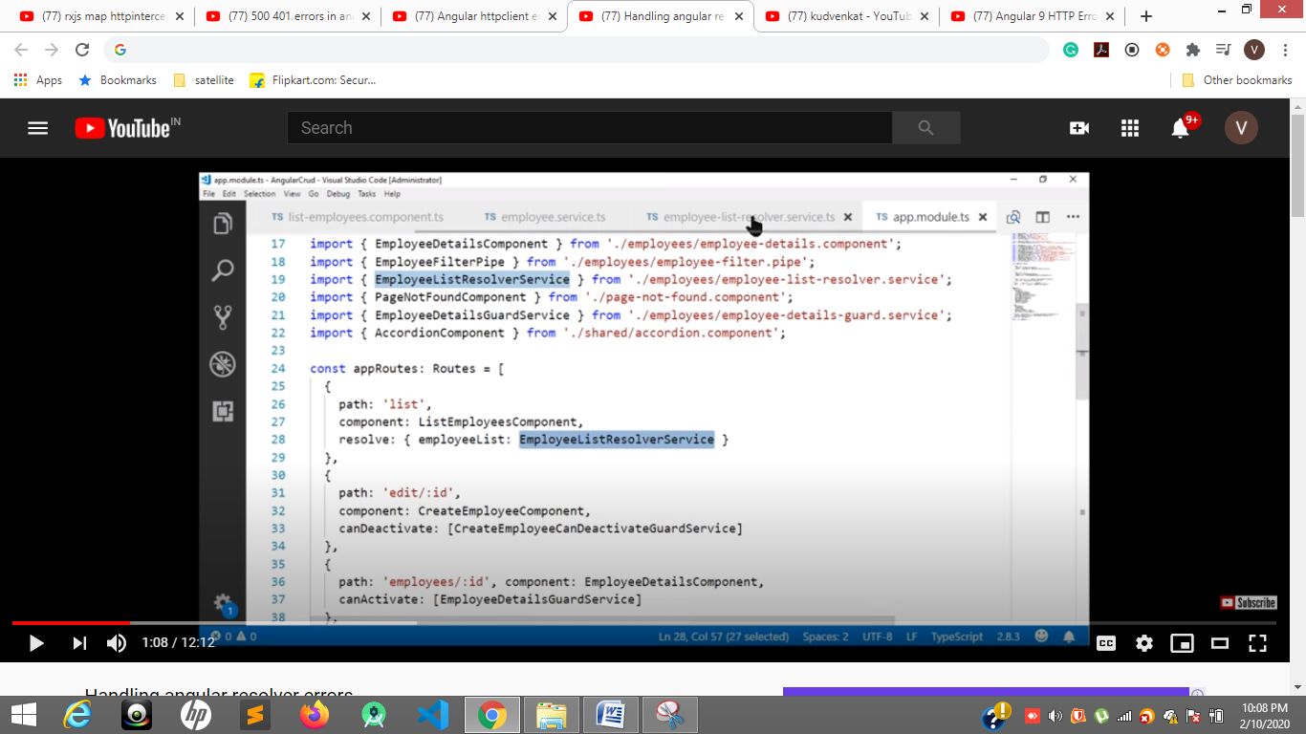

**28 if resolve was failed list rout can’t be activated**

**Stp 2**

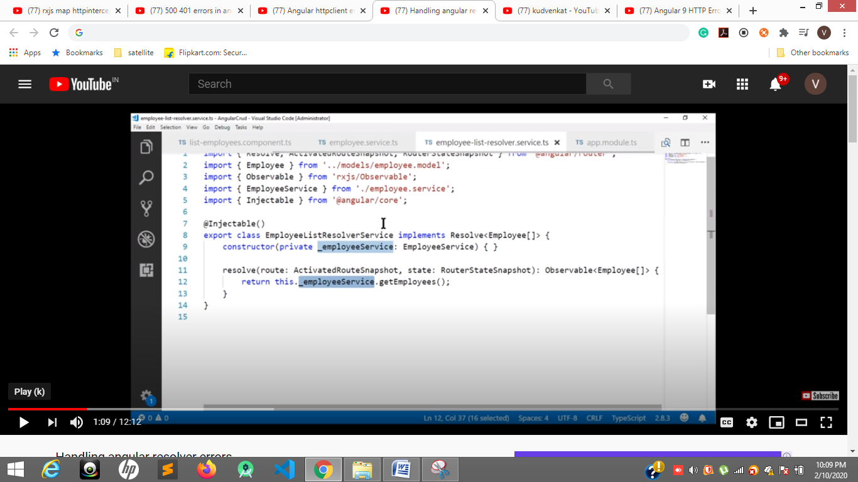

**Step3**

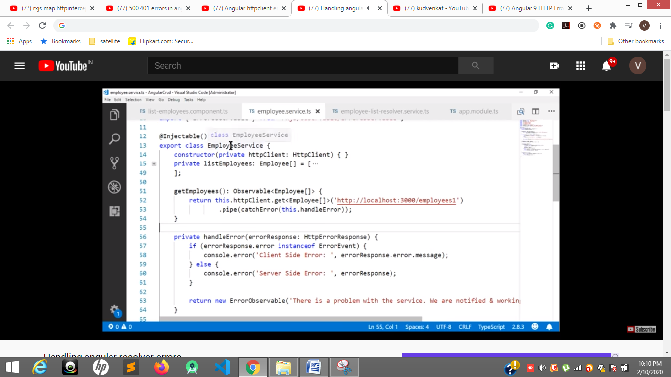

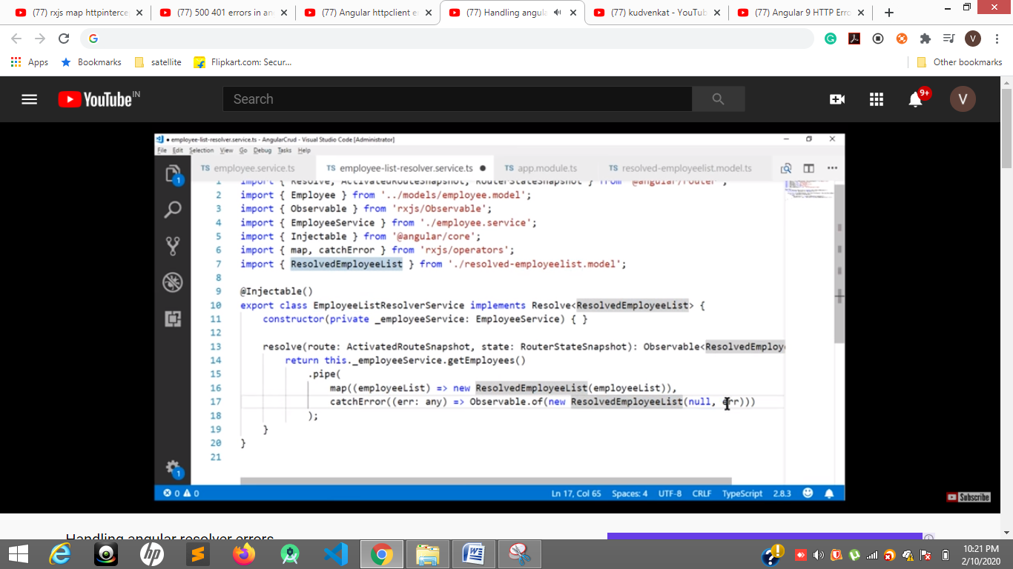

Angular 9 HTTP Error Handling Using Pipe,CatchError and ThrowError Full Example

[**https://www.youtube.com/watch?v=-Z2wTZCYu80**](https://www.youtube.com/watch?v=-Z2wTZCYu80)

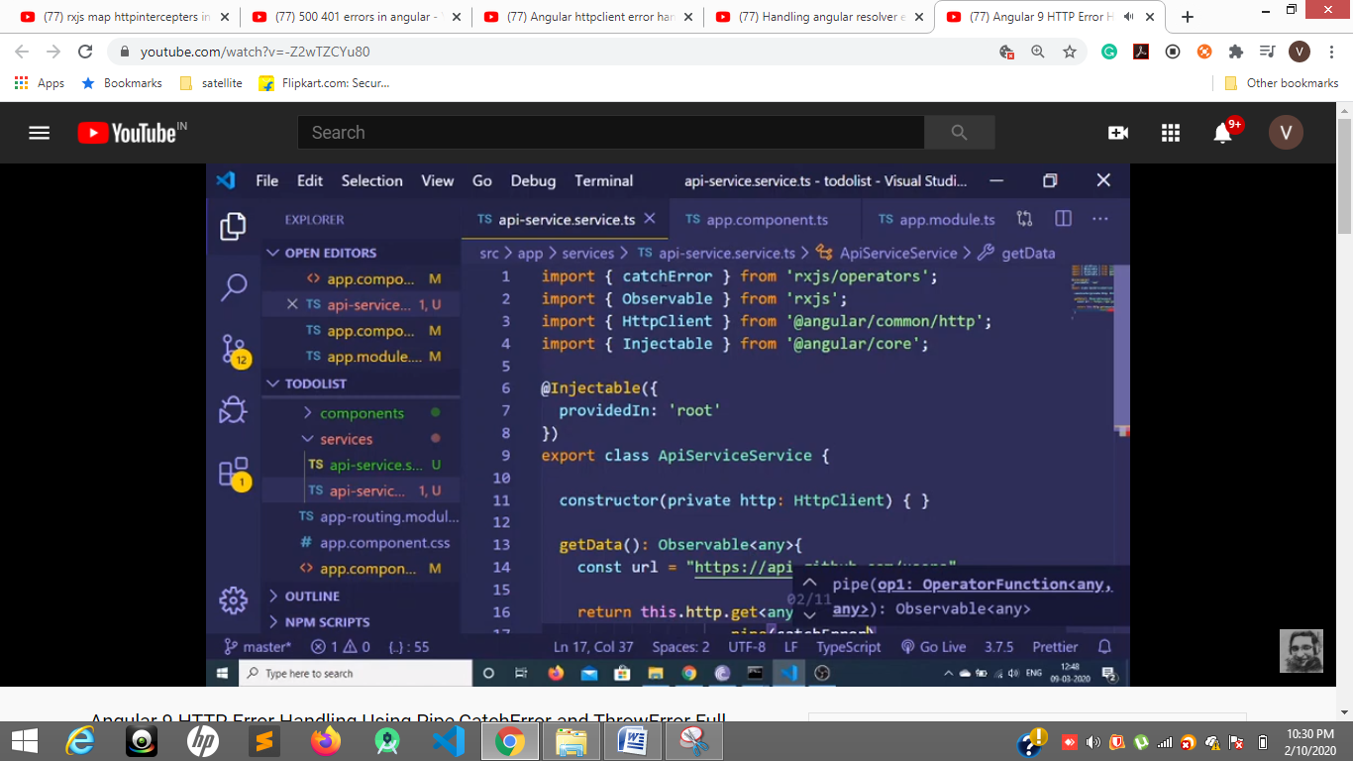**1 line**

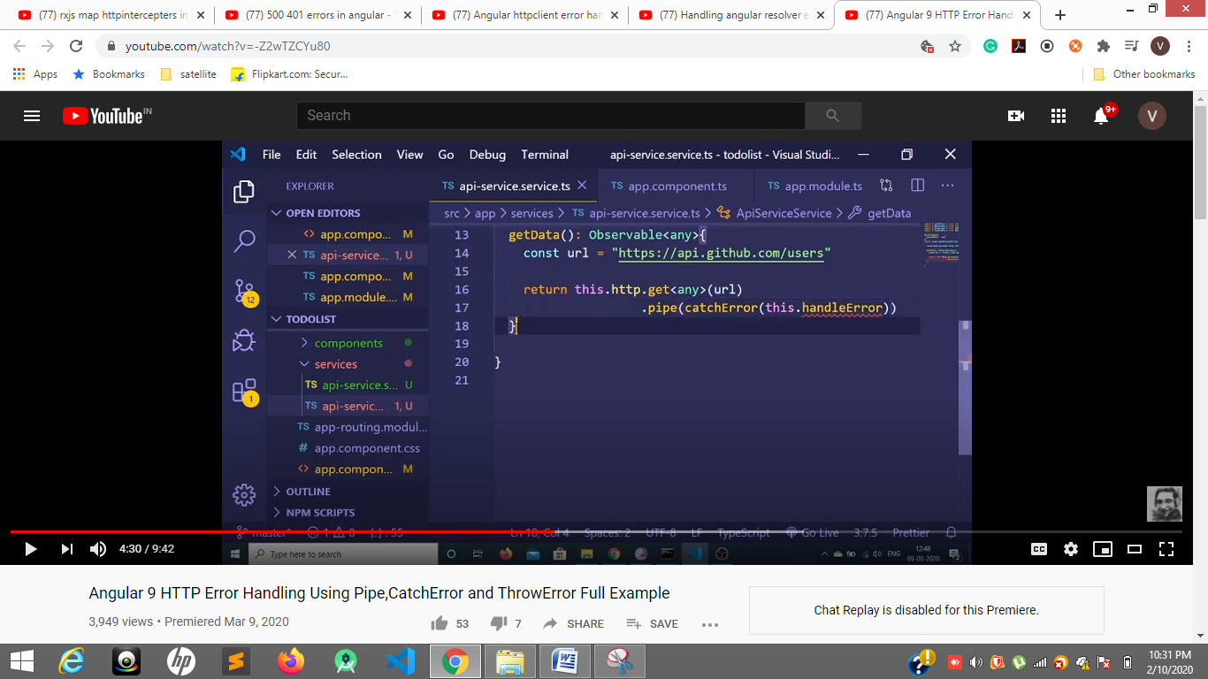

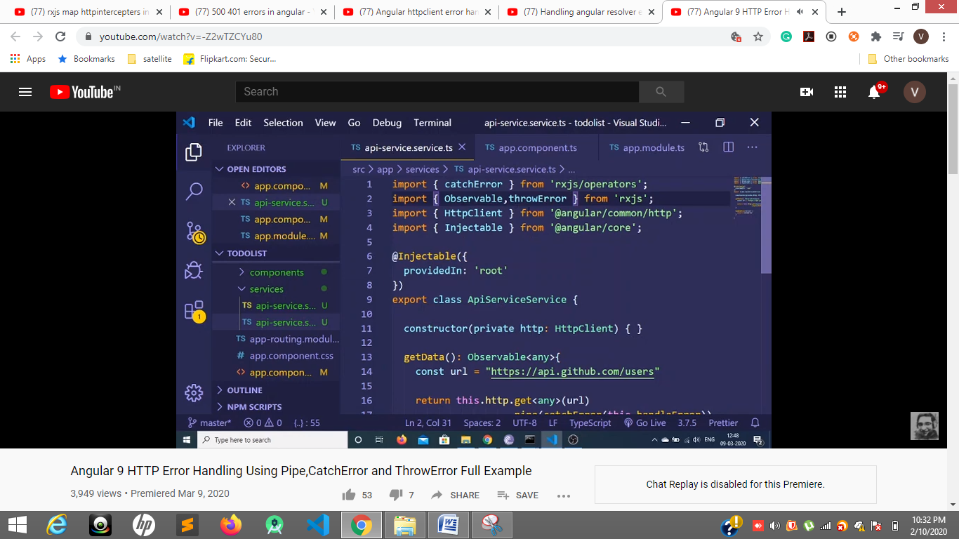

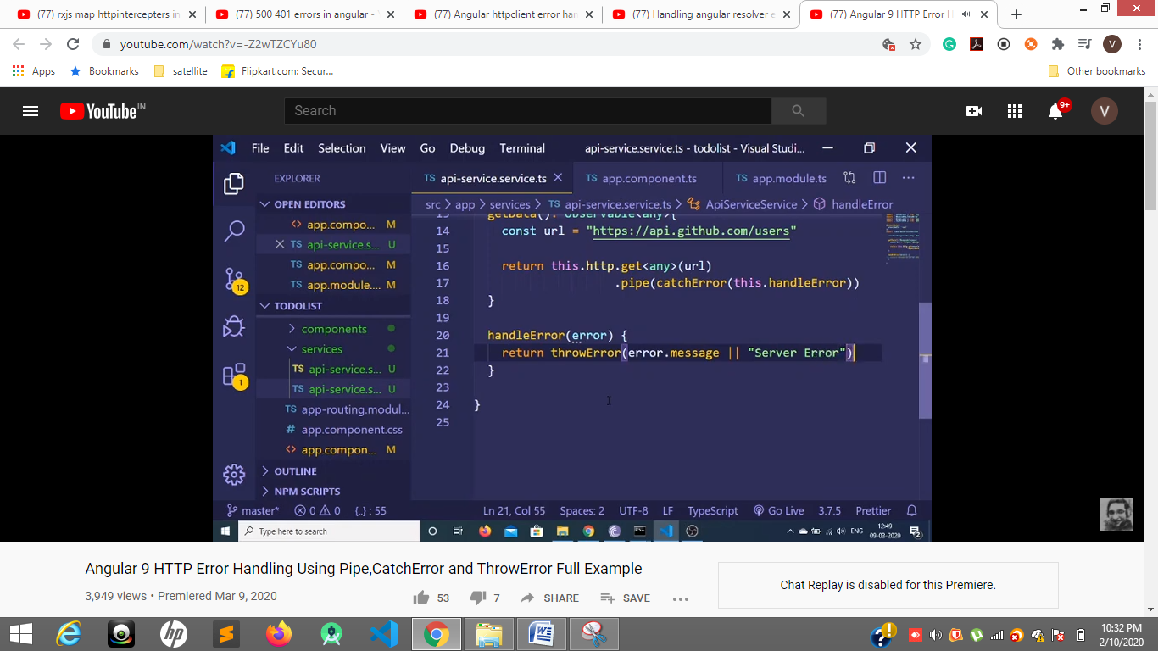

**20 21**

[**https://www.youtube.com/watch?v=clpgSBh6t2Q**](https://www.youtube.com/watch?v=clpgSBh6t2Q)

**Page not found 404**

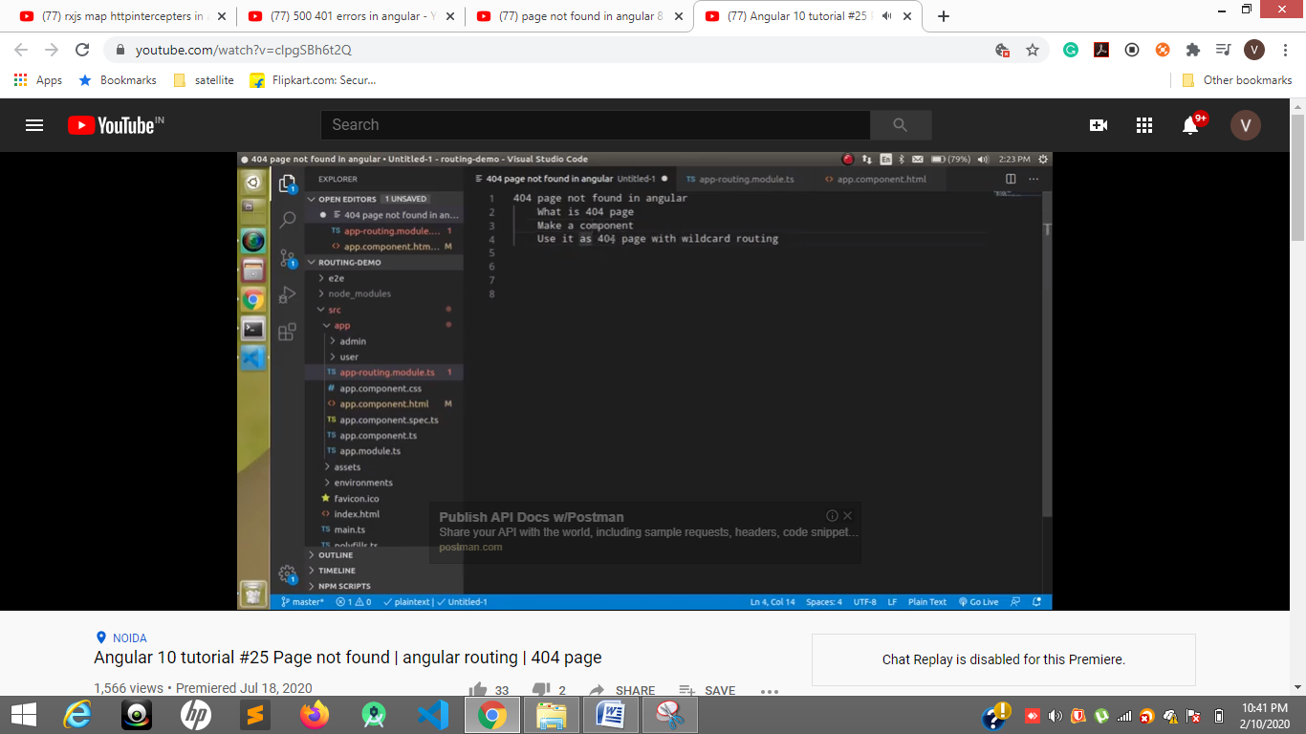

**4 line disply page not found by using wildcard routing**

**\*\* means wildcard routing**

**Method one**

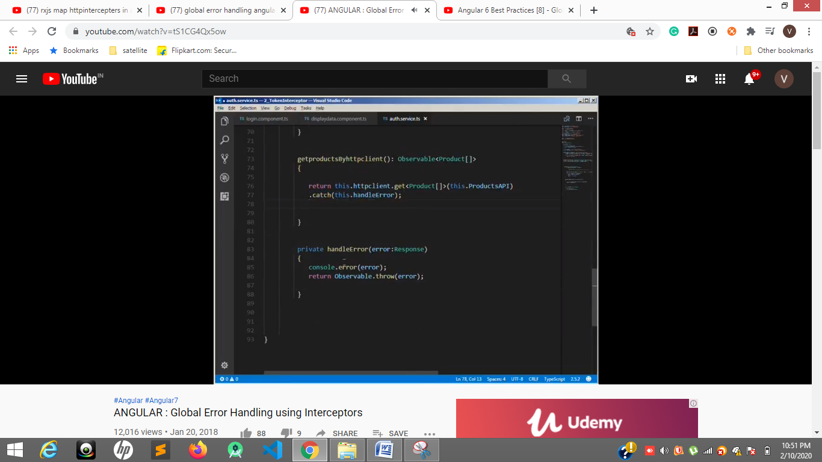

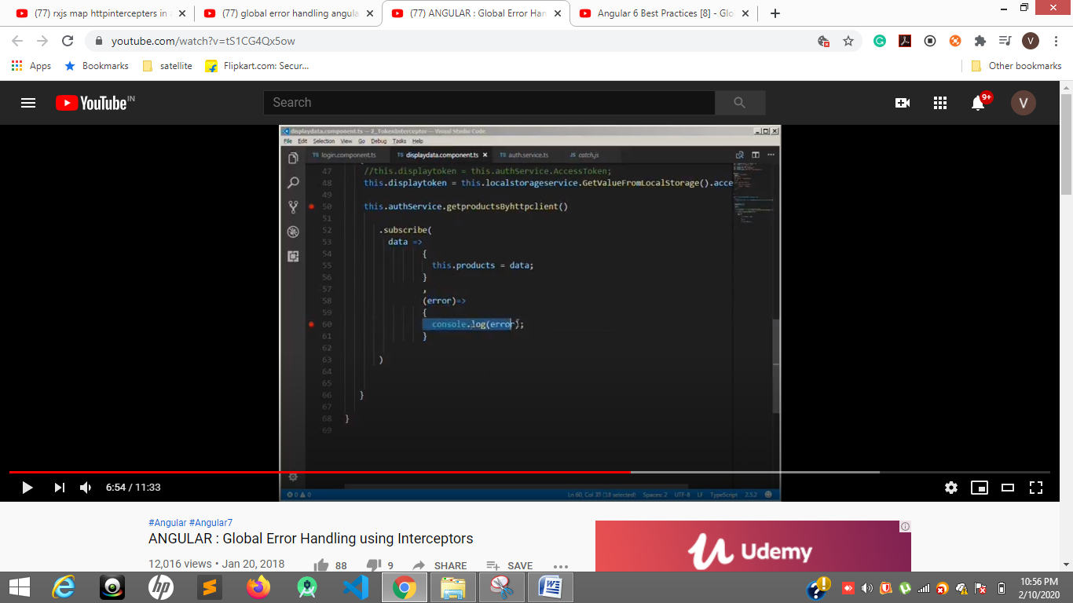

**Method 2 error handler with http interceptors**

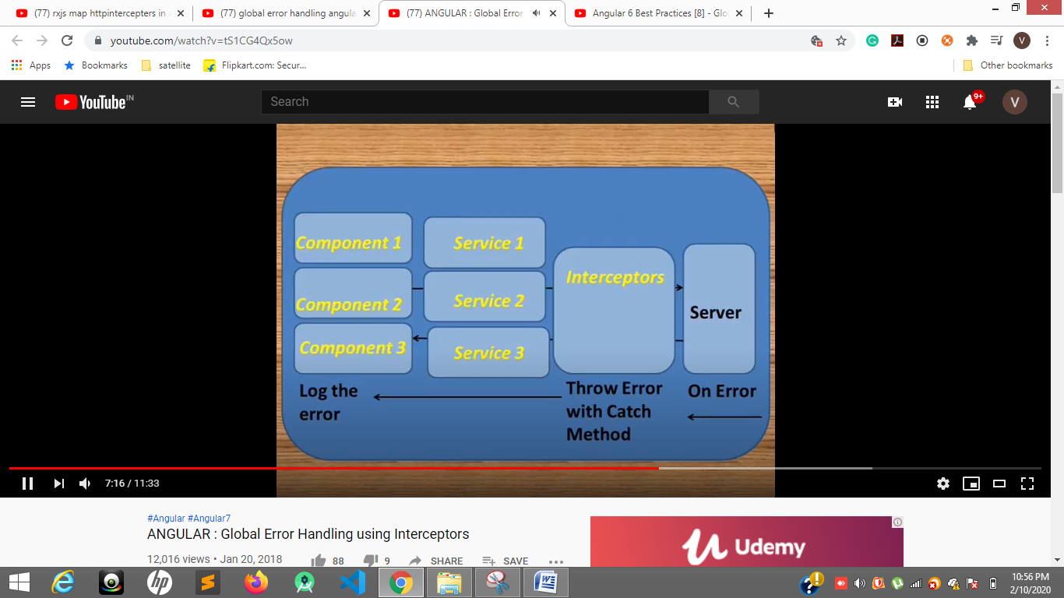

**ng test --code-coverage**

**3.3 code coverage**

If you want to create code-coverage reports every time you run the test suite, you can set the following option in the CLI configuration file, angular.json:

"test":{   
 "options":{   
 "codeCoverage": true   
 }  
}

(or) run the below command in the project root directory.

ng test --code-coverage

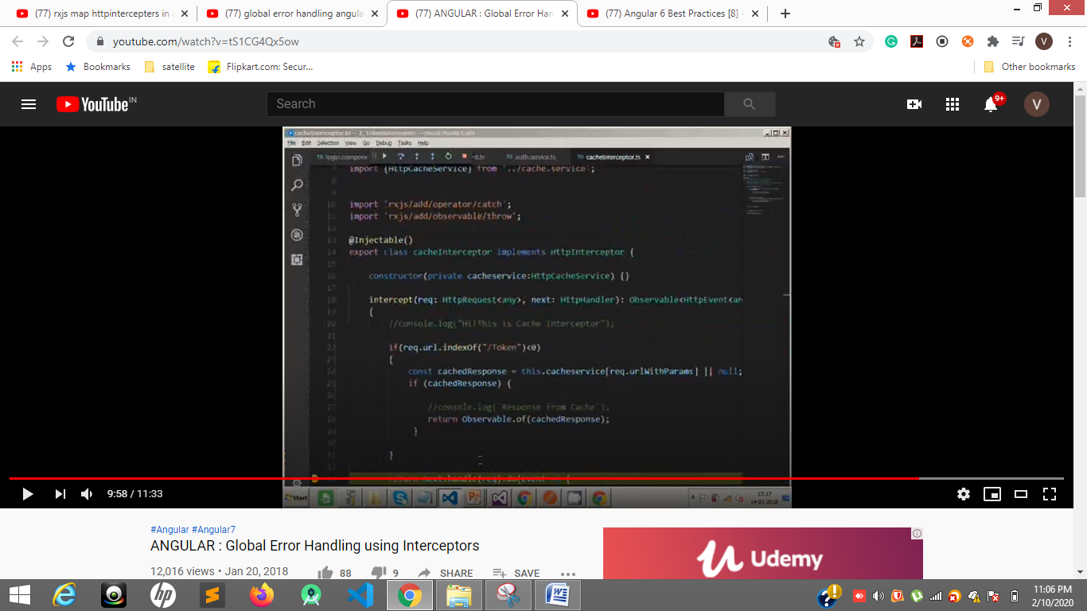

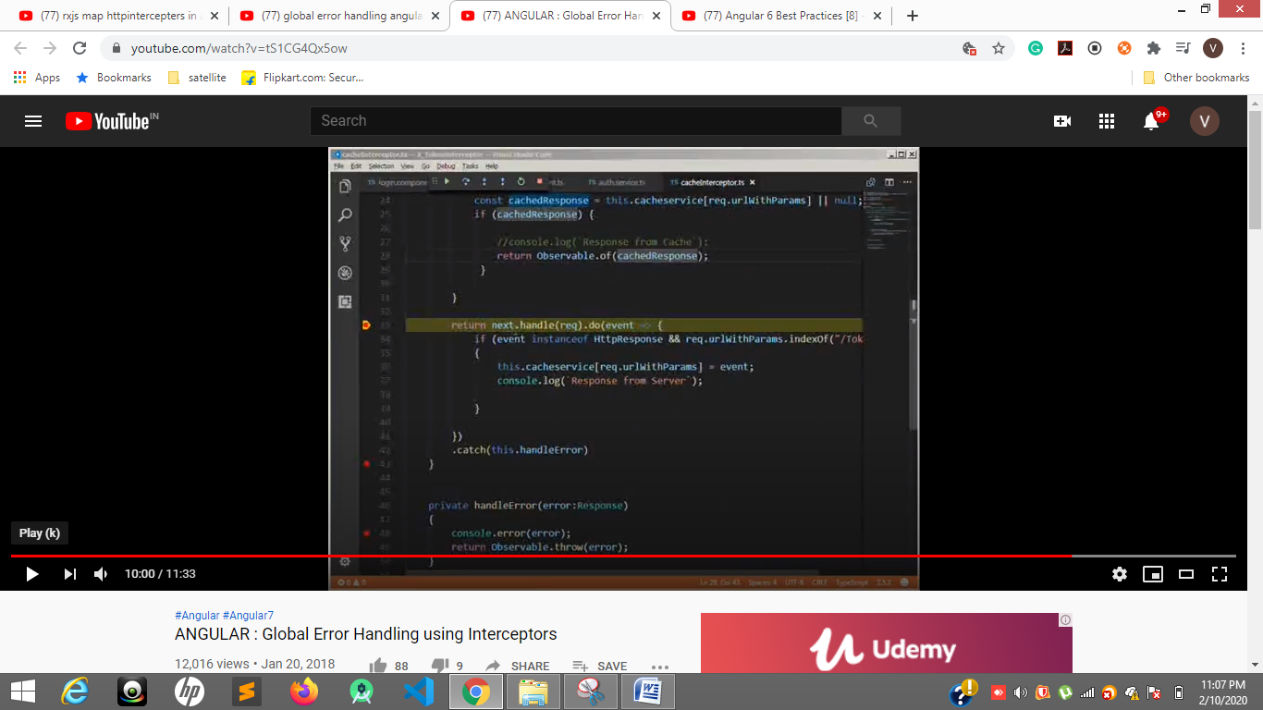

[**https://www.youtube.com/watch?v=e1hroLSkULw**](https://www.youtube.com/watch?v=e1hroLSkULw)

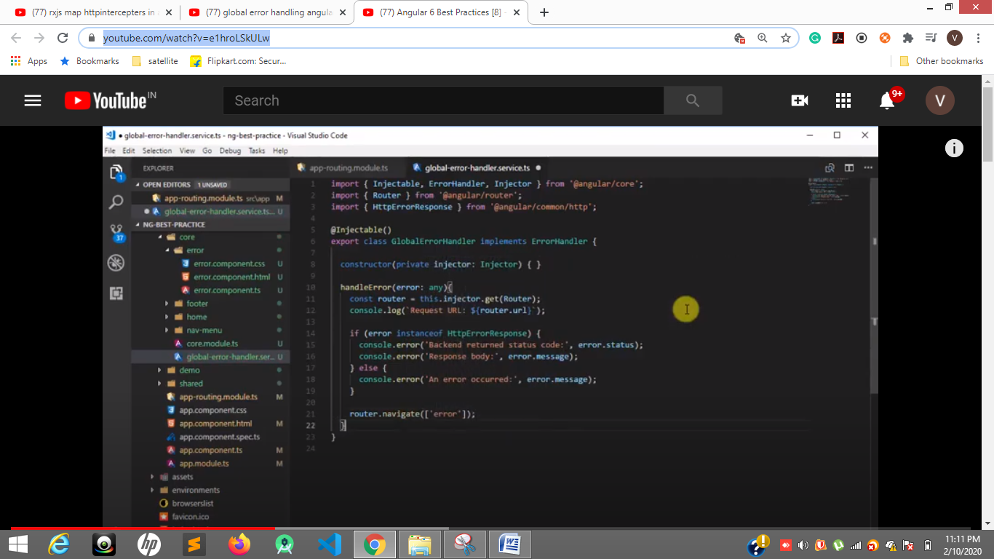

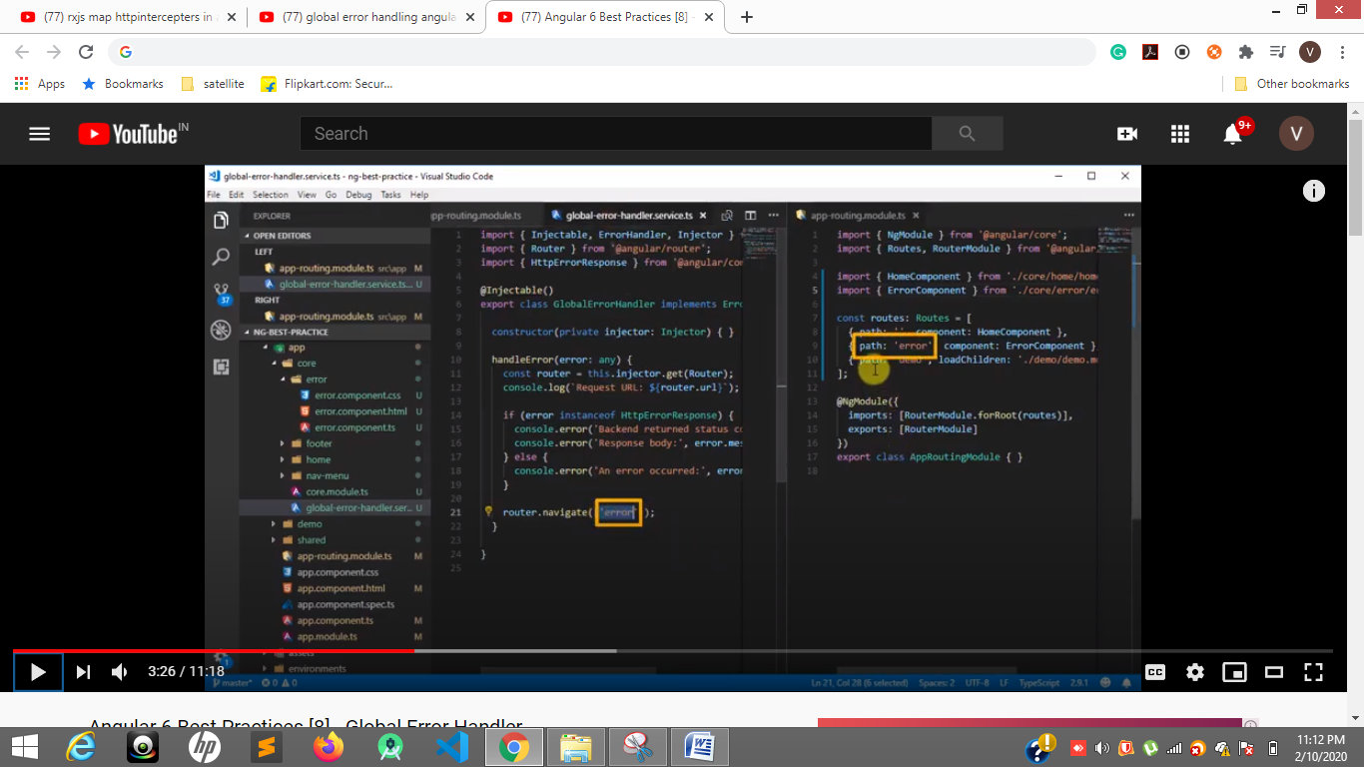

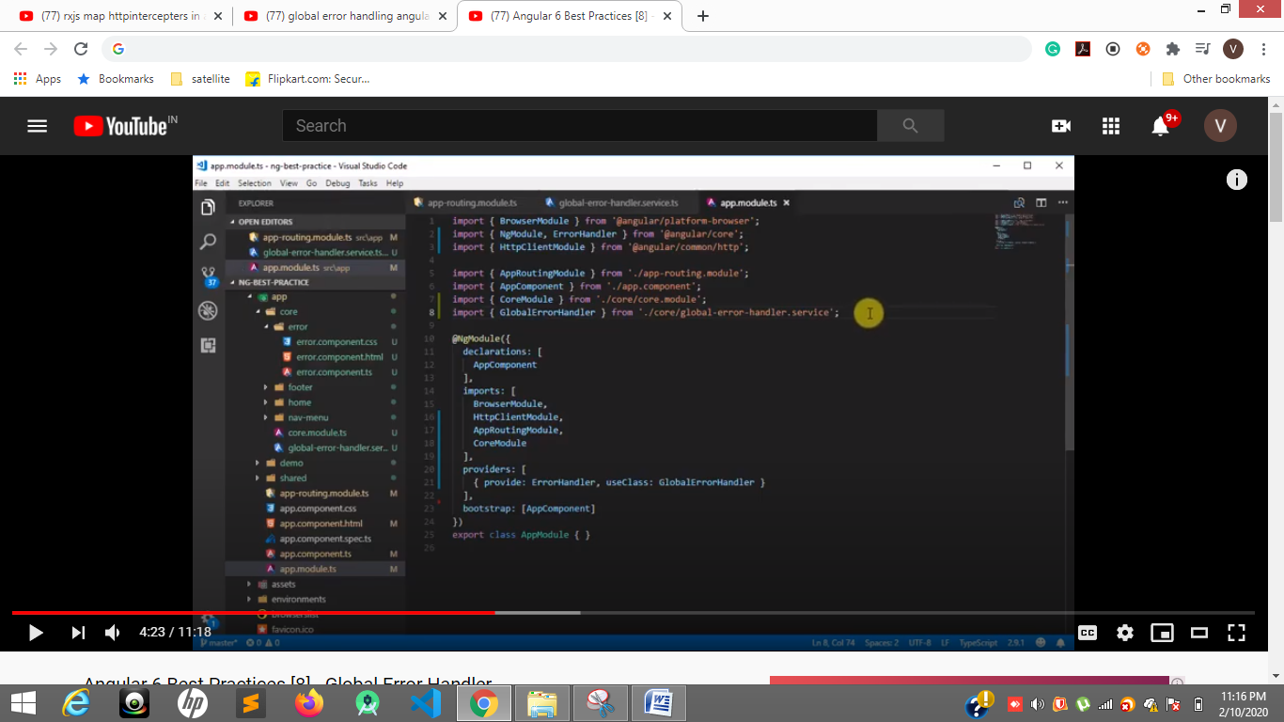

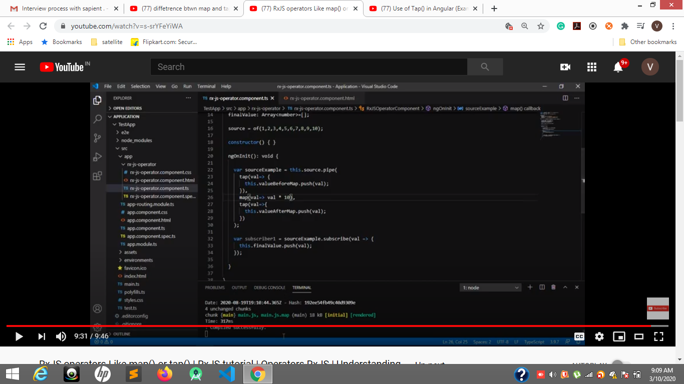

[**https://offering.solutions/blog/articles/2019/10/20/tap-map-switchmap-explained/**](https://offering.solutions/blog/articles/2019/10/20/tap-map-switchmap-explained/)

[**https://dzone.com/articles/object-oriented-javascript-objects-encapsulation-a**](https://dzone.com/articles/object-oriented-javascript-objects-encapsulation-a)

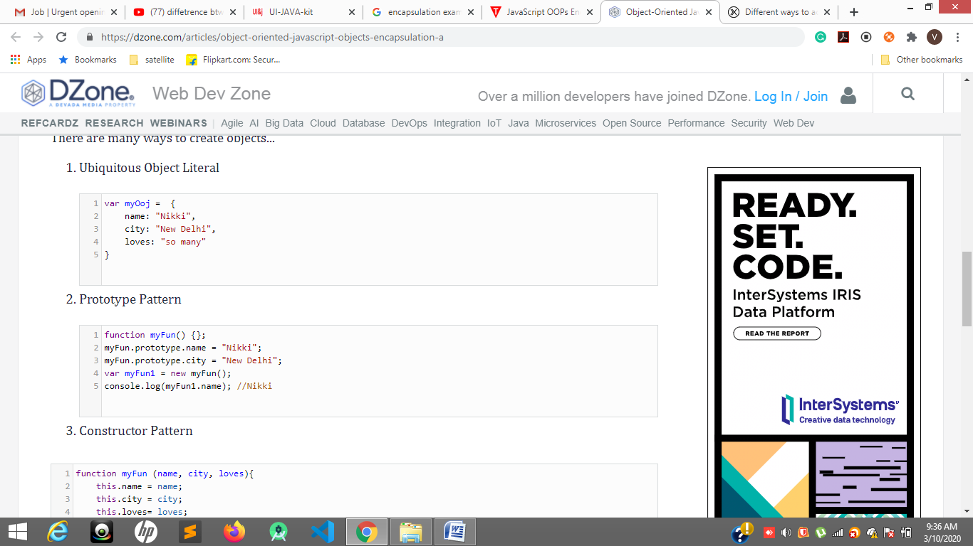

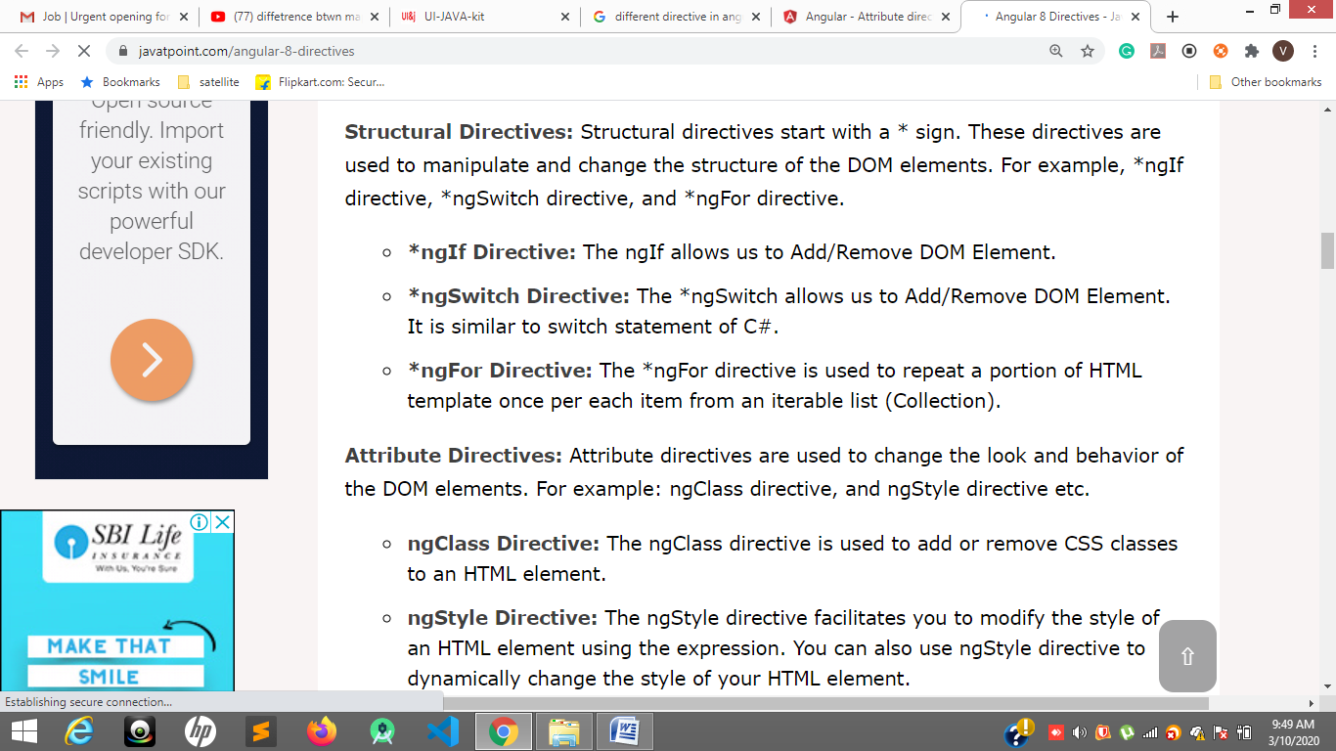

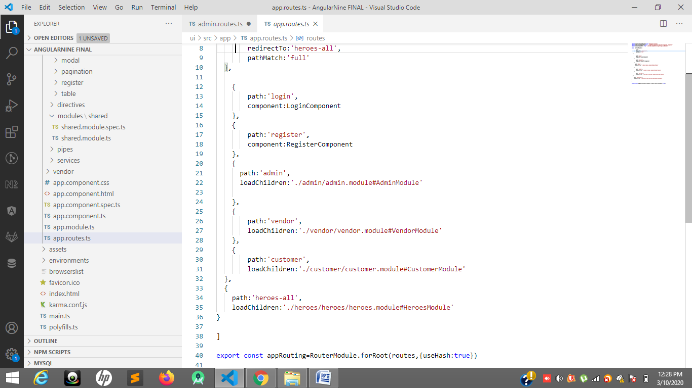

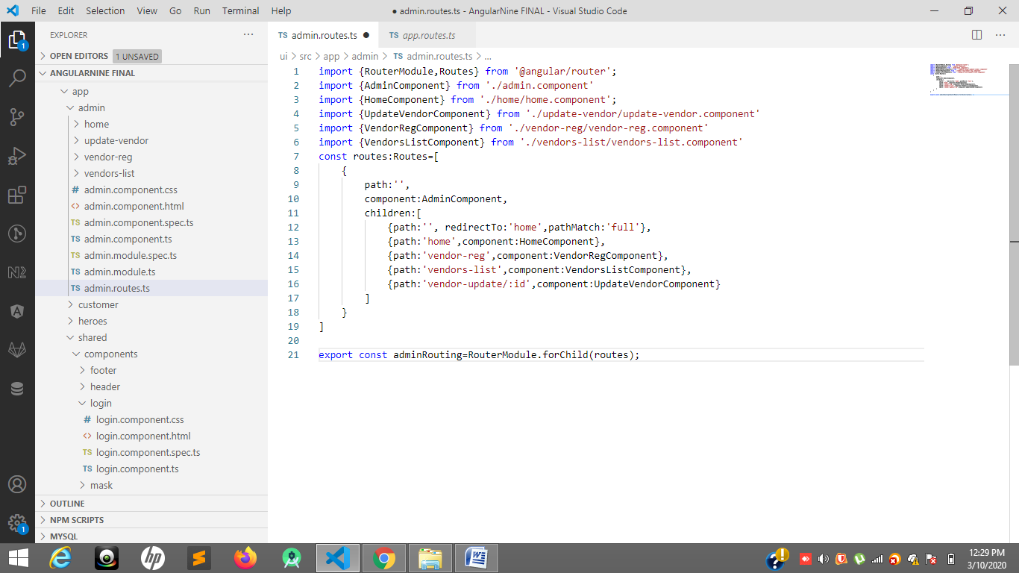

**Path , component or** children[path:, **component**],

for lazy loading🡪 loadChildren:'./customer/customer.module#CustomerModule'

**com1 h3 made Blue color**

**com2 h3 made red color**

[**https://www.youtube.com/watch?v=bUITojTRMnM**](https://www.youtube.com/watch?v=bUITojTRMnM)

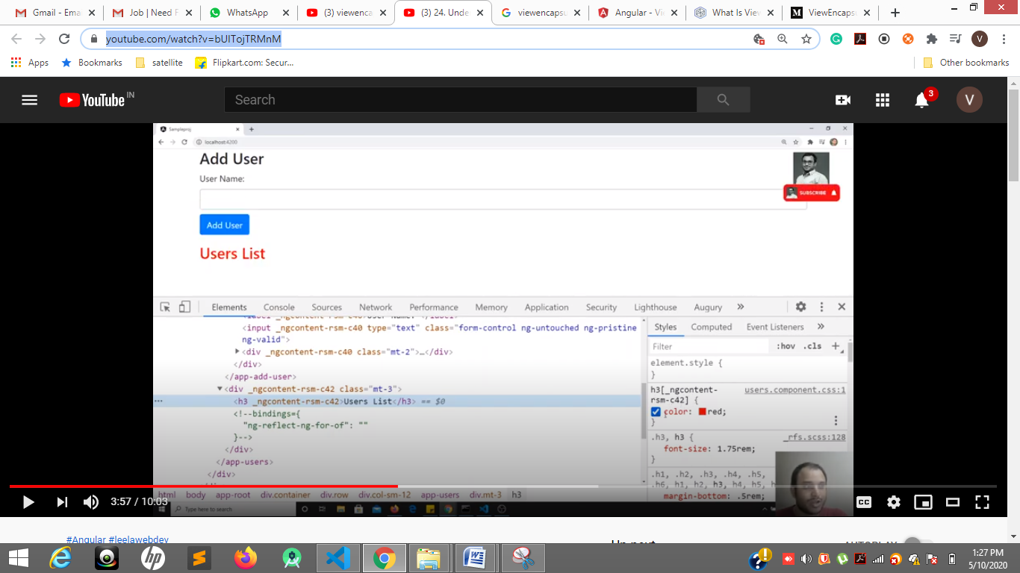

**Angular by default is which create unique property to elements. Ngcontent-rsm-c42**

**To overcome that we have viewencapsulation.emulator by default**

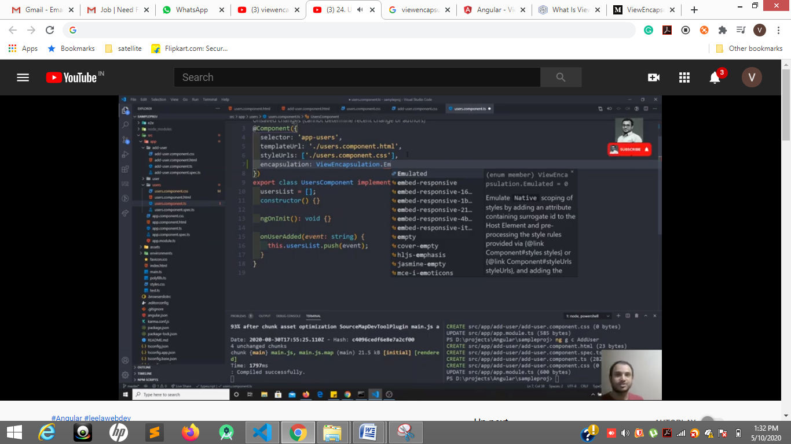

**viewencapsulation.none ----will remove unique property of element so applied to all components**

[**https://stackoverflow.com/questions/35651993/diff-between-viewencapsulation-native-viewencapsulation-none-and-viewencapsulat**](https://stackoverflow.com/questions/35651993/diff-between-viewencapsulation-native-viewencapsulation-none-and-viewencapsulat)

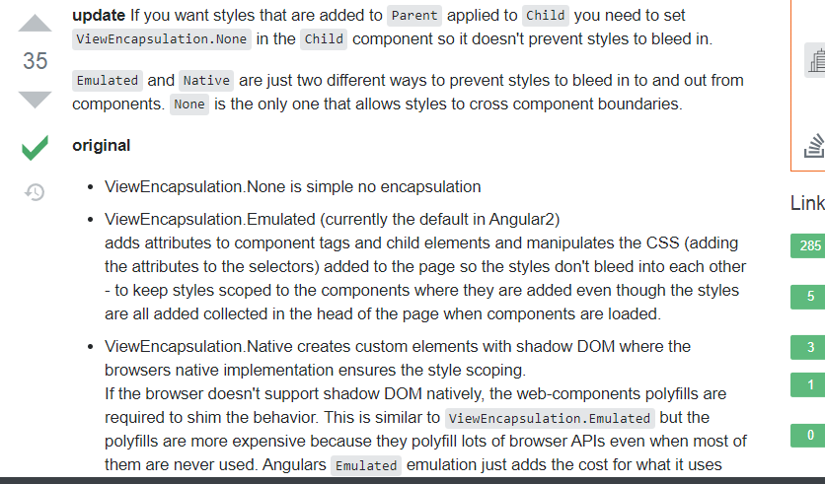

**Creating custom directive**

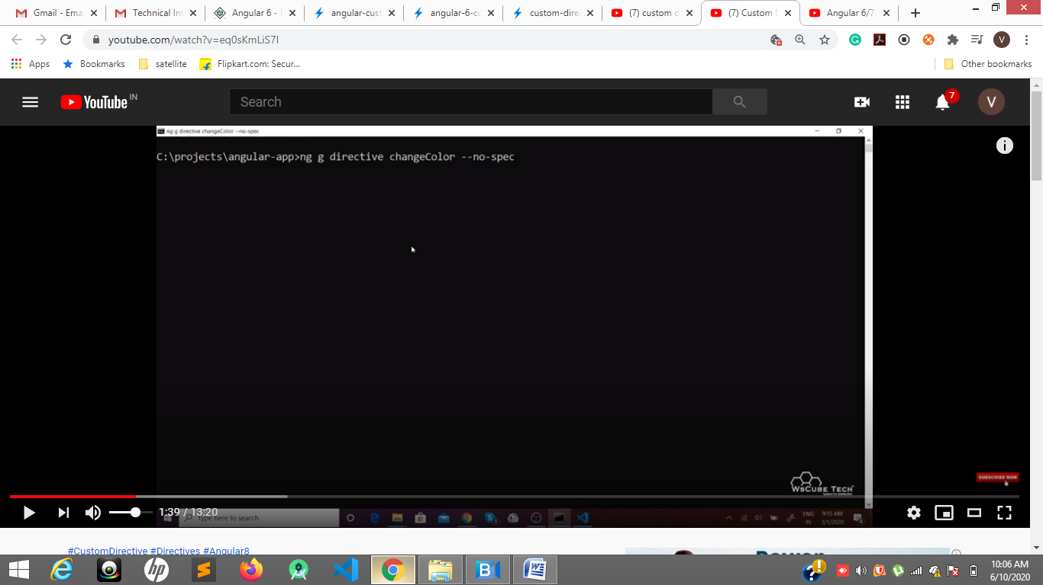

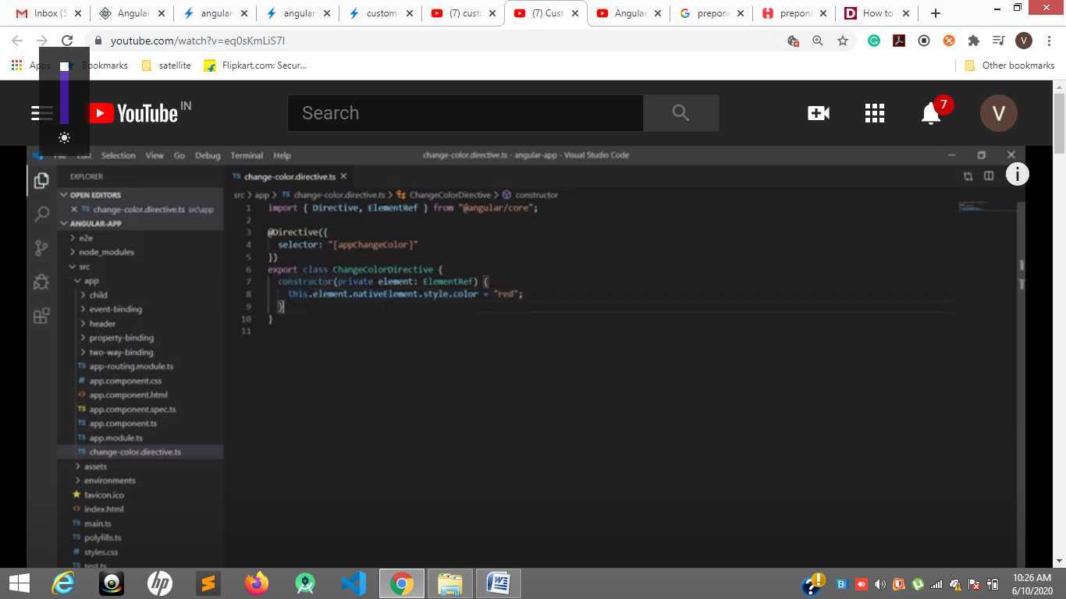

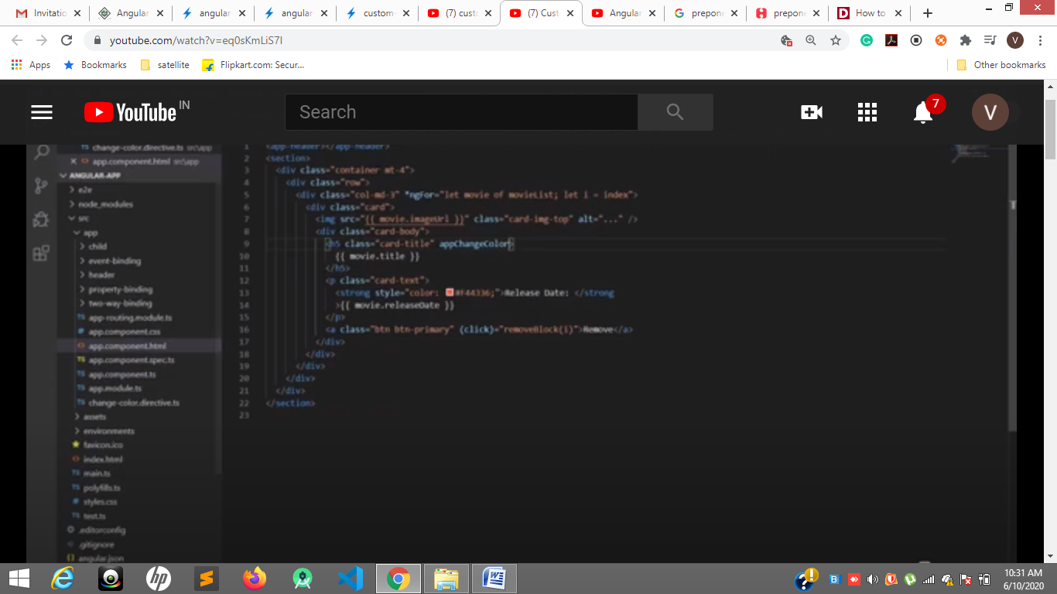

**@ngModule**

**@component**

**@injectable**

**@directive**

**@hostlistner –mouseEnter- mouseLeave**

[**https://medium.com/@nishu0505/wildcard-routes-in-angular-edbf9433a9ba**](https://medium.com/@nishu0505/wildcard-routes-in-angular-edbf9433a9ba)

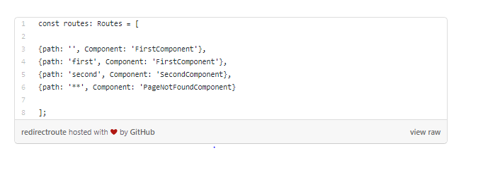

This is because inside our application, there is no component like TestComponent. So to avoid this error, and instead tell the user that the route doesn’t exist, we use **WILDCARD ROUTES.**

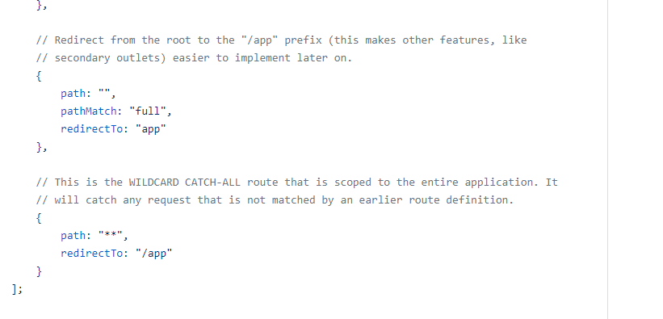

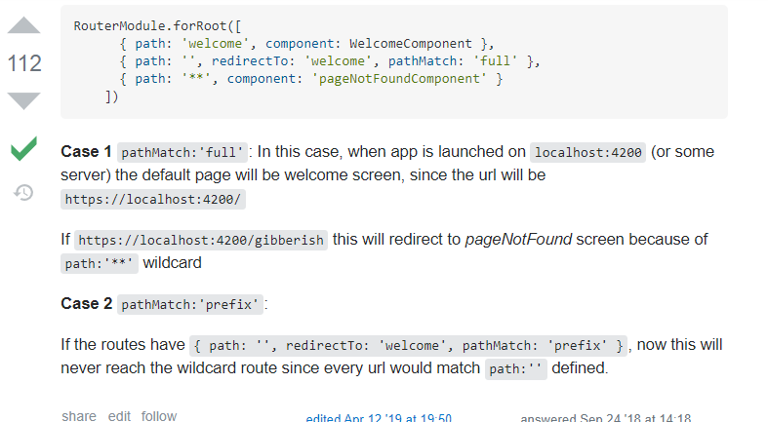

**Pure and impure pipes**

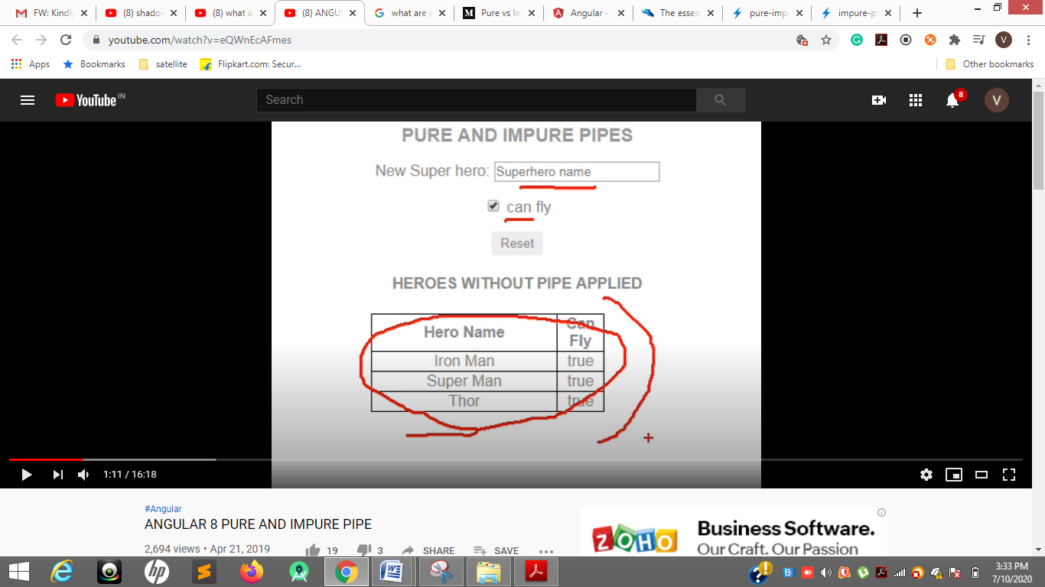

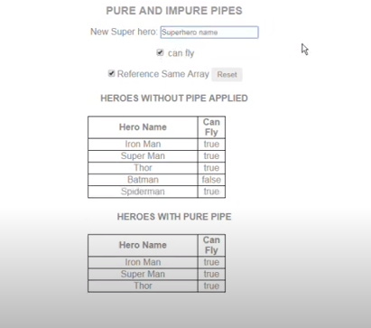

**Without pipe has the array 5 values in an array but those not coming in pure pipe 3 –values shwoing as pure pipe not able to detect the changes.**

**Pure pies are not executed when there is same instance of array. Different instance pure pipes will execute.**

By default pipes are Pure

**Impure pipe**

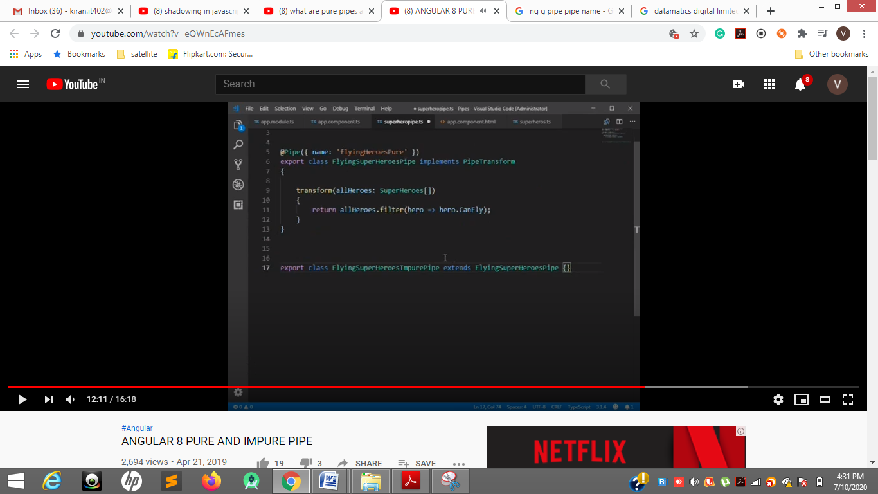

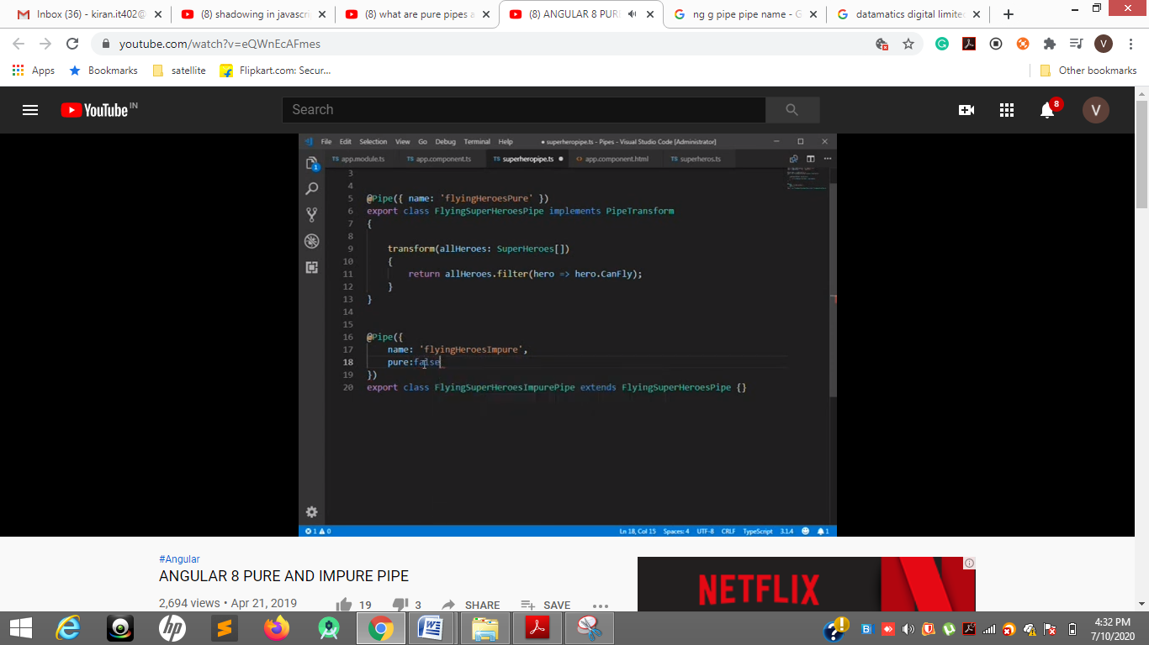

**18 line pure = false**

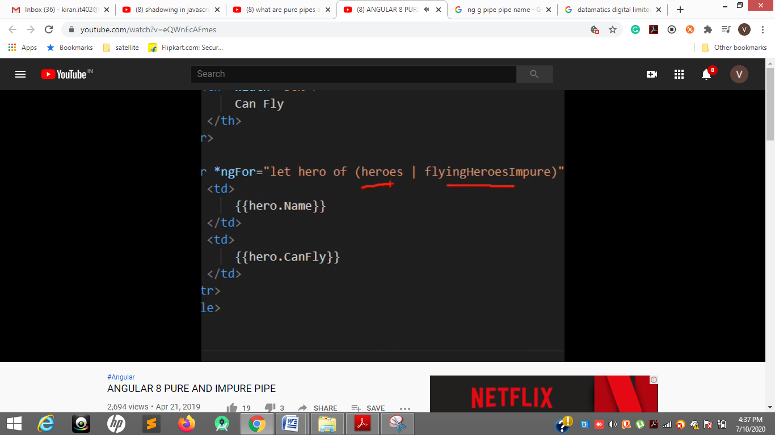

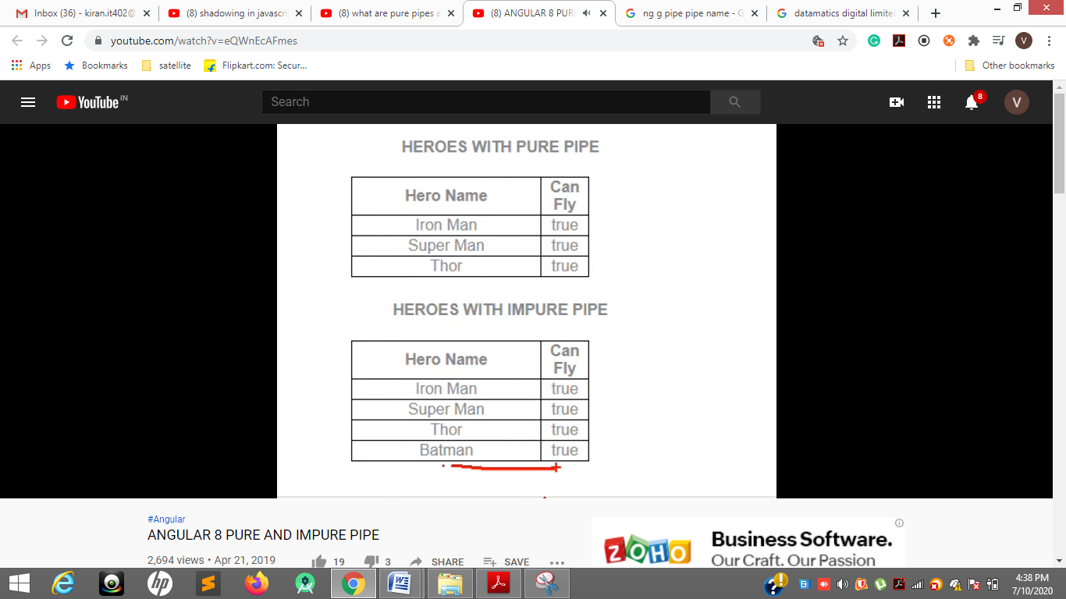

**Impure pipes execute whether it is new instance or alrady existing instance**

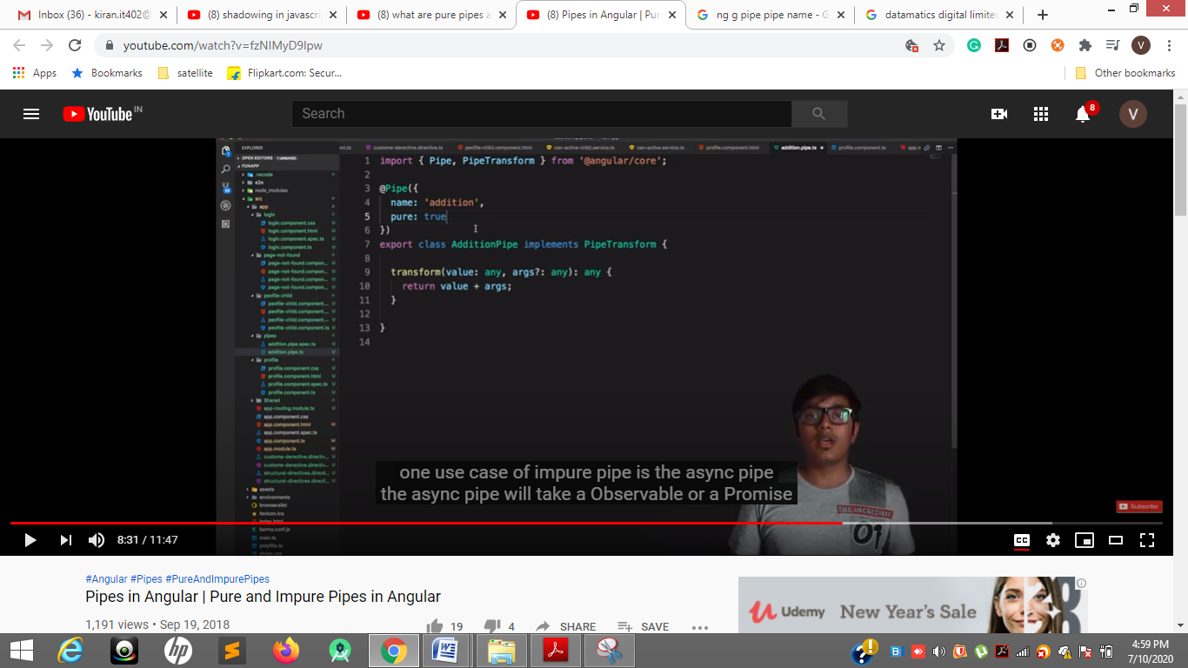

**Async pipe example of impure pipe**

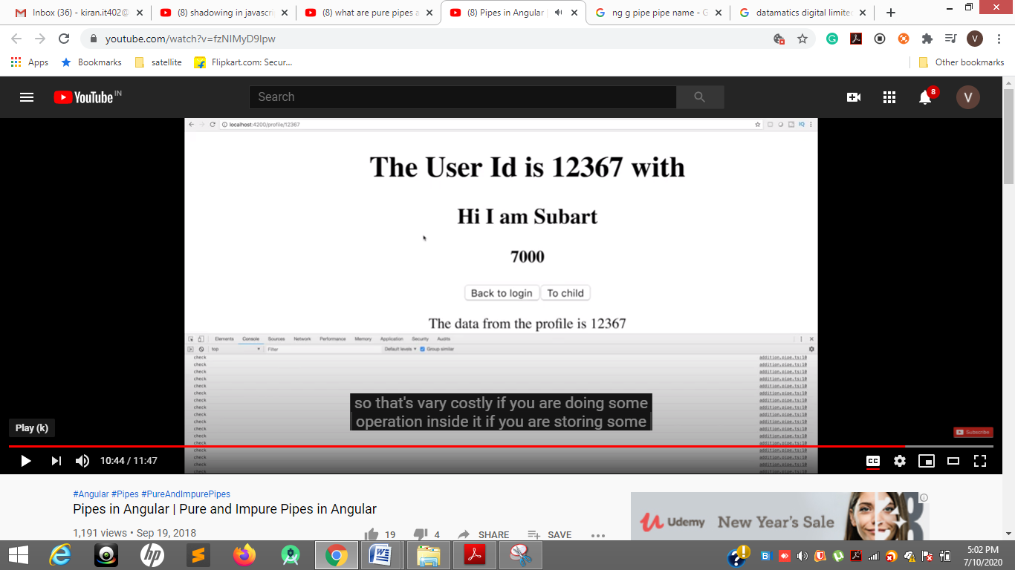

**In inspect for every change impure pipe is called pure = false**

[**https://www.youtube.com/watch?v=G7WaP-yoiQg**](https://www.youtube.com/watch?v=G7WaP-yoiQg)

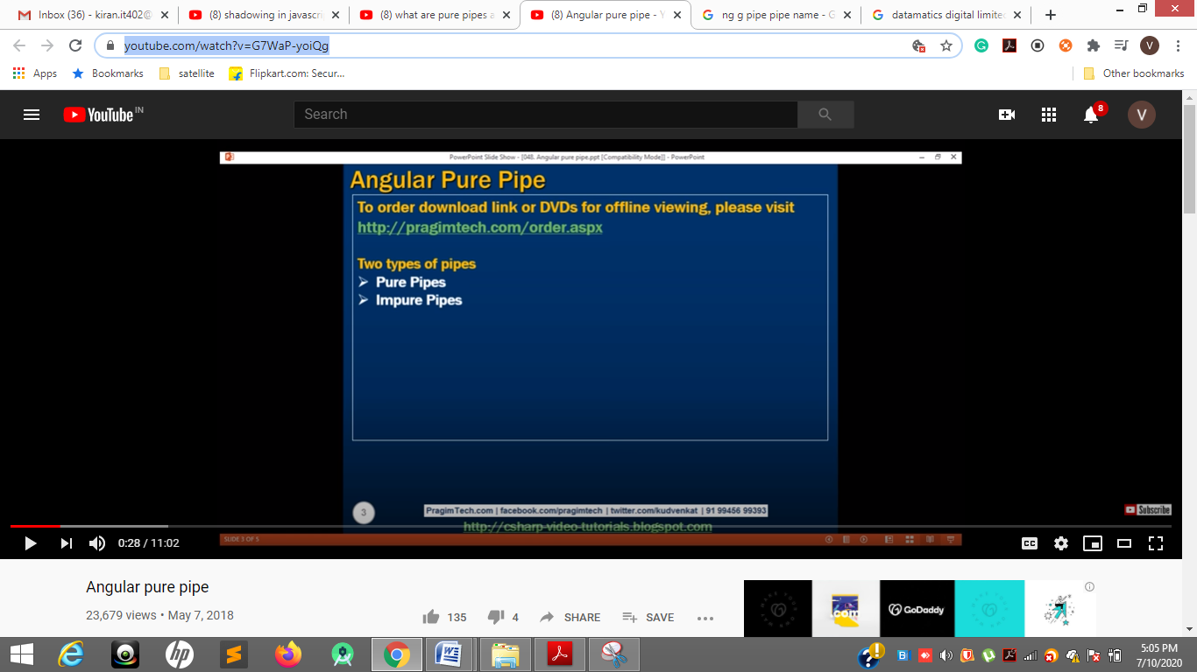

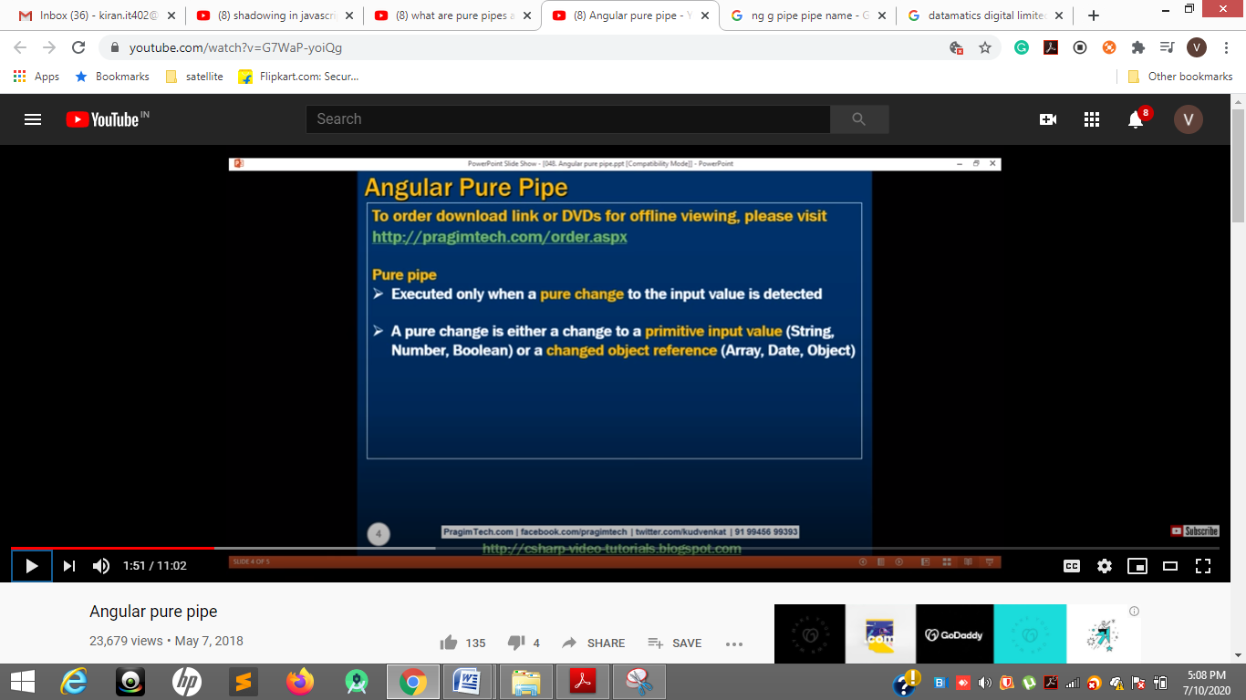

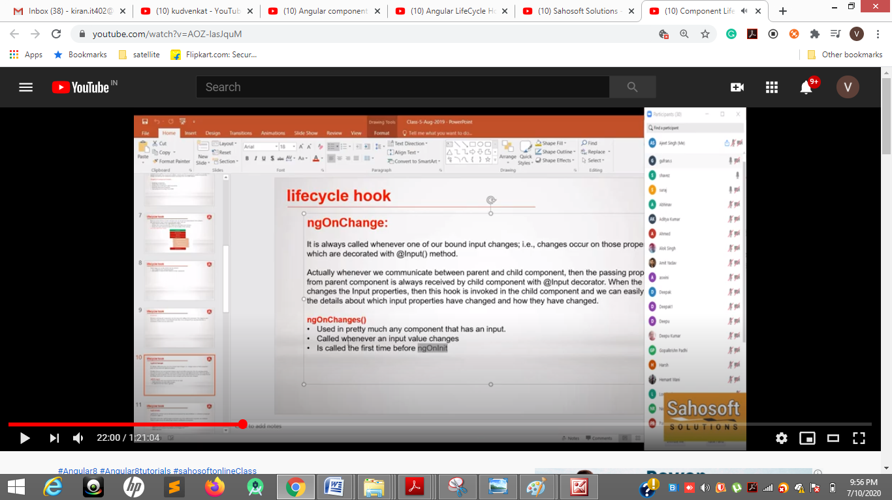

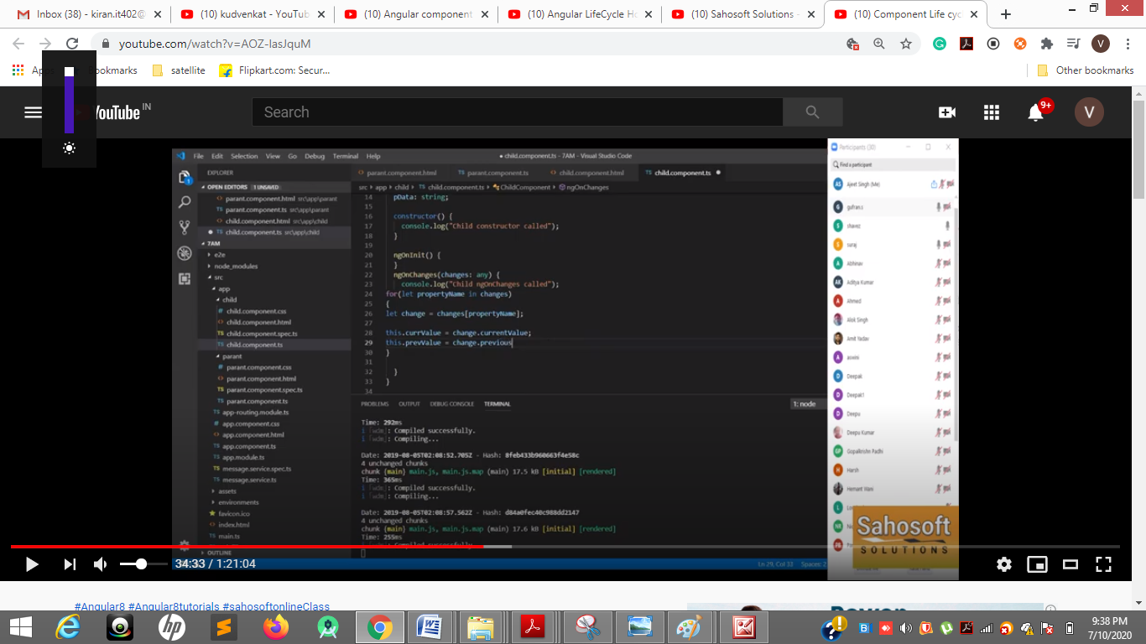

**Changes previous and current value**

**For in**

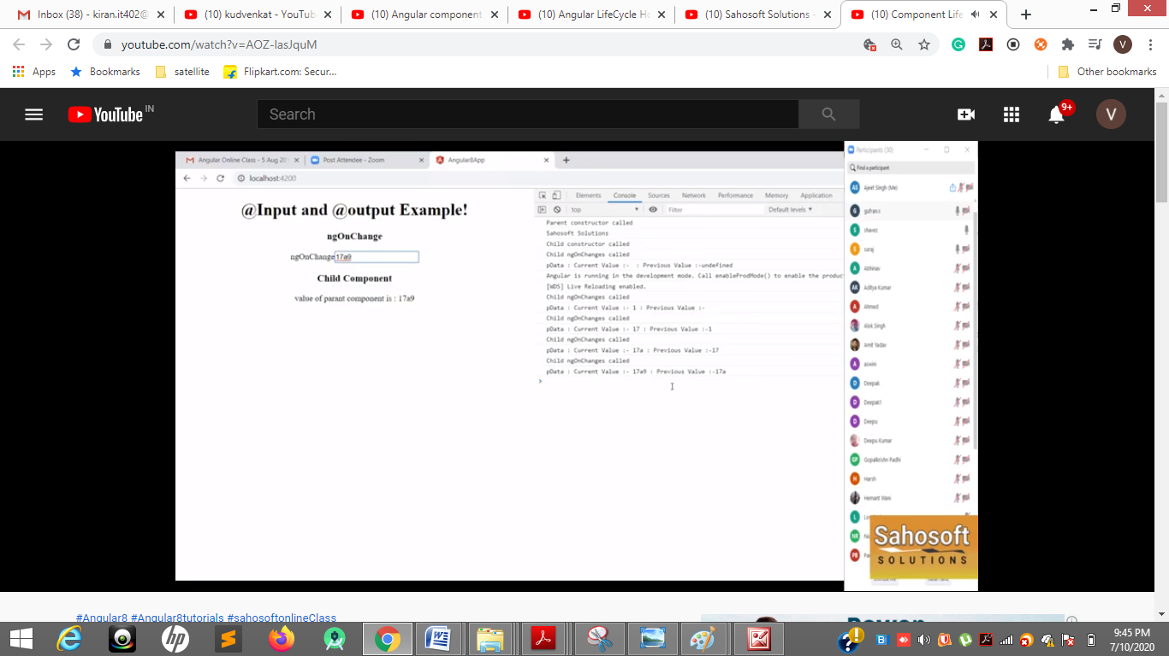

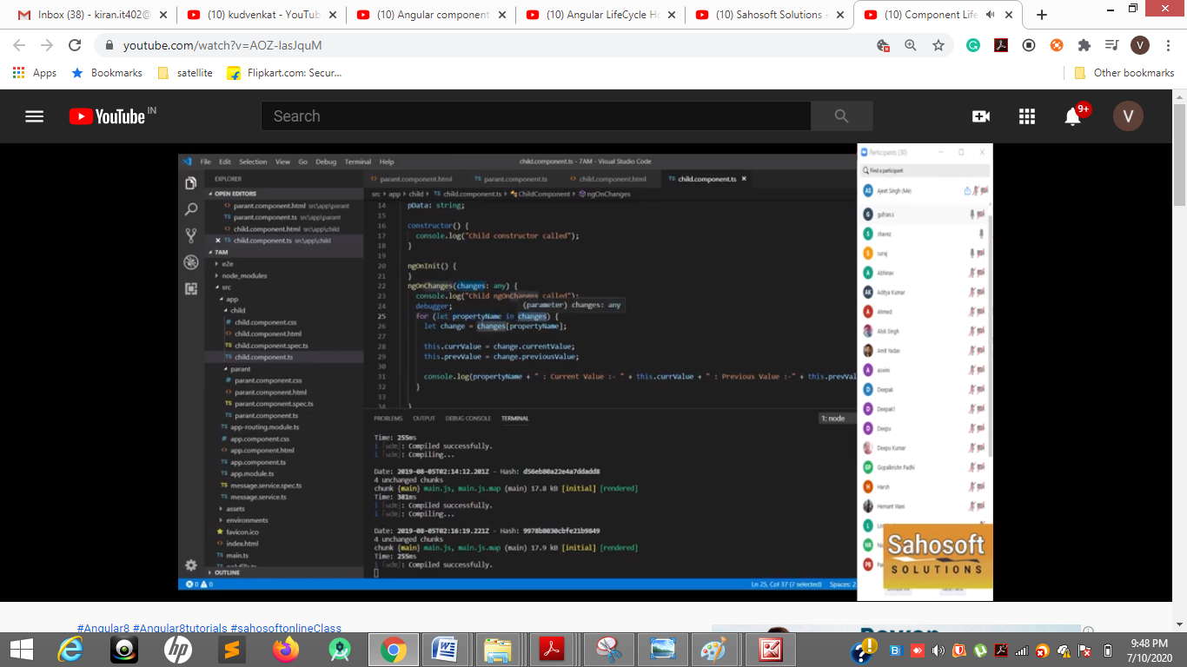

**Currentchange ------ previouschange**

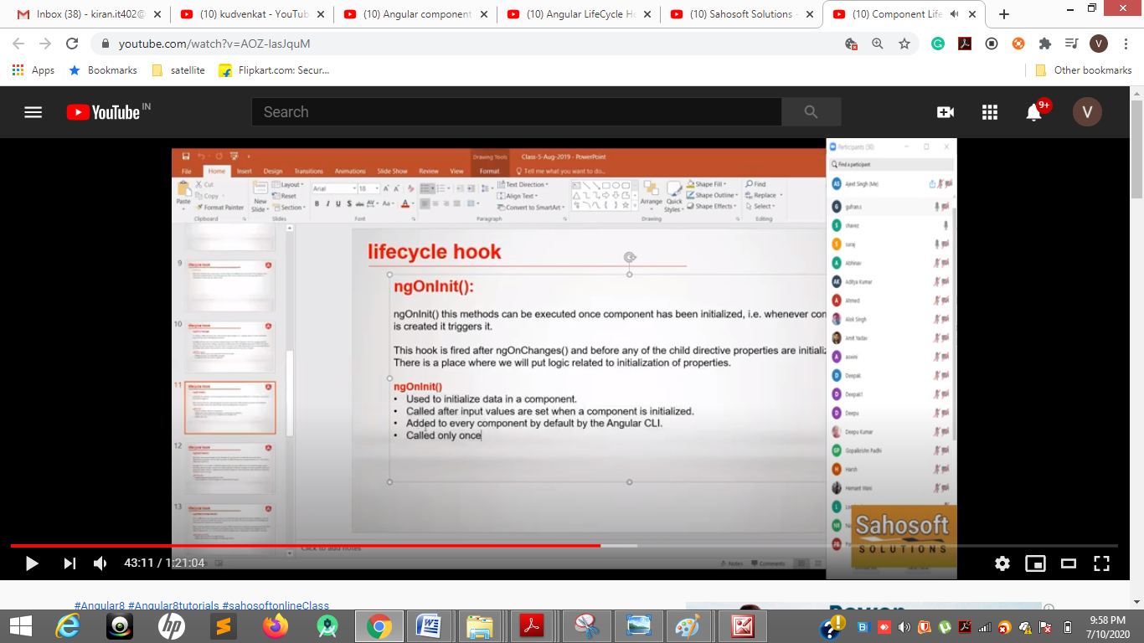

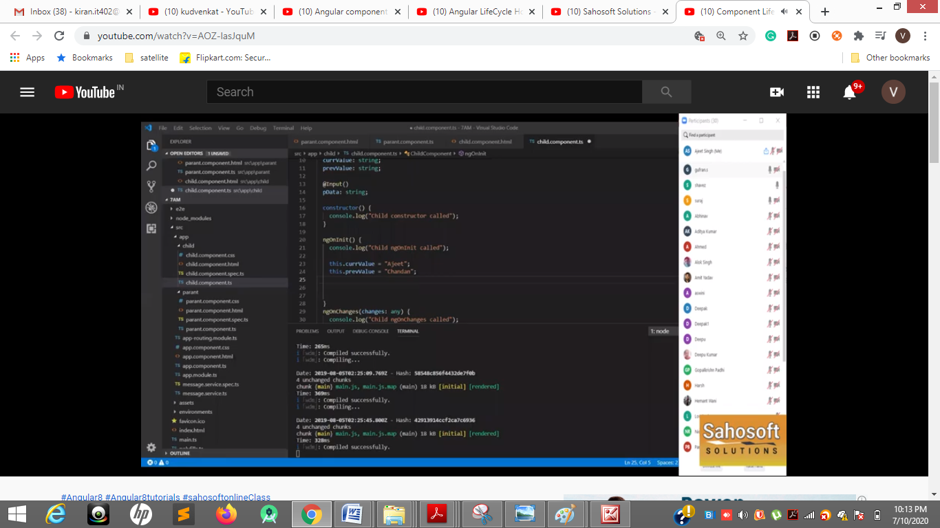

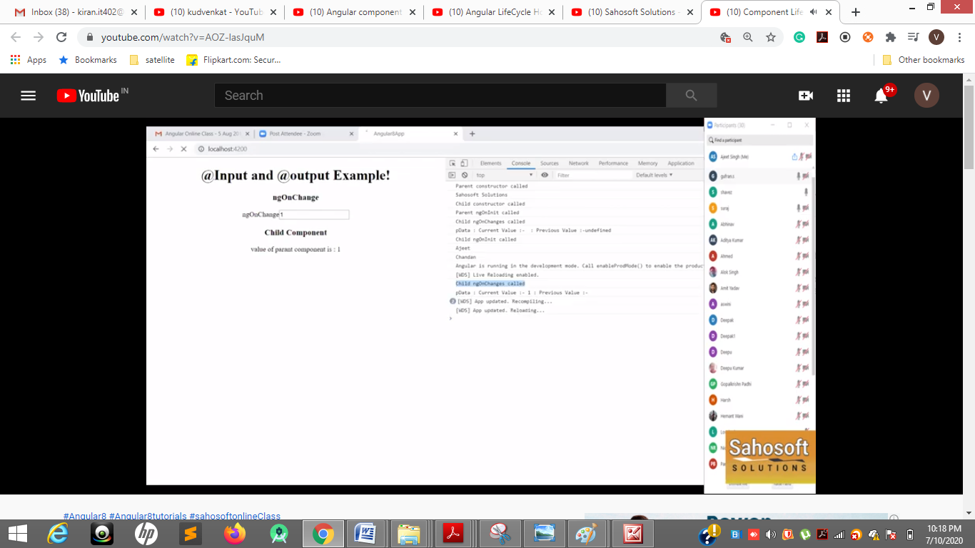

**Ngoninit called only once and ngOnChange called for every input change**

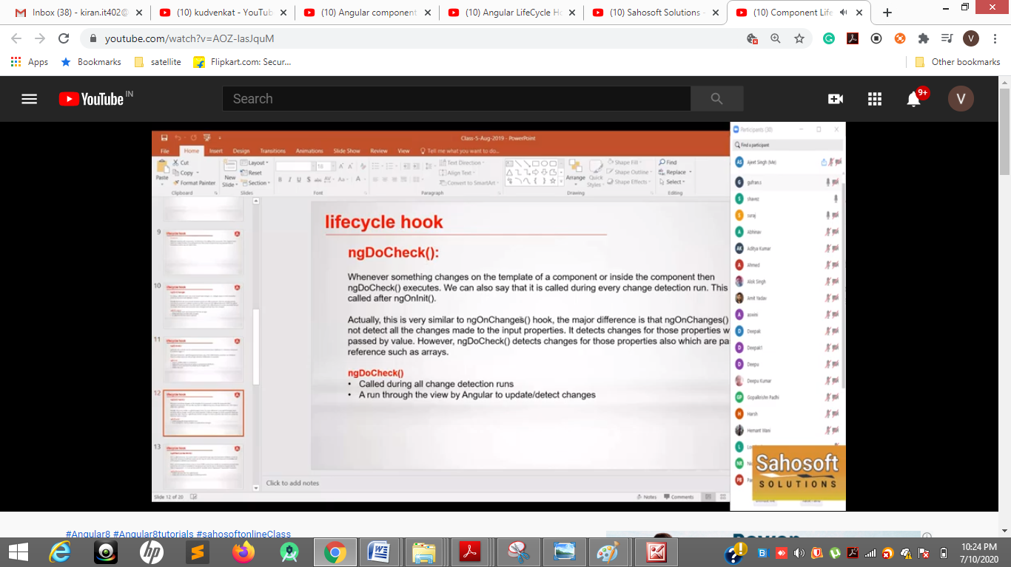

**Even changes in the template ngDocheck will trigger update /detect changes**

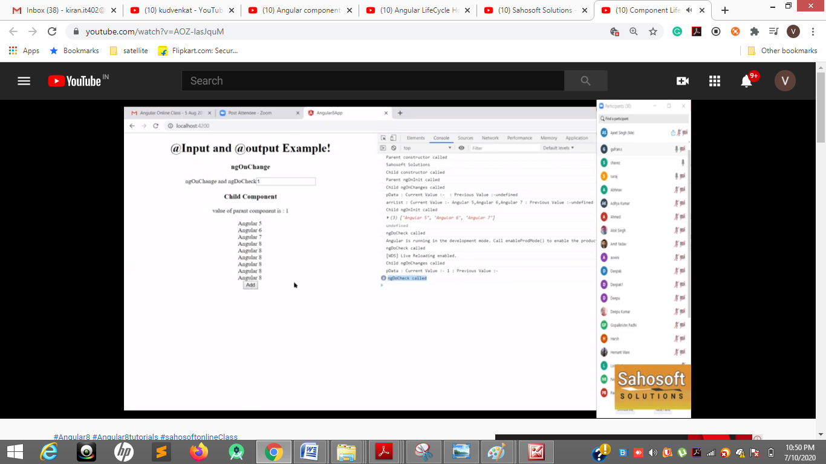

**1 press ngOnchange and ngDoCheck triggerd but on click of add template view change only ngDoCheck triggered**

[**https://www.youtube.com/watch?v=zTyrYppDy1A**](https://www.youtube.com/watch?v=zTyrYppDy1A)

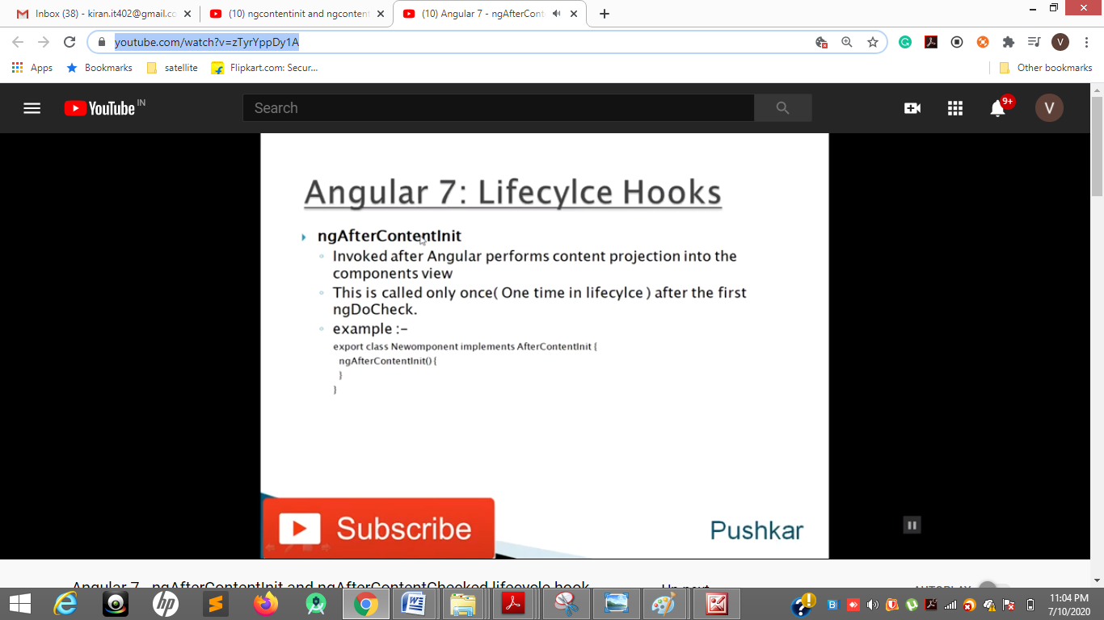

**ngAfterContentInit is triggered only once**

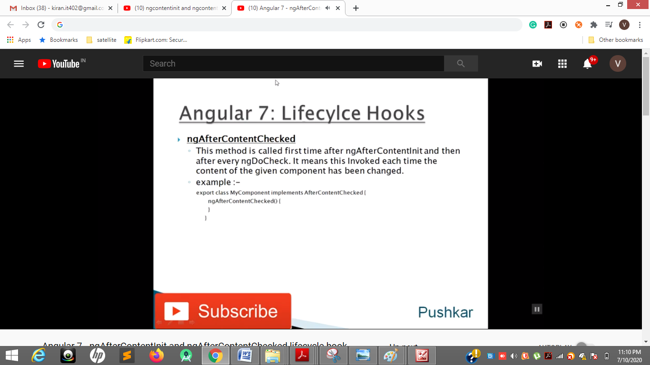

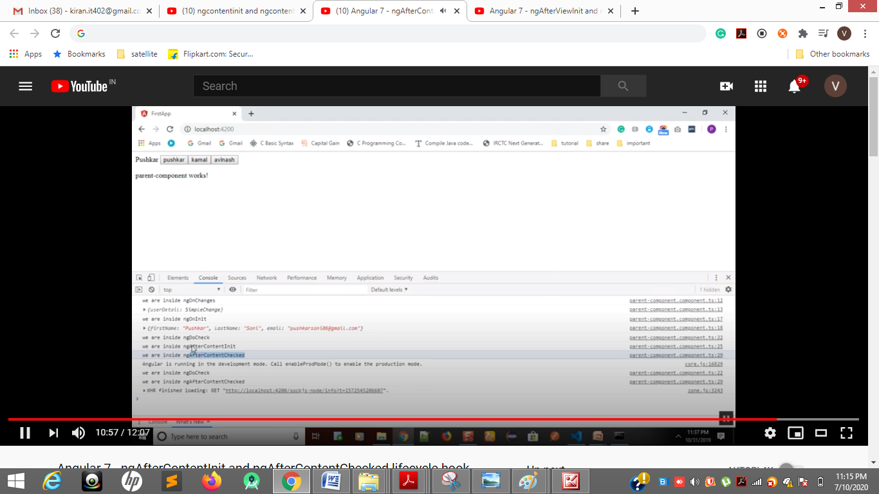

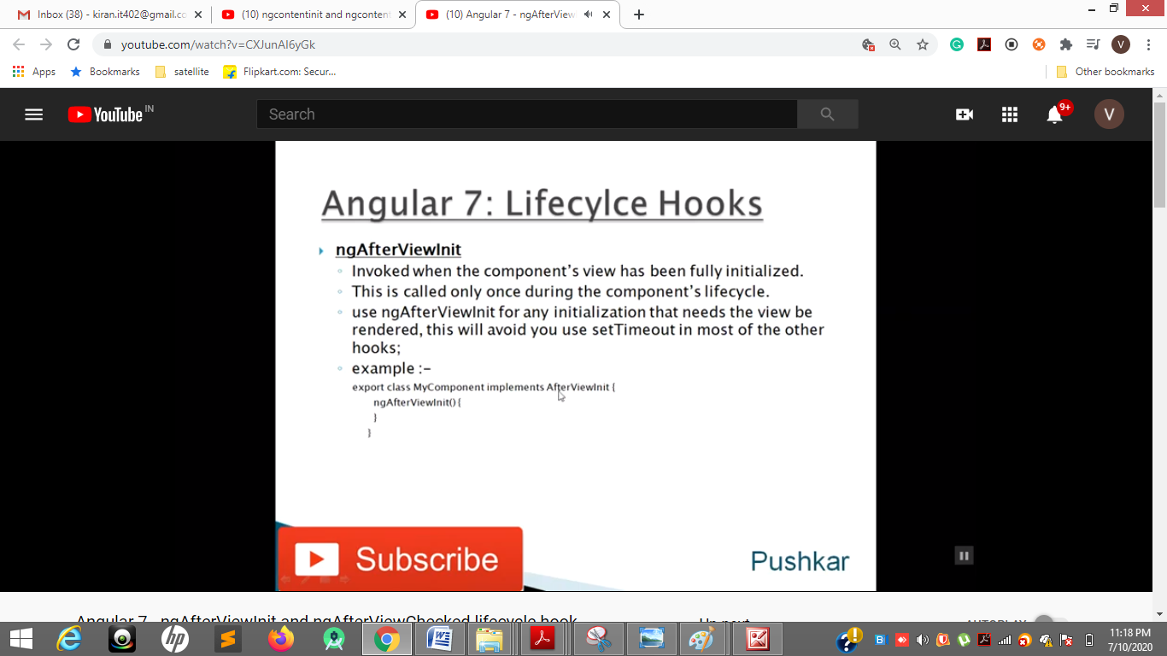

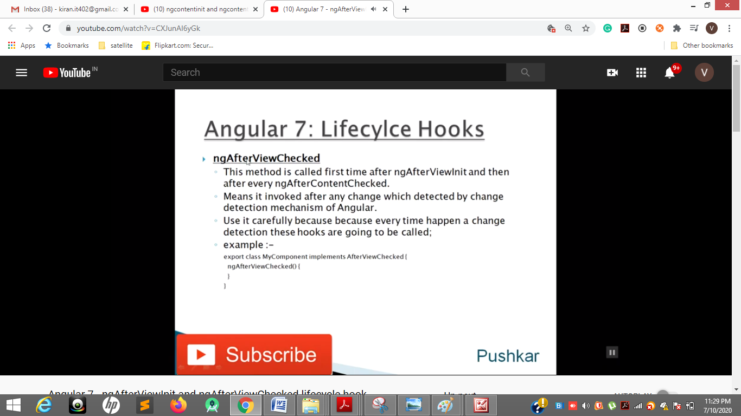

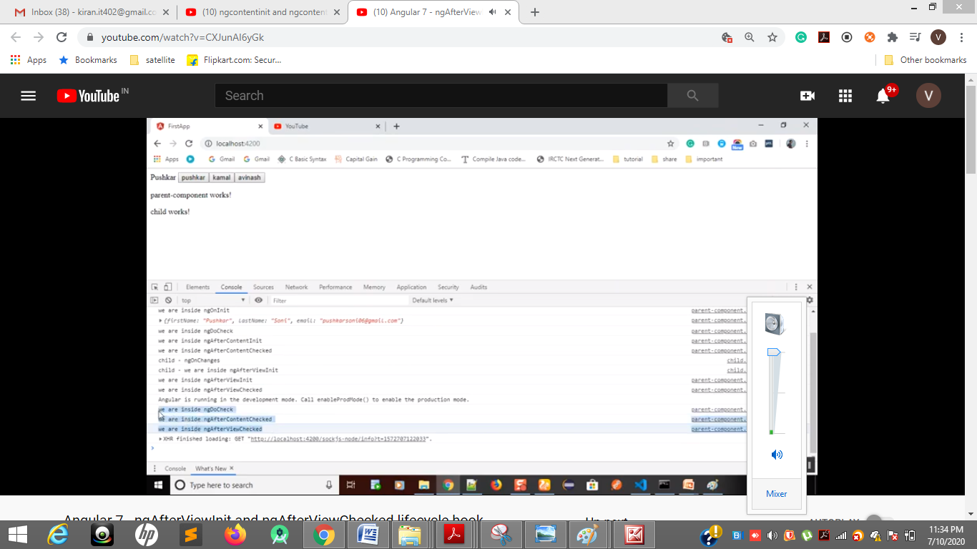

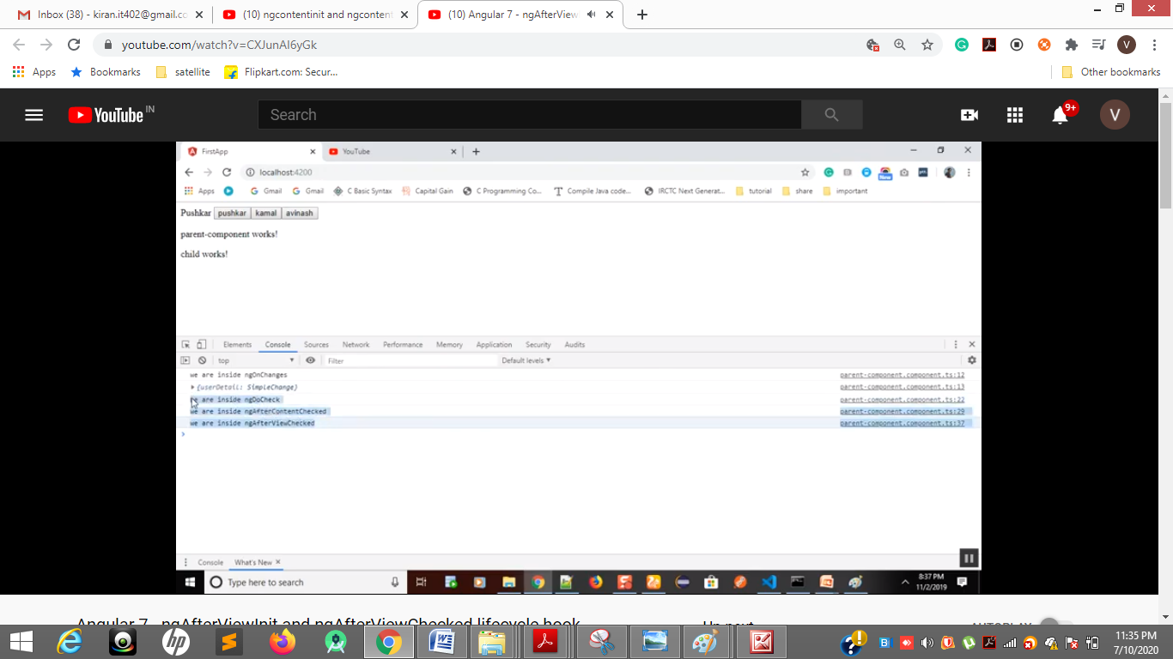

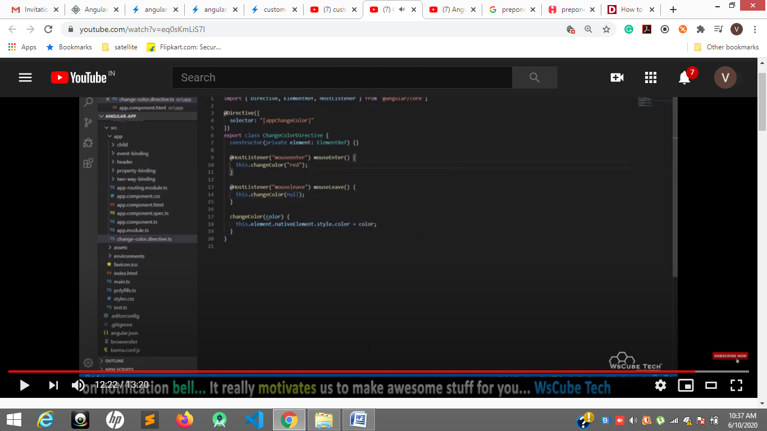

[**https://www.freecodecamp.org/news/everything-you-need-to-know-about-ng-template-ng-content-ng-container-and-ngtemplateoutlet-4b7b51223691/**](https://www.freecodecamp.org/news/everything-you-need-to-know-about-ng-template-ng-content-ng-container-and-ngtemplateoutlet-4b7b51223691/)

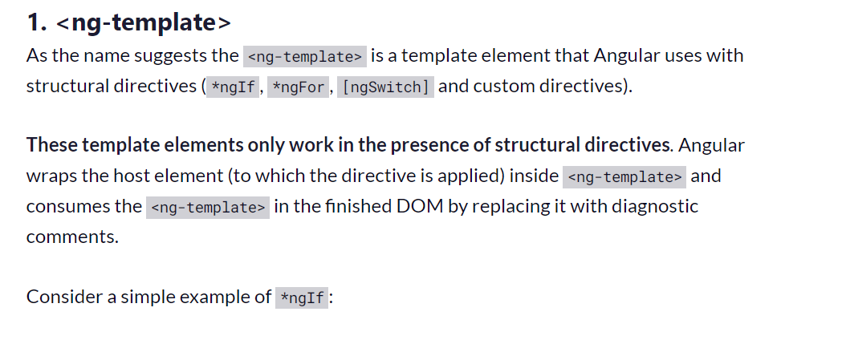

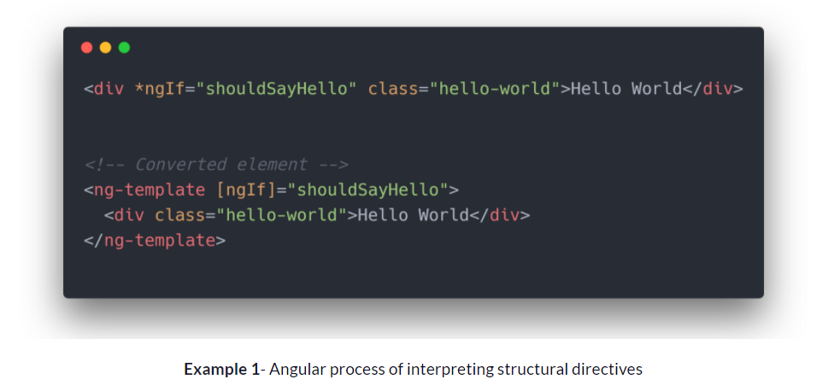

**Ng-container**

[**https://www.youtube.com/watch?v=a5UD4AB-C44**](https://www.youtube.com/watch?v=a5UD4AB-C44)

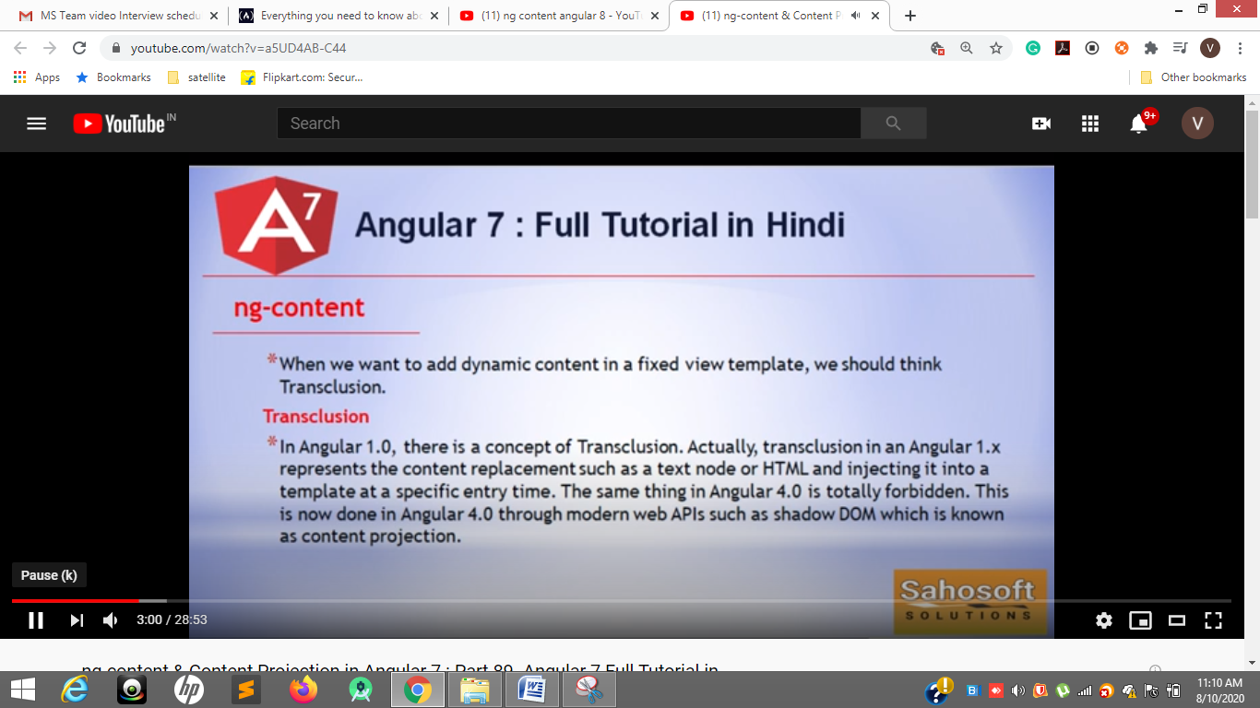

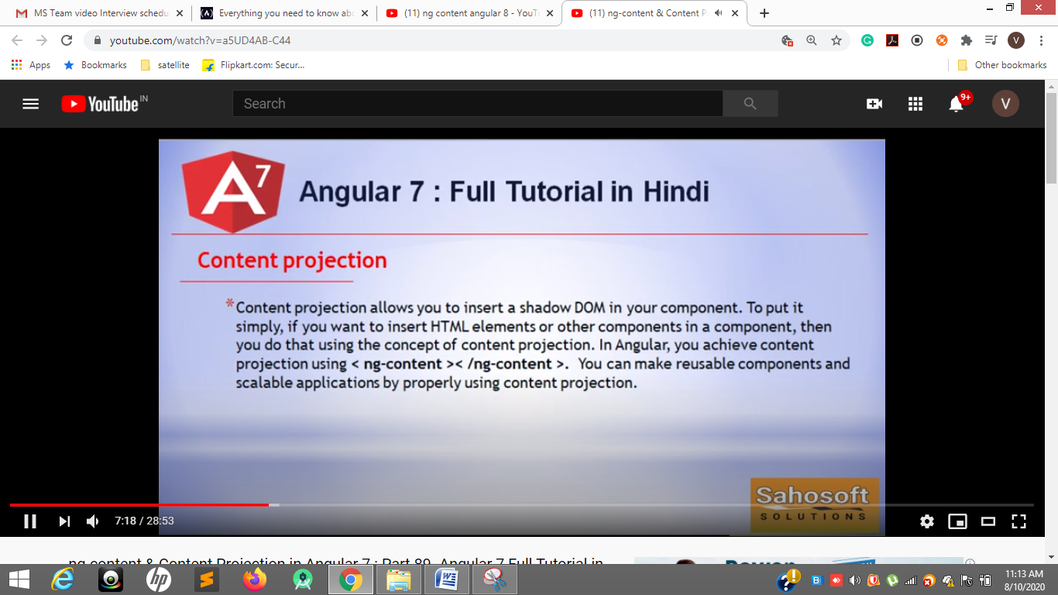

**Ng content and content projection**

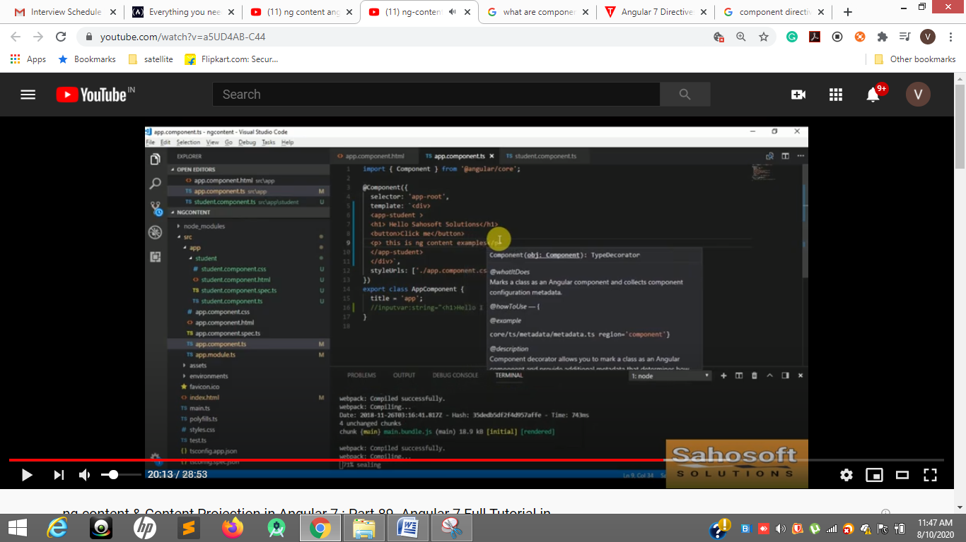

**Parent component Line 6 , 7 , 8,9**

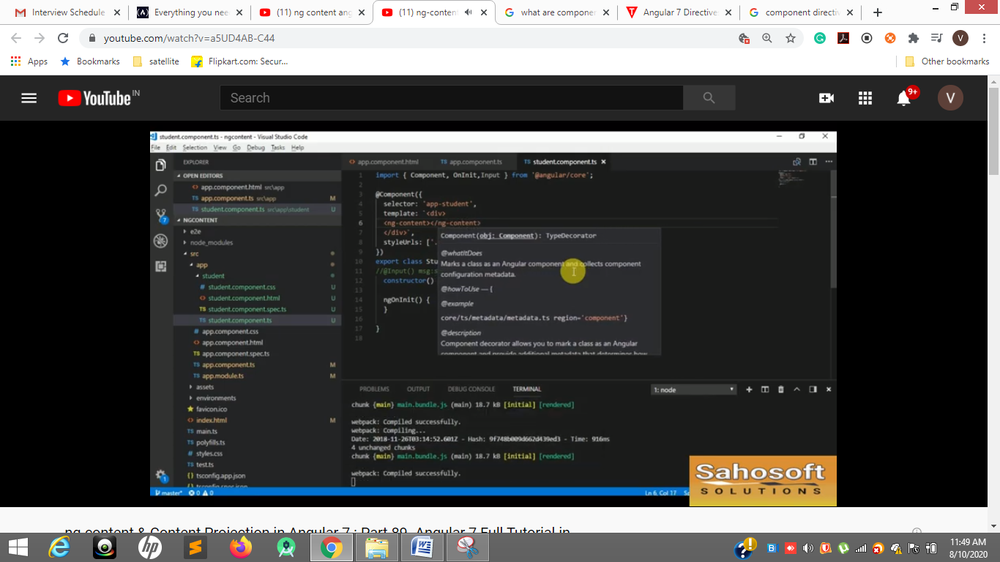

**Child component line 6**

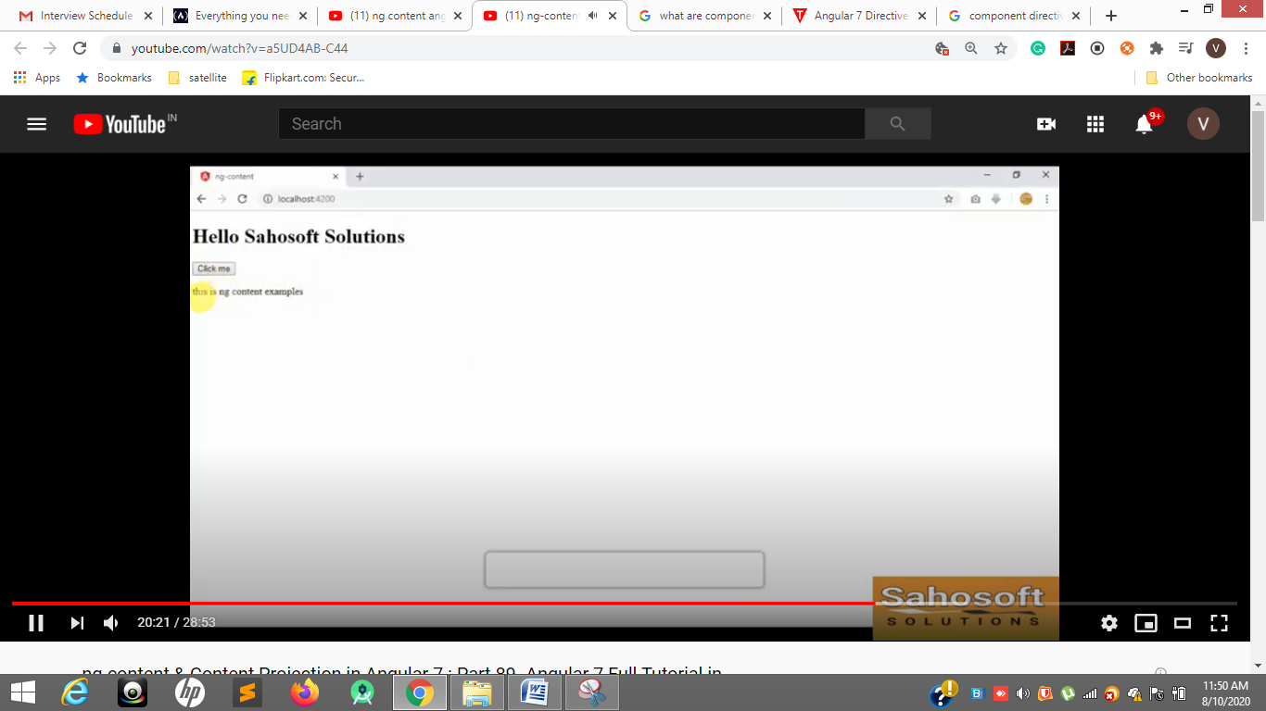

**@input we can pass like this <p> inner content</p>**

**Ng content we can pass inner content directly**

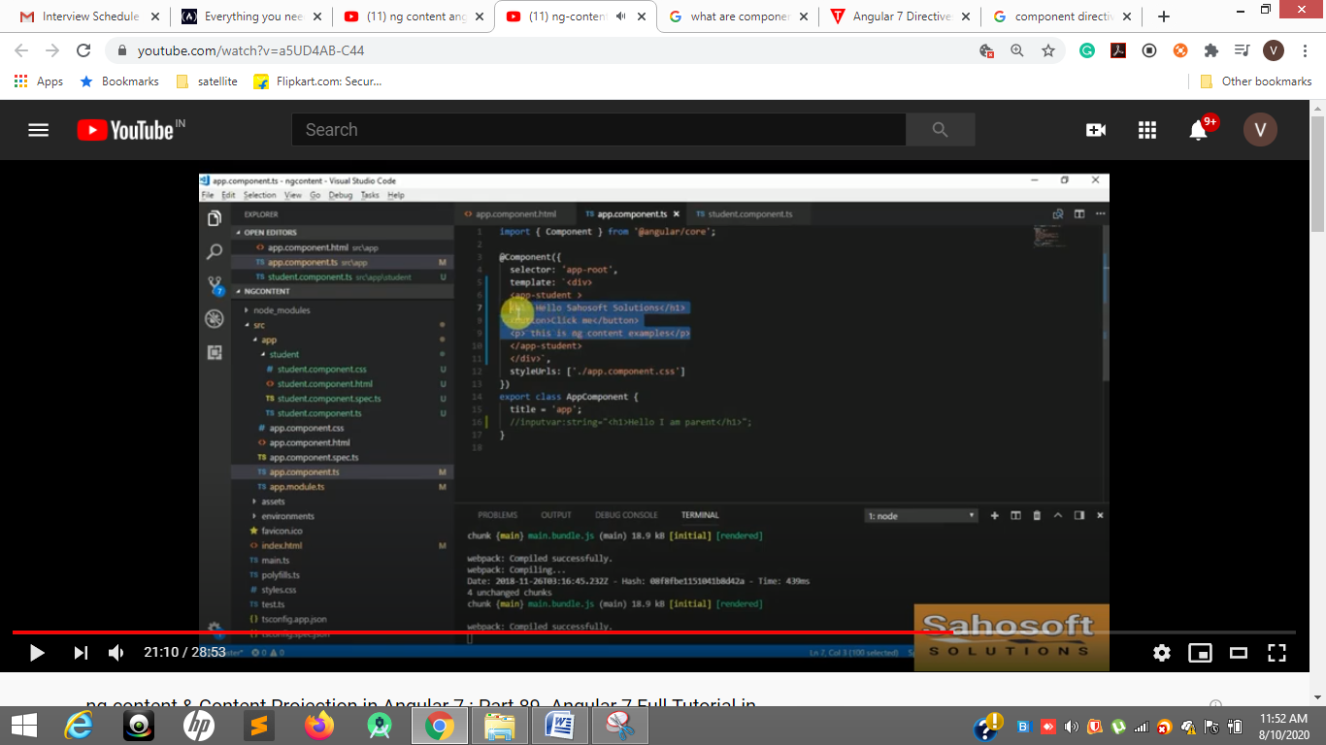

**16 – green line**

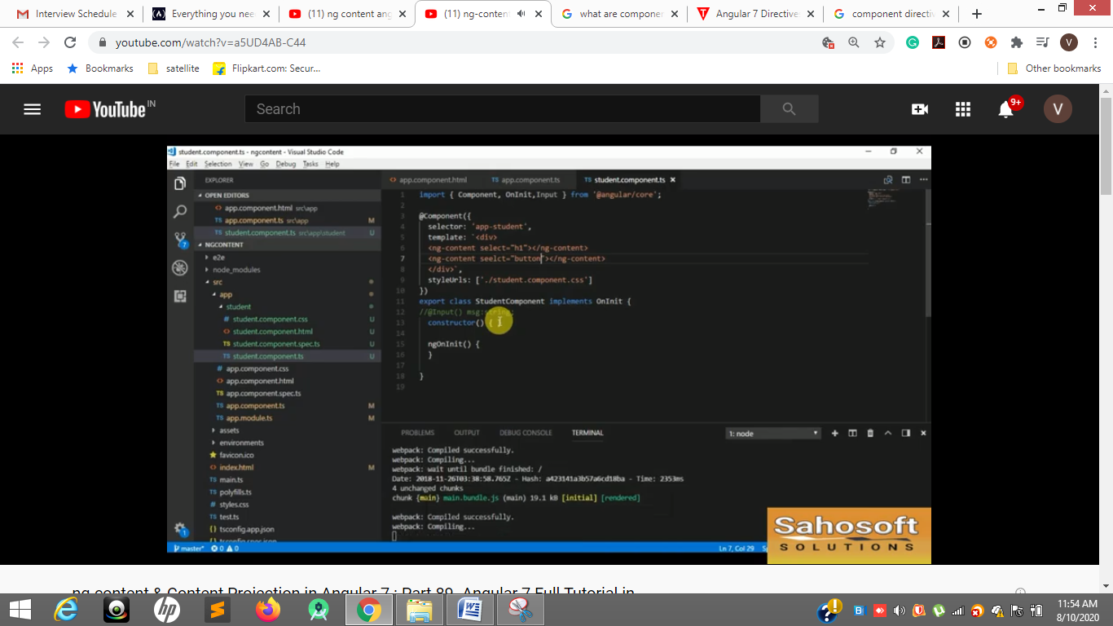

**Select= h1 and select= button**

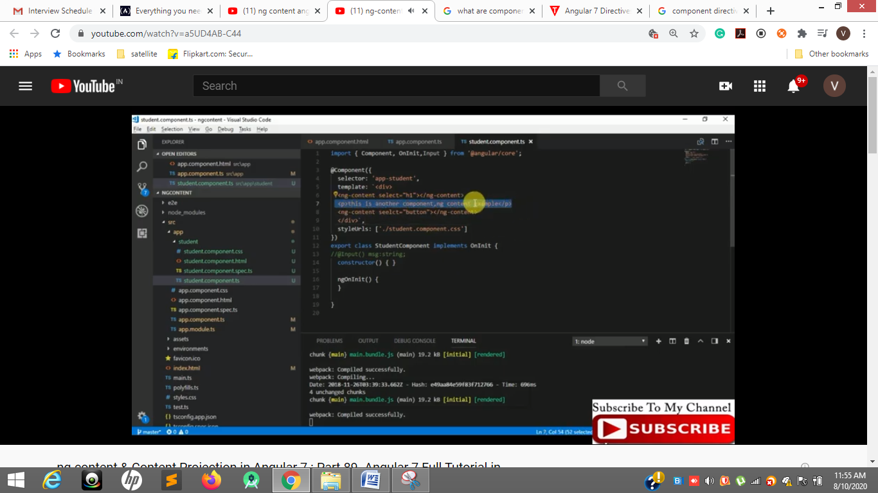

**Line—7, 6, 8**

**Header and button from parent but in between we need to insert some data from children then between selections we can write <p></p>**

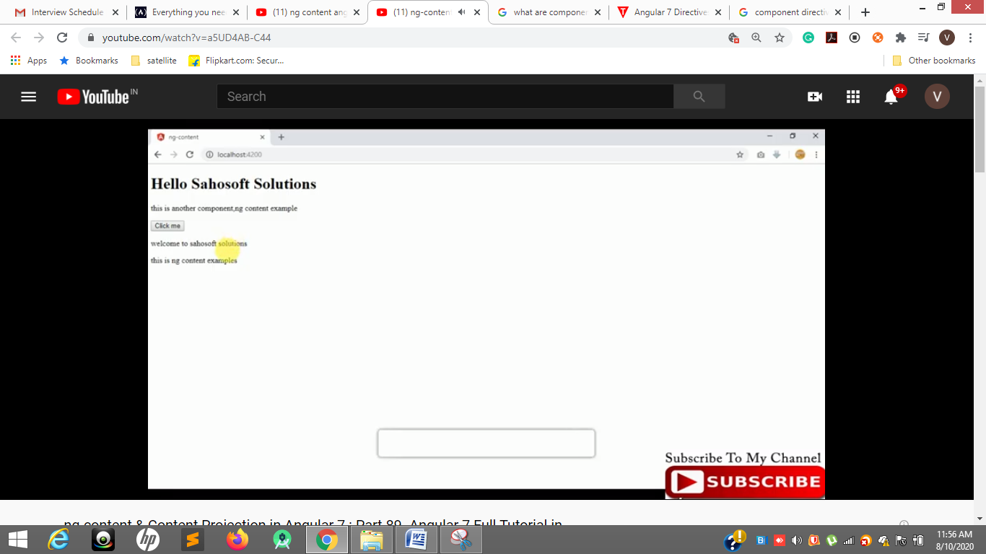

**Header and button from parent but in between we need to insert some data from children then between selections we can write <p></p>**

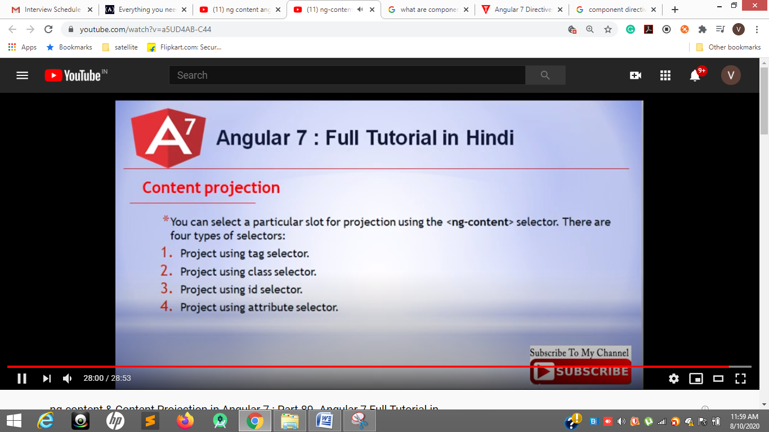

[**https://www.youtube.com/watch?v=m2QkHKAcmgI**](https://www.youtube.com/watch?v=m2QkHKAcmgI)

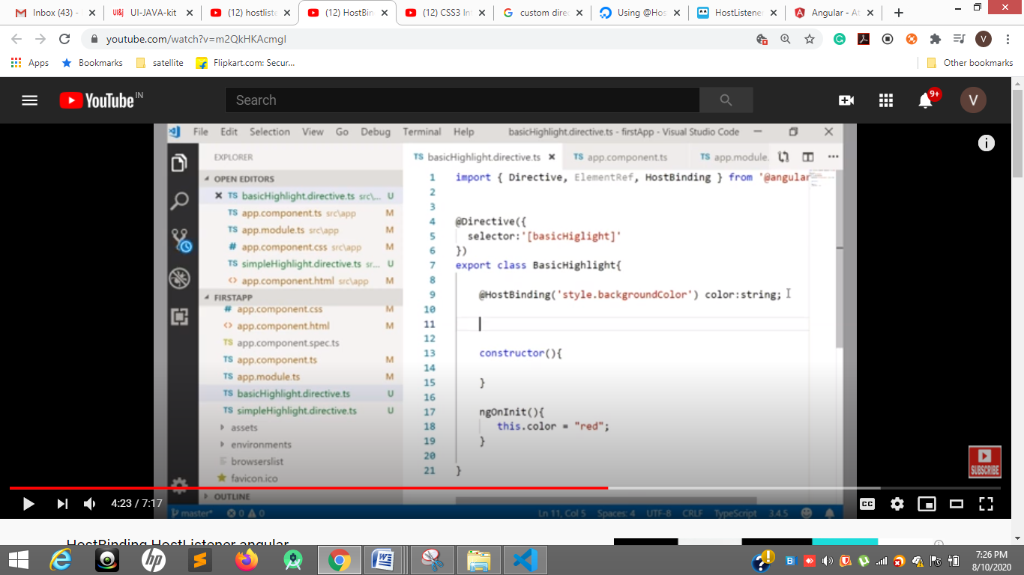

**hostBinding is binding a css properties**

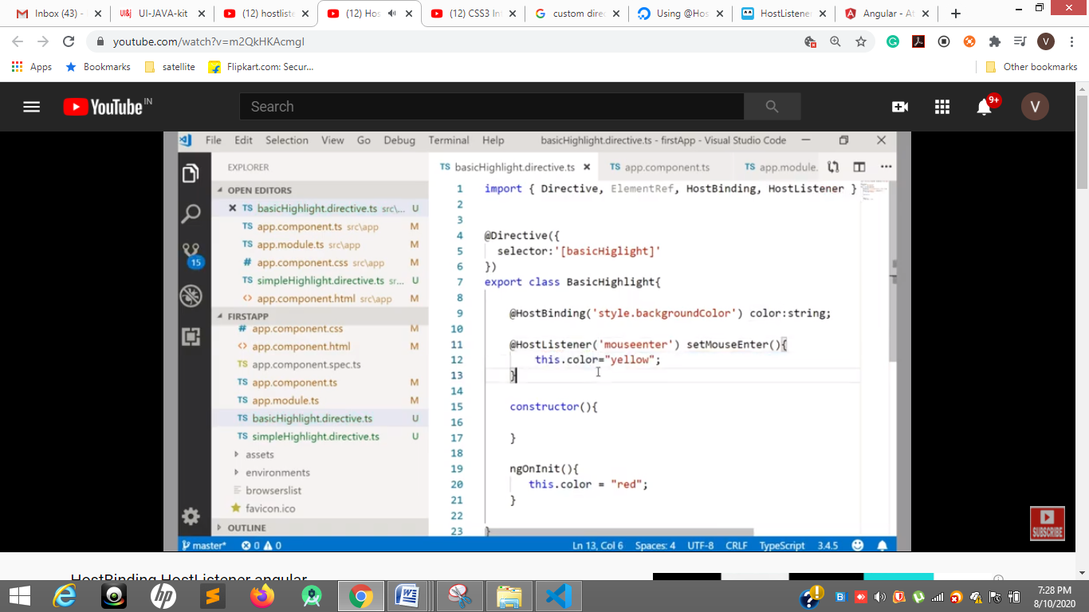

**hostListner for mouseevents – mouseleave and key events**

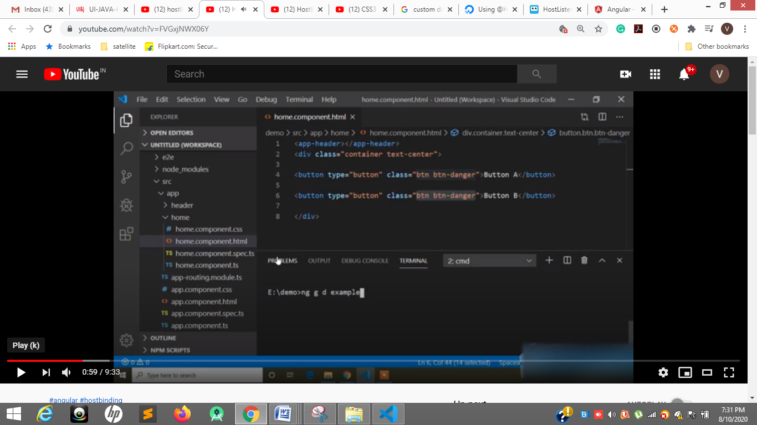

**Ng g d directive name for custom directives**

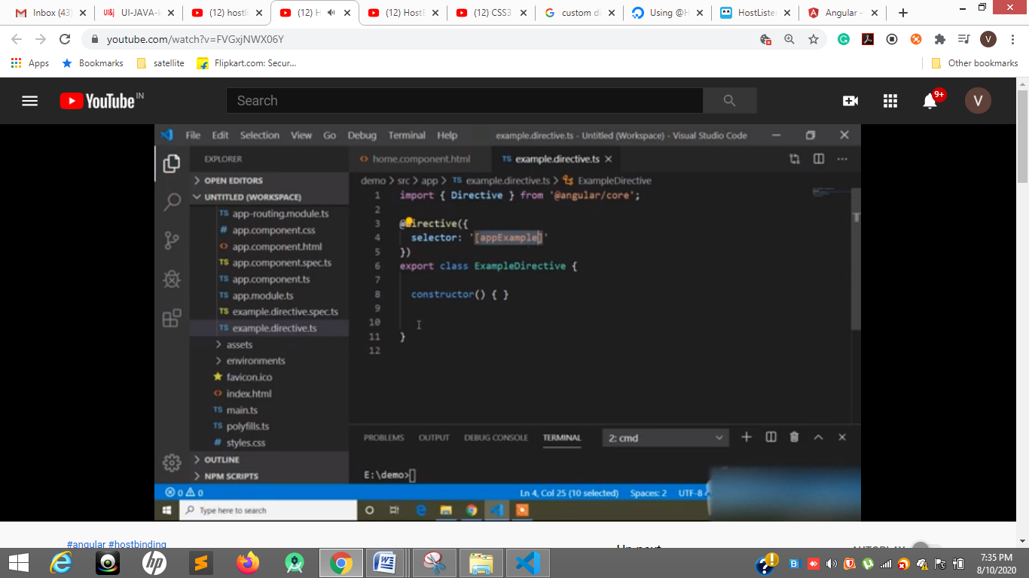

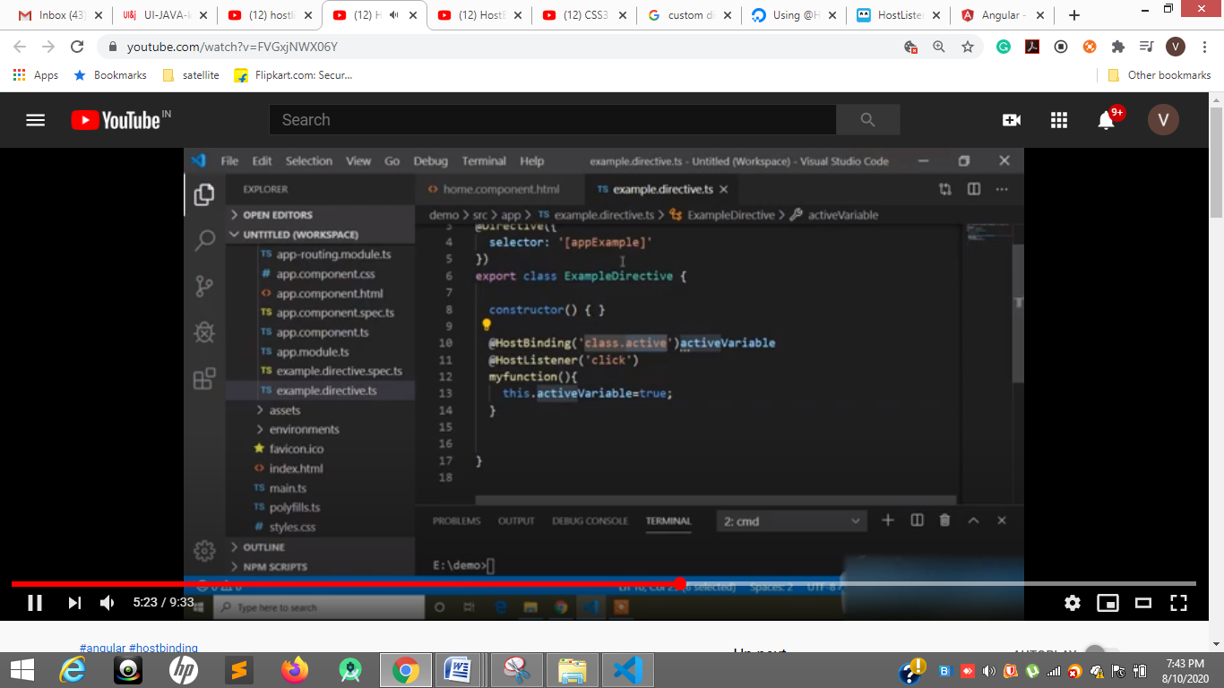

**hostBinding()**

**Class.active we can give class i.e styles in HostBinding**

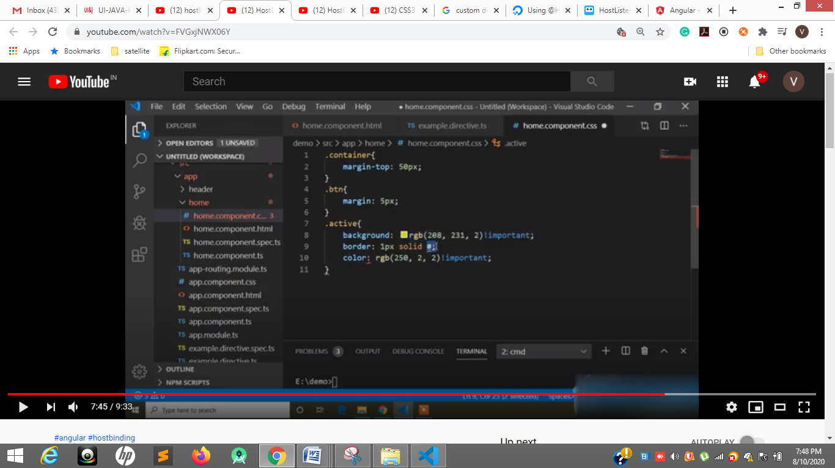

**Css applied for active class**

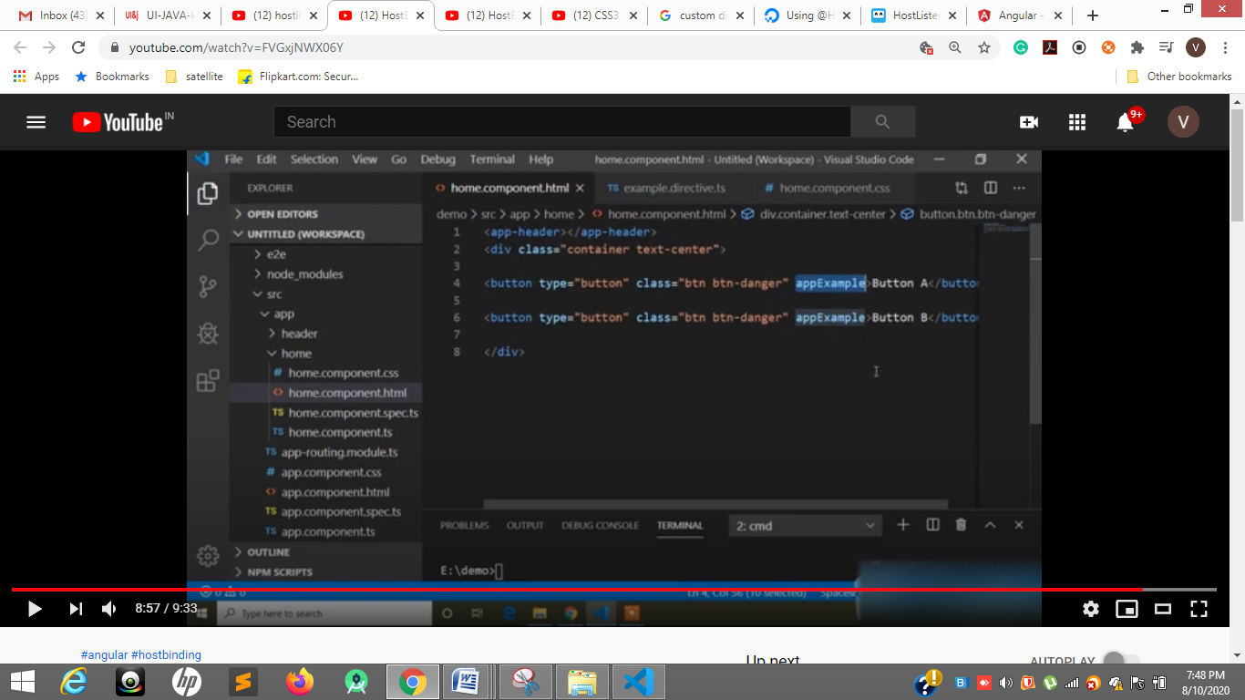

**Applied for buttons**

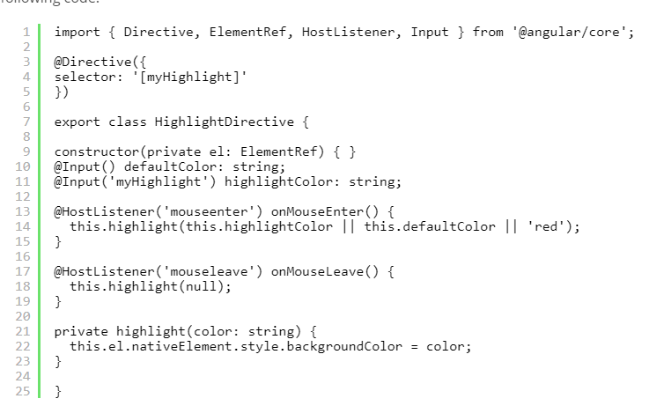

**@HostListener**

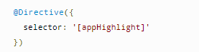

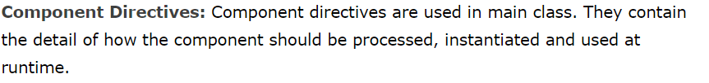

[**https://juristr.com/blog/2018/01/ng-app-runtime-config/?utm_source=devto&utm_medium=crosspost**](https://juristr.com/blog/2018/01/ng-app-runtime-config/?utm_source=devto&utm_medium=crosspost)

**Run –time and compile time**

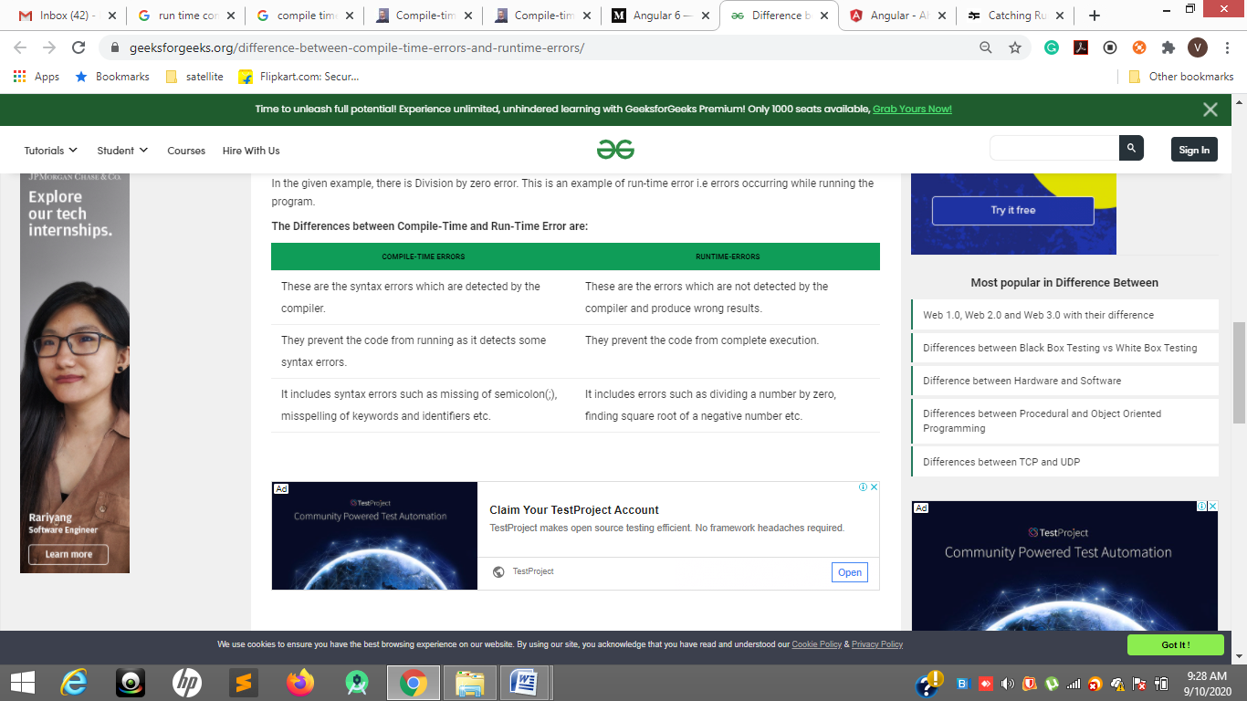

**Compile time error is syntactical error**

**A error occurred during exicution called run-time error**

**Run time errors also called as exceptions like Undefied, not defined**

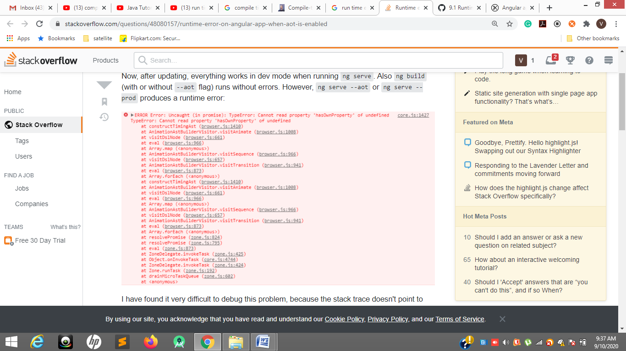

**The above are called Run time errors**

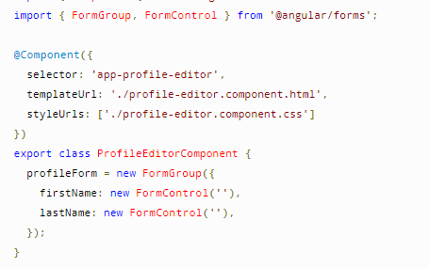

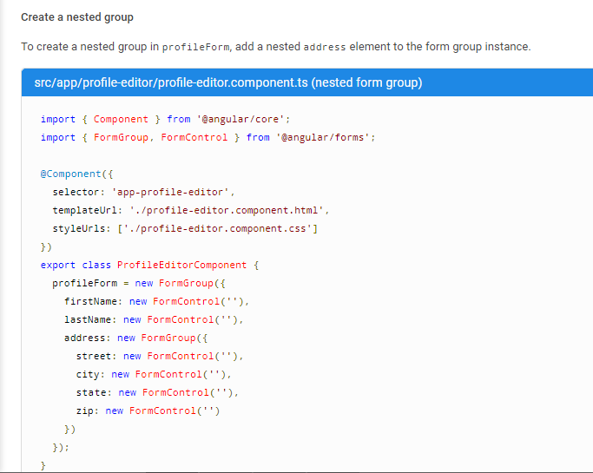

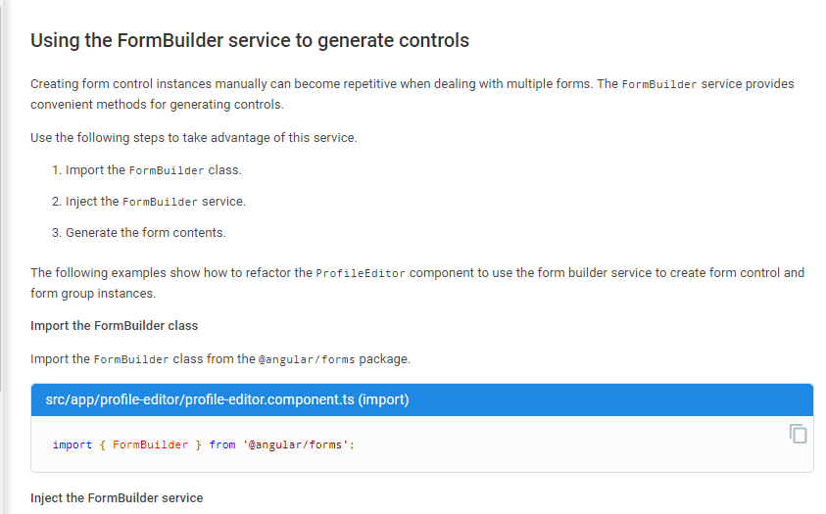

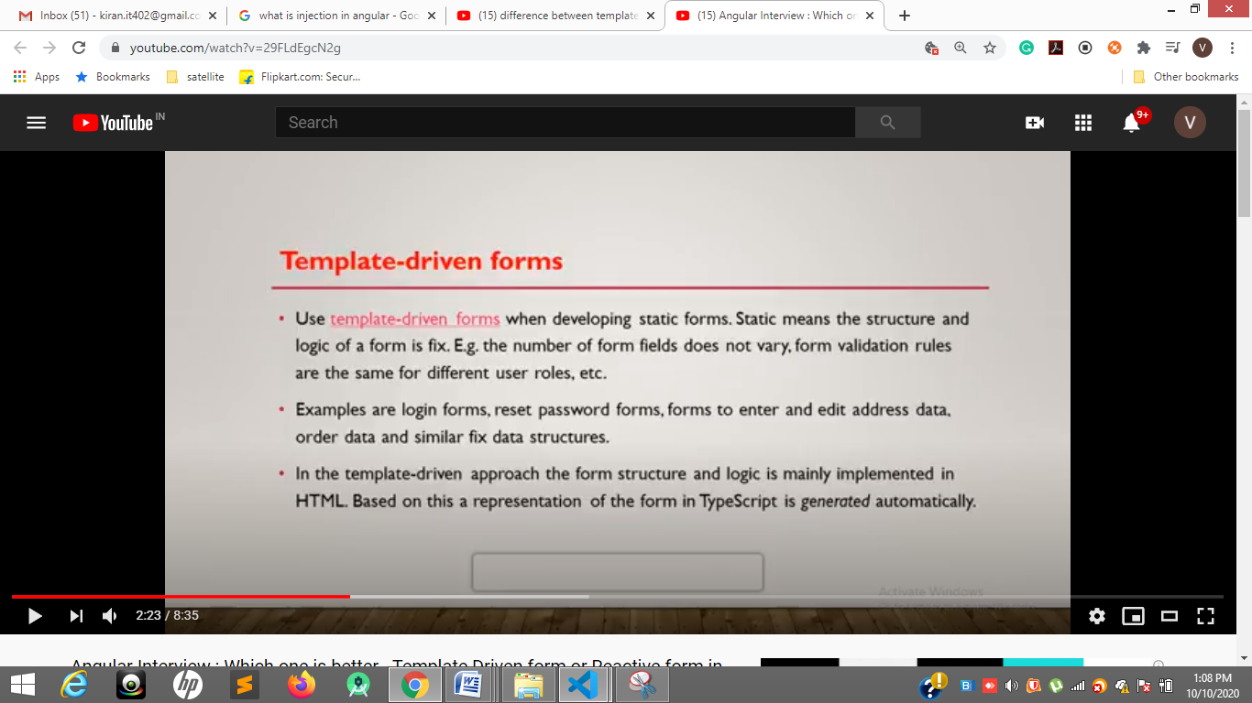

**Like login and register fixed form field**

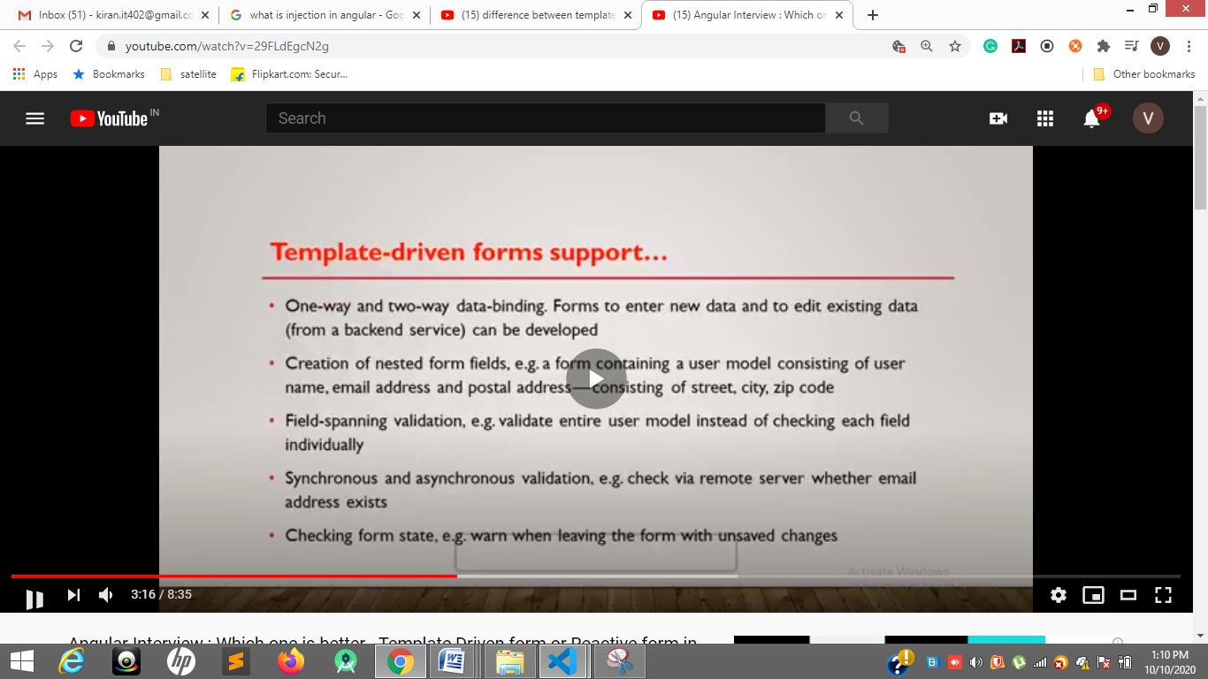

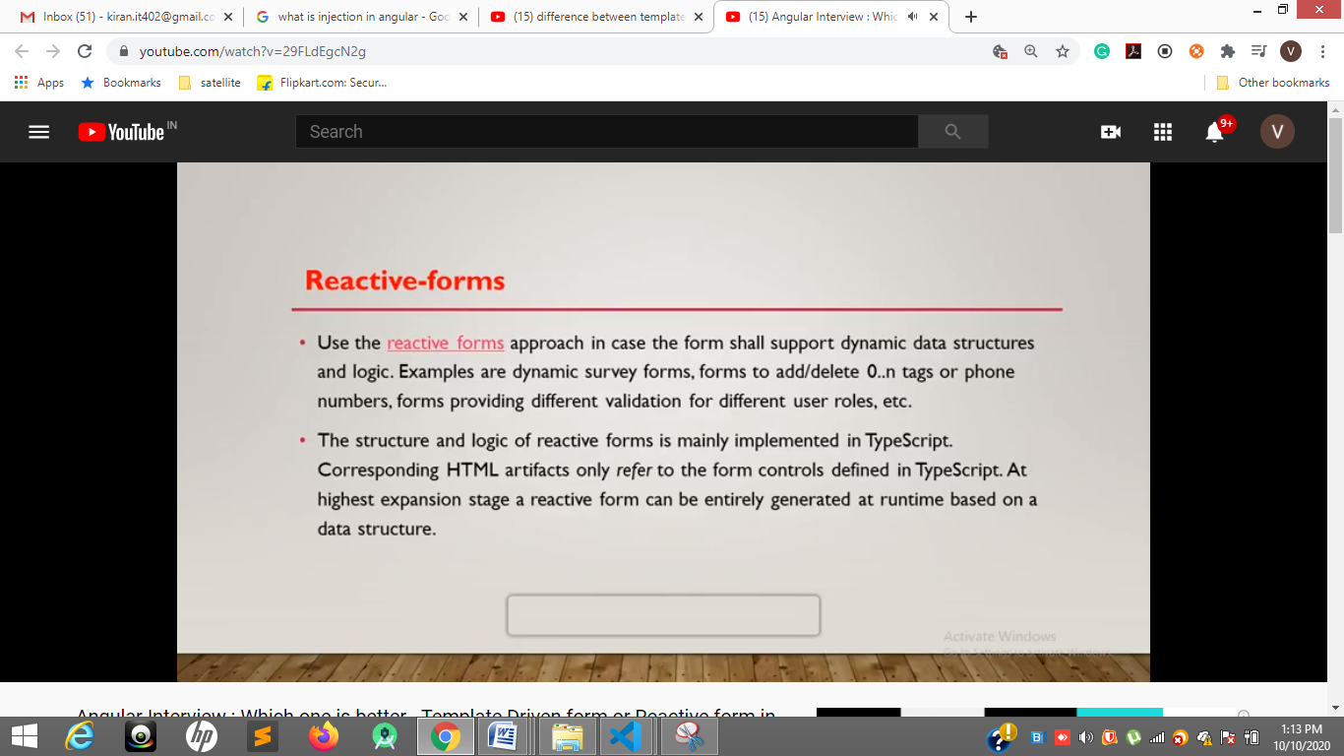

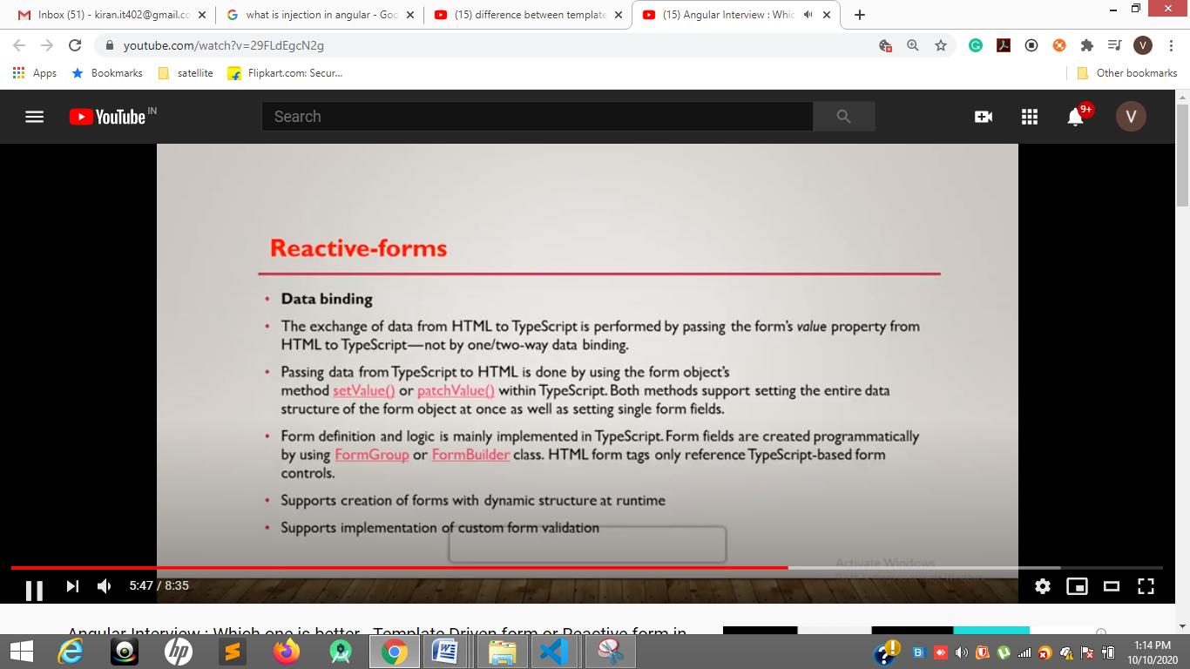

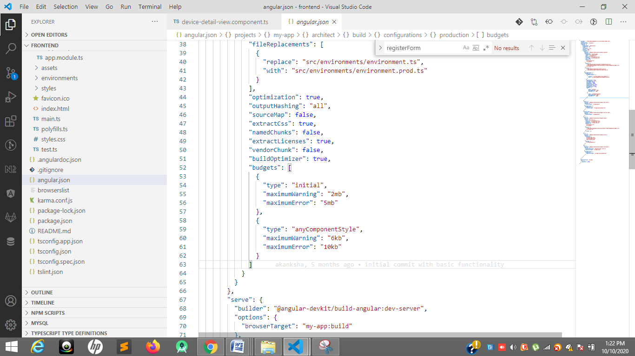

**Angulat.json 55 ang 56 line**

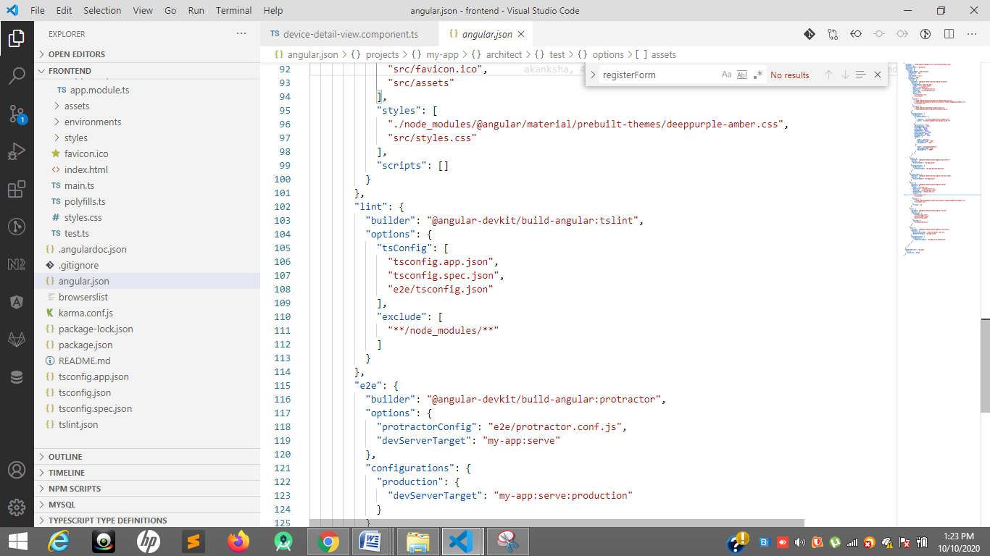

[**https://www.youtube.com/watch?v=r0xz6KzwYeY**](https://www.youtube.com/watch?v=r0xz6KzwYeY)

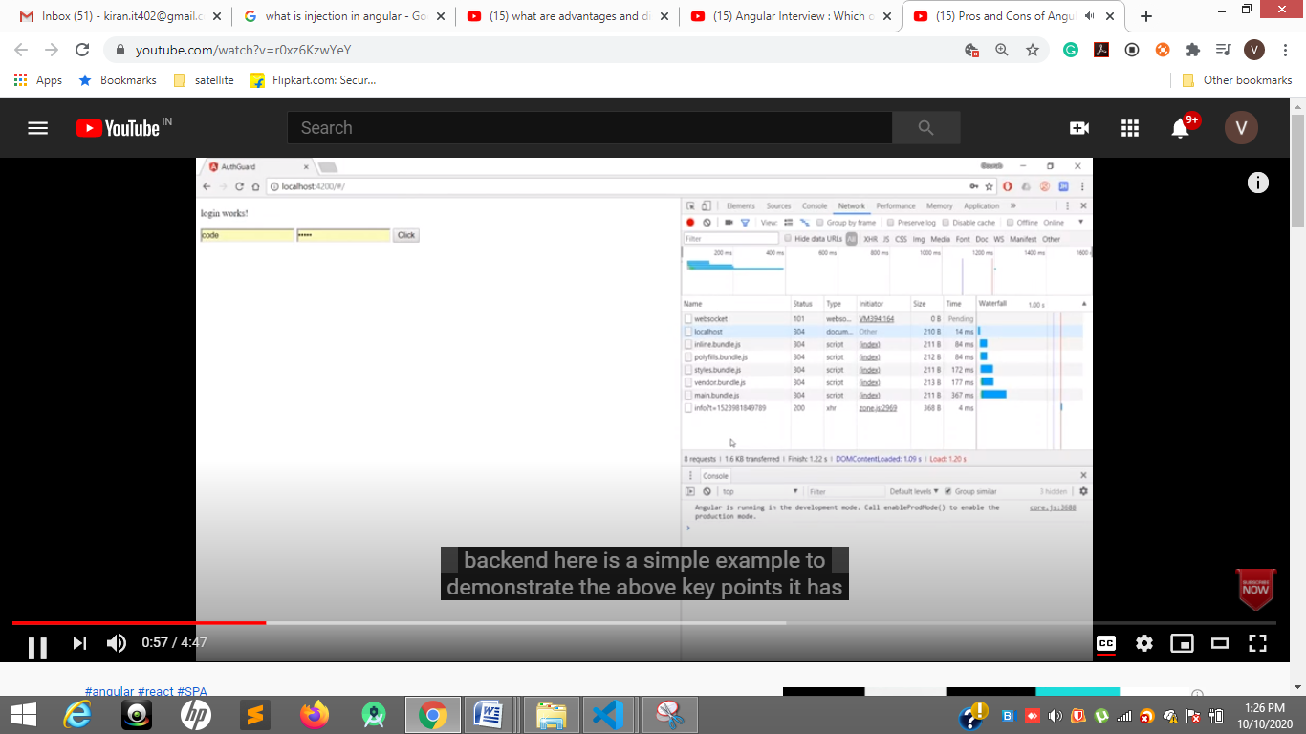

**It download all the files at a time and render the files as per the path**

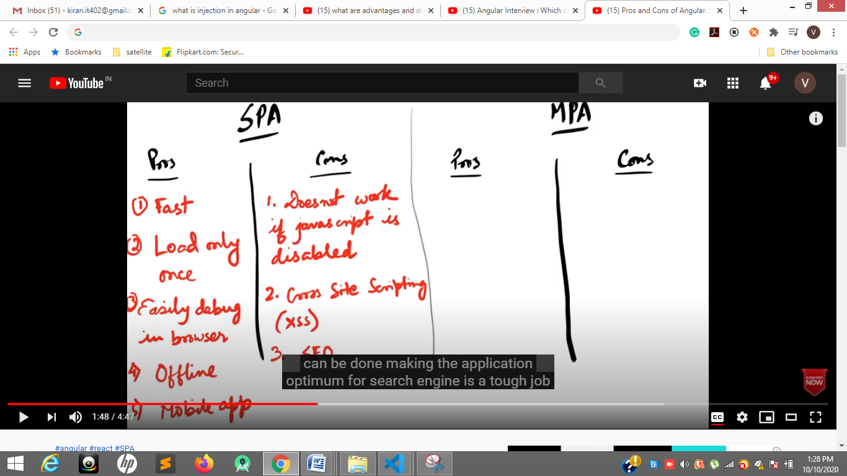

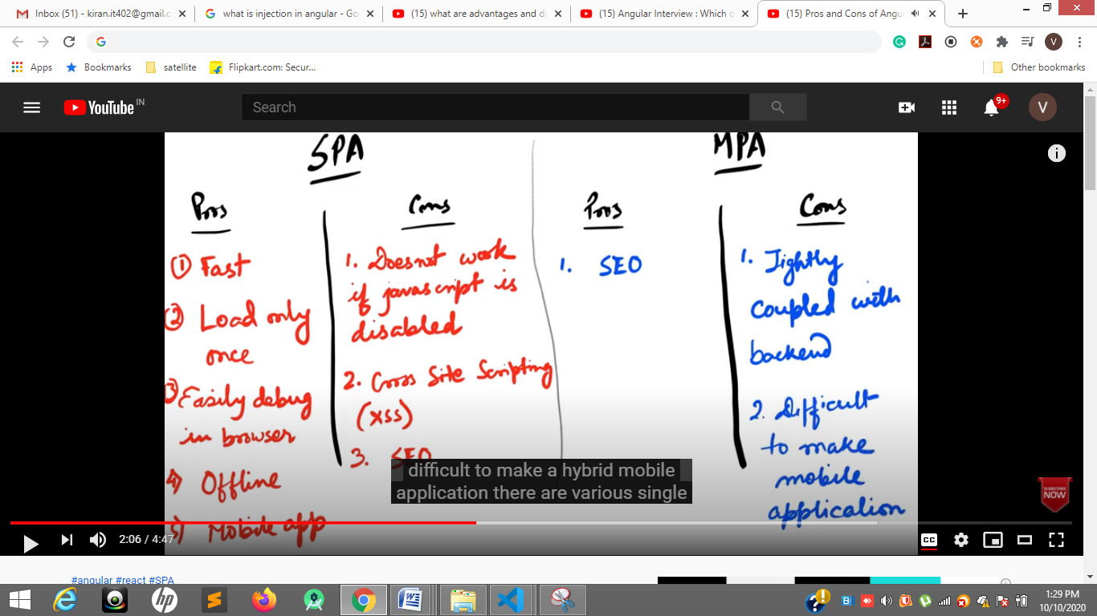

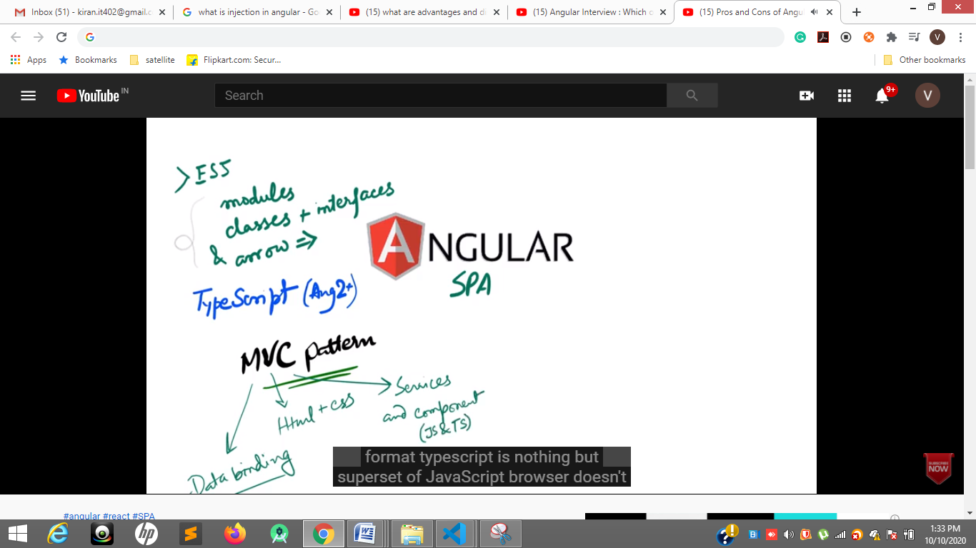

**Typescript is superset of javascript**

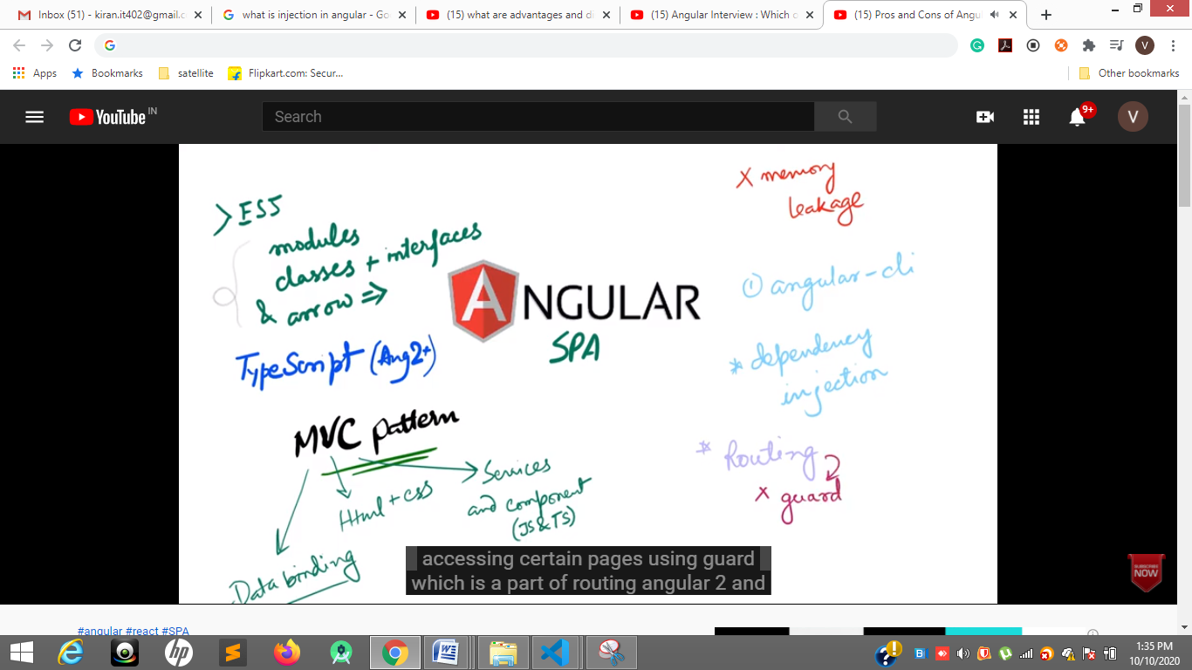

**Memory lekage ng destroy, secure application by auth Guards**

**By using lagy loding in routes we can load**

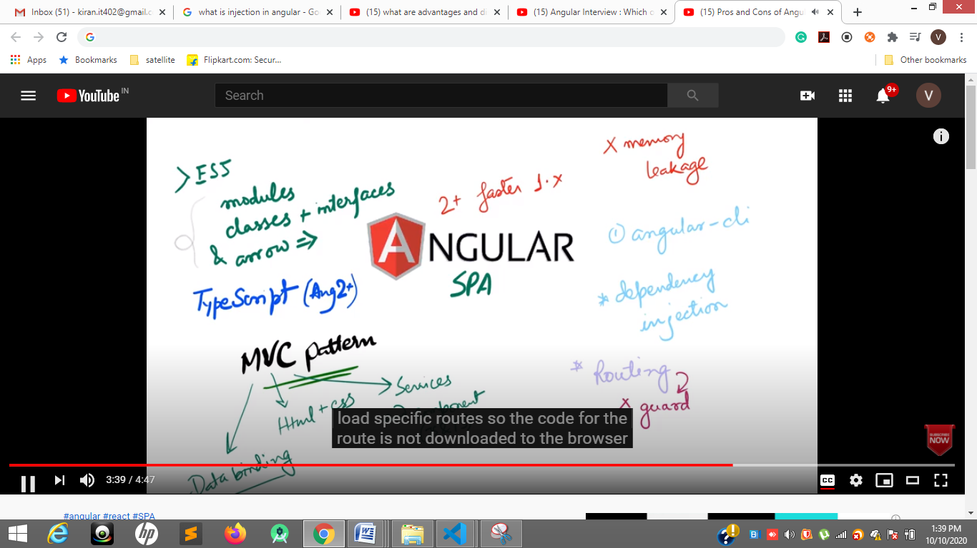

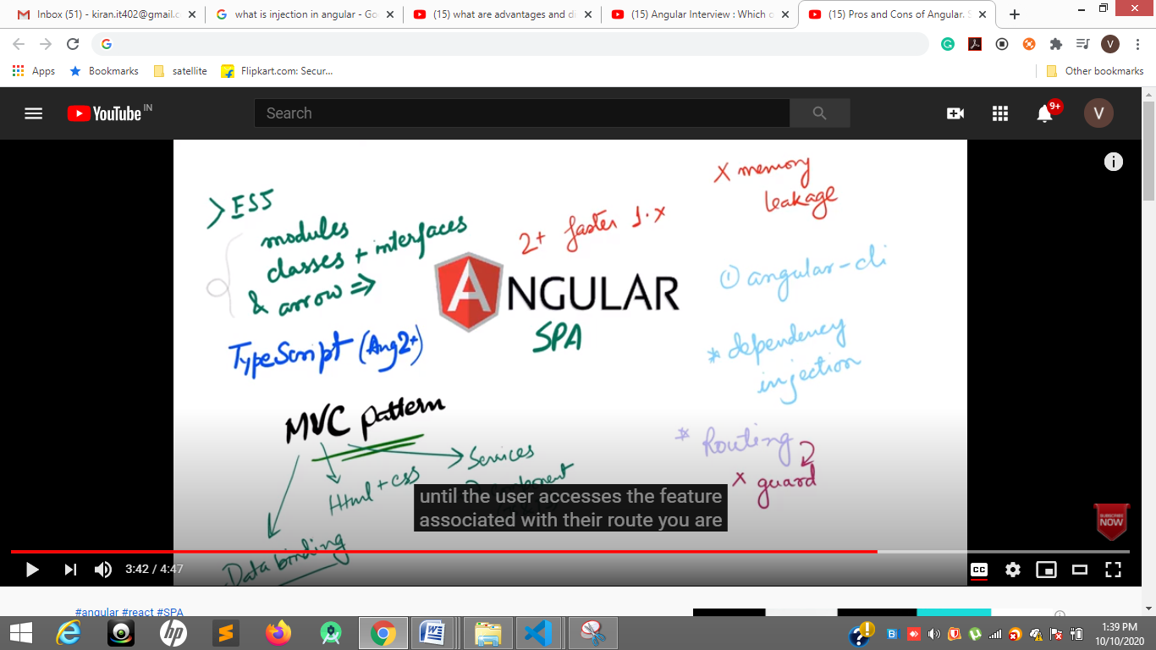

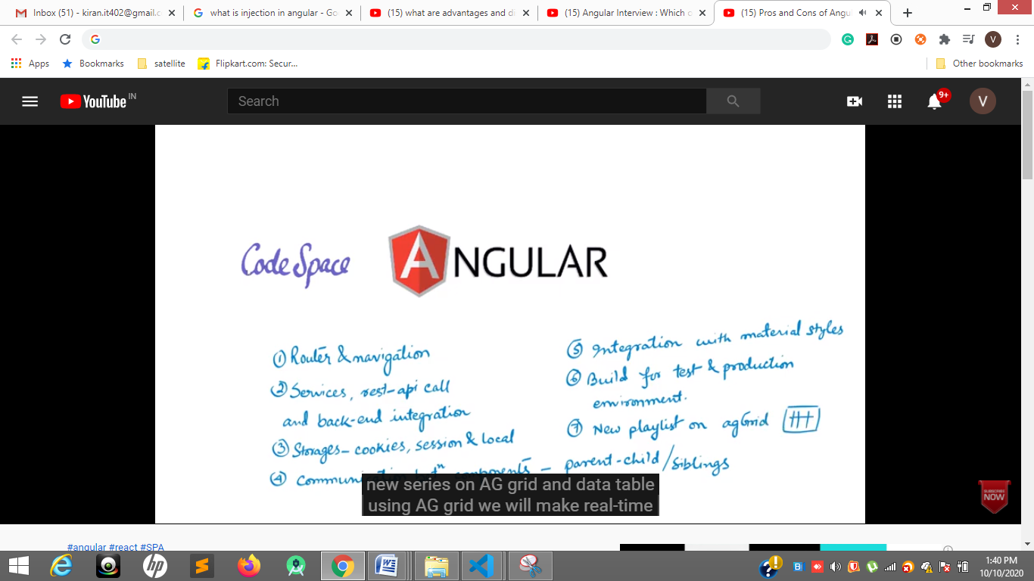

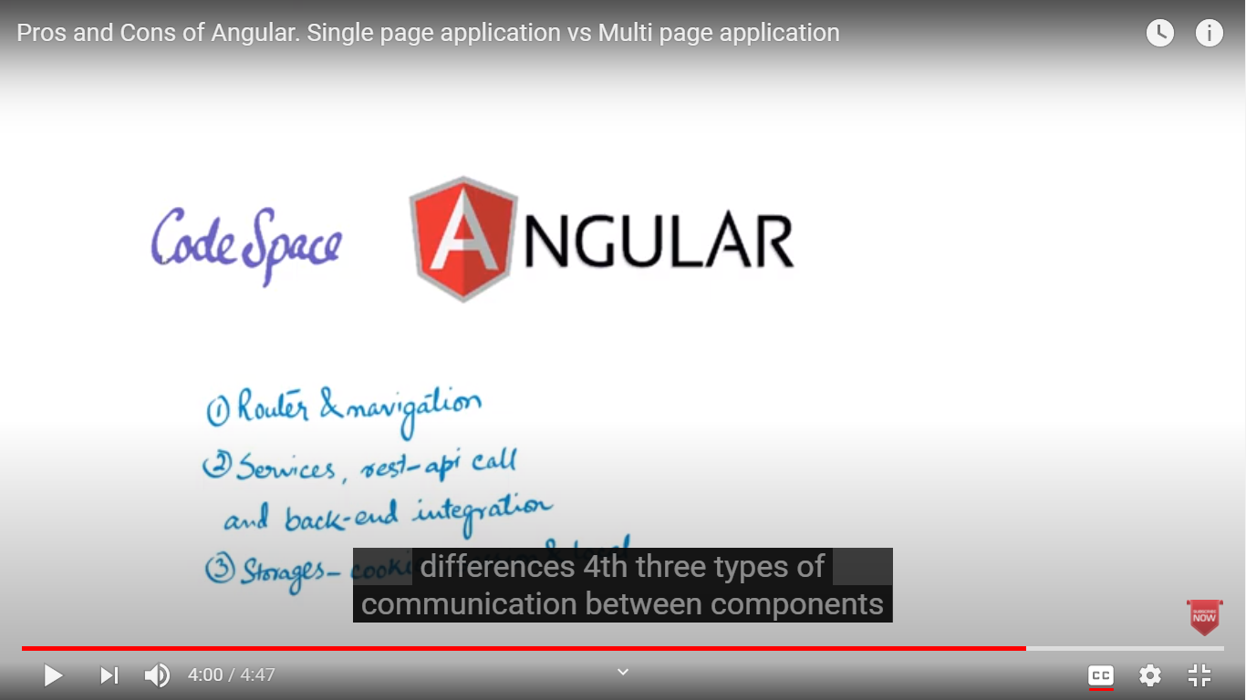

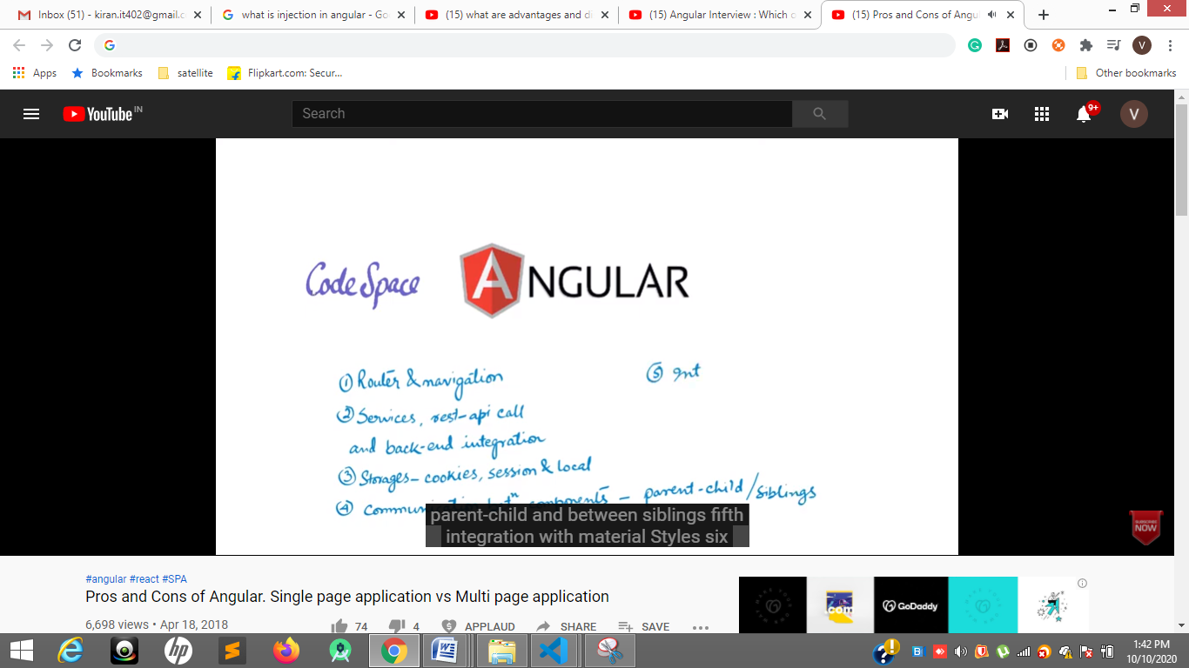

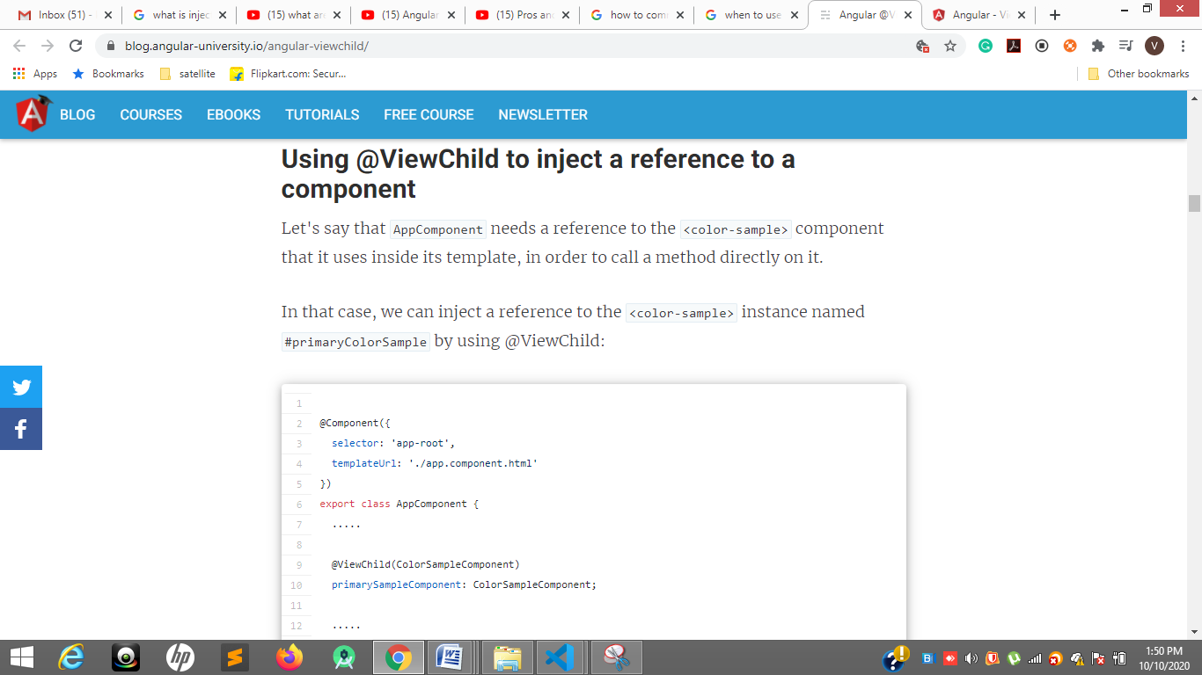

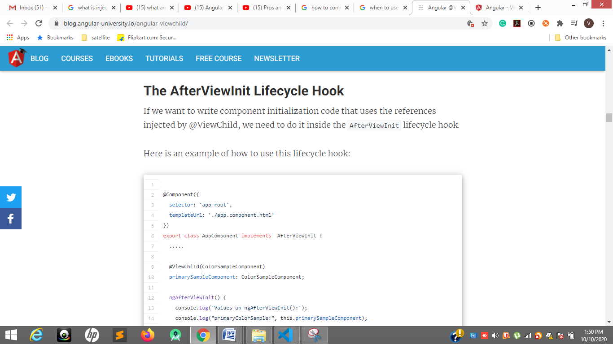

[**https://blog.angular-university.io/angular-viewchild/**](https://blog.angular-university.io/angular-viewchild/)

[**https://blog.angular-university.io/angular-viewchild/**](https://blog.angular-university.io/angular-viewchild/)

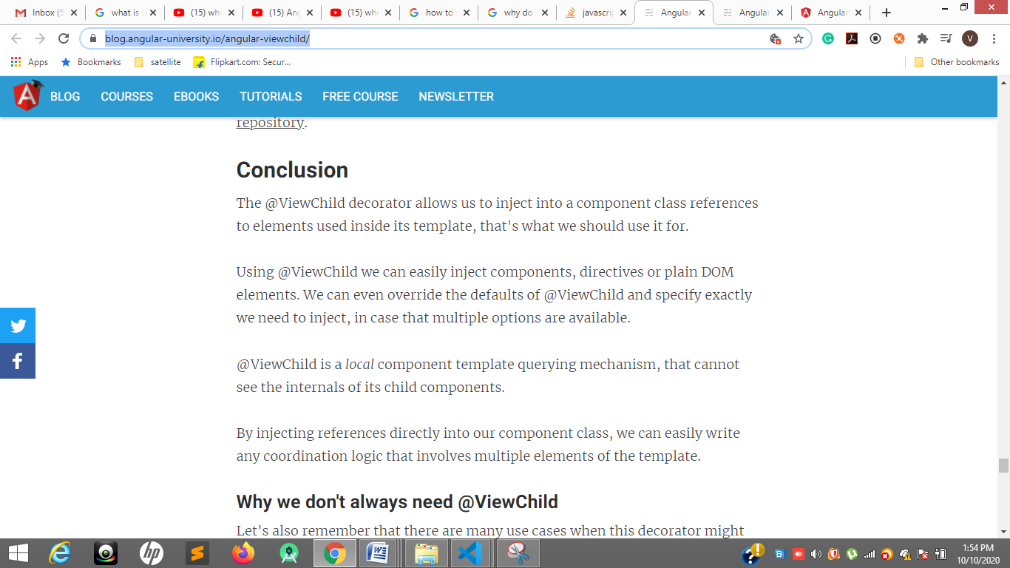

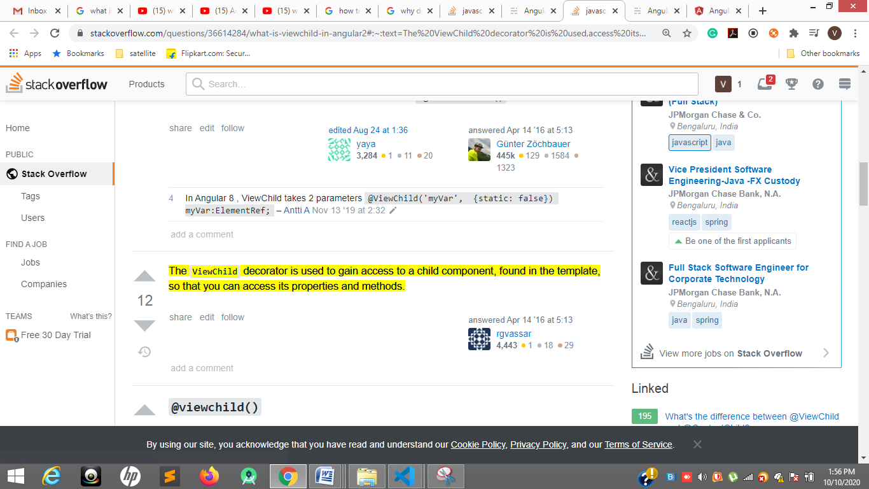

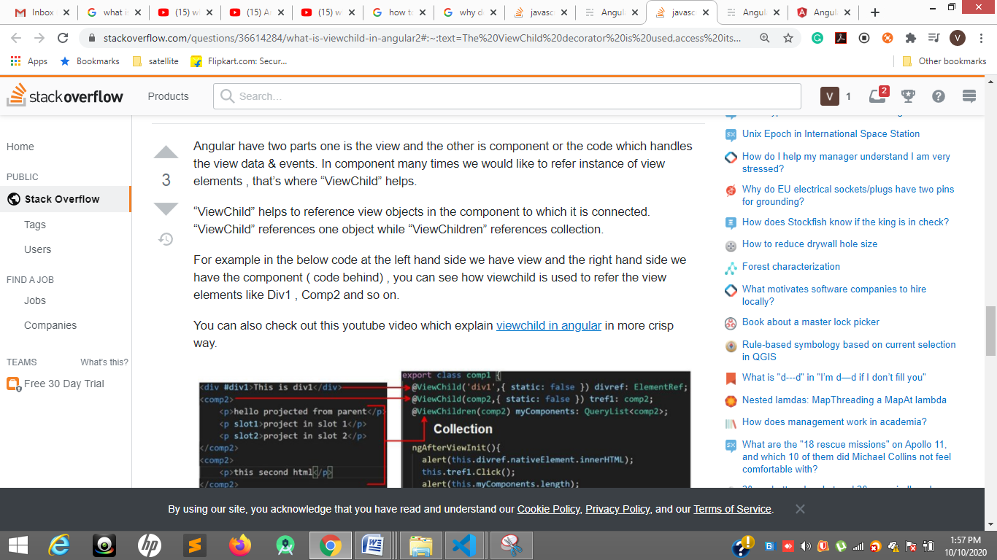

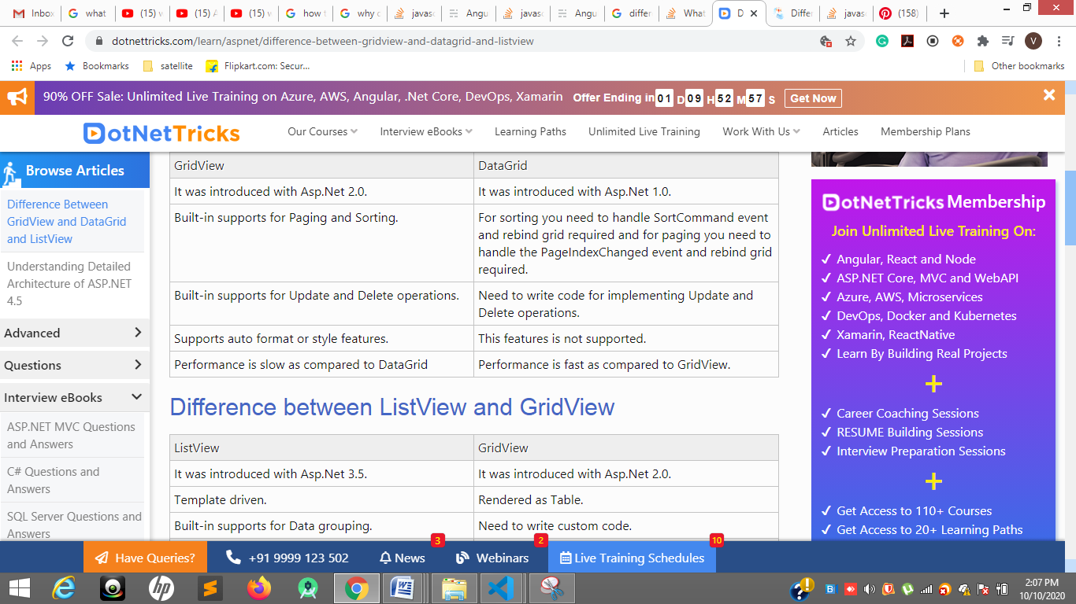

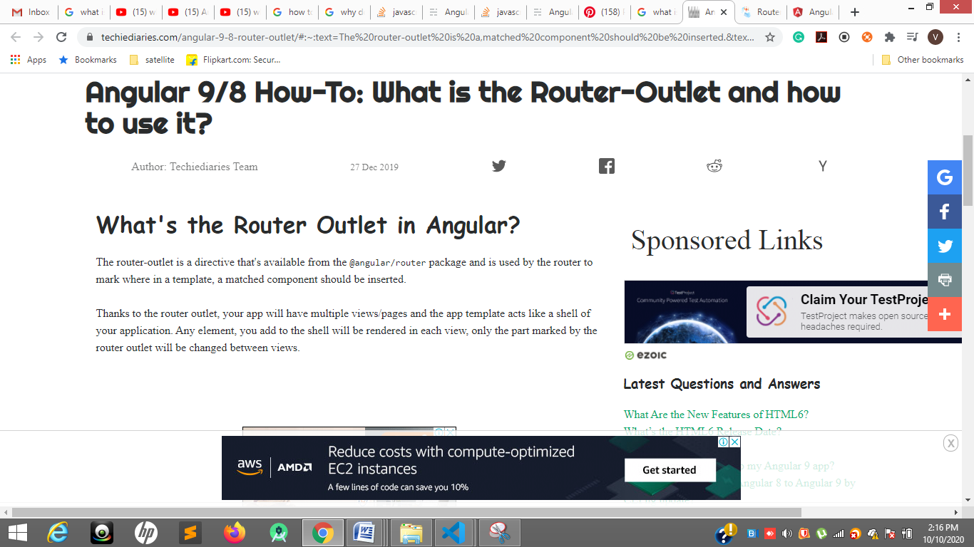

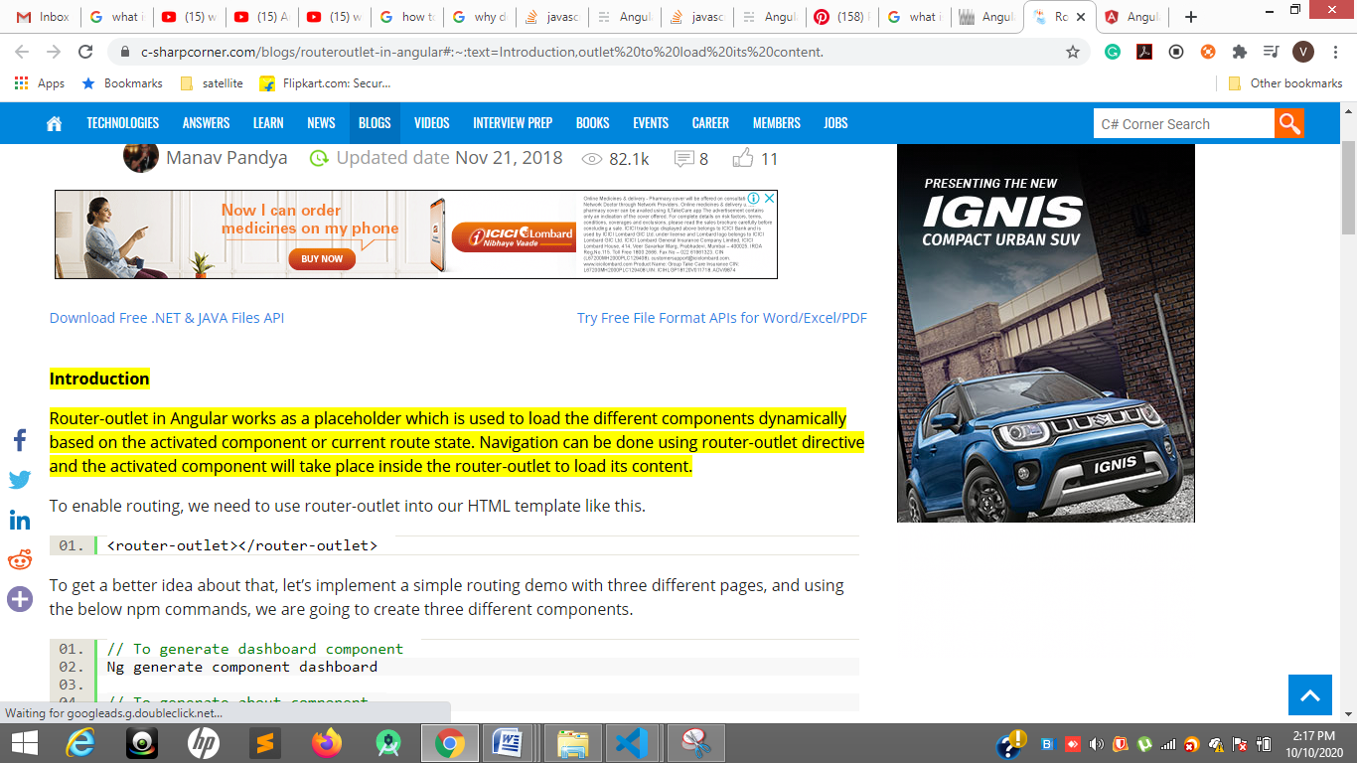

[**https://www.youtube.com/watch?v=RPOHD2BEH7A**](https://www.youtube.com/watch?v=RPOHD2BEH7A)

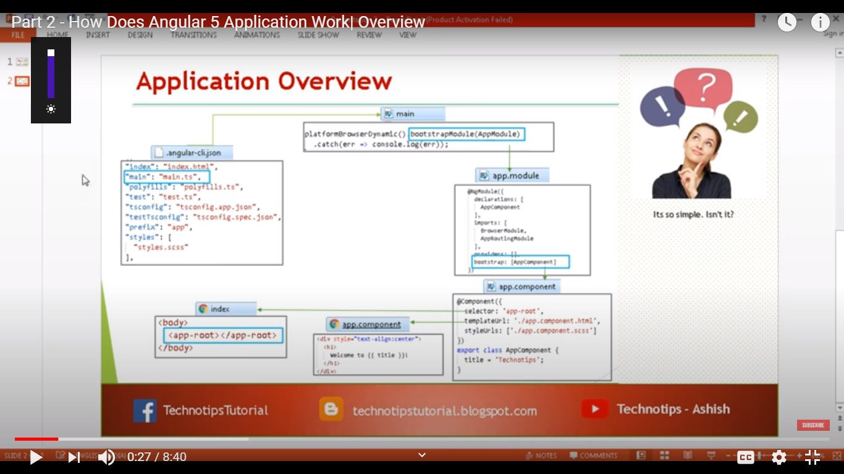

**Sttep1**

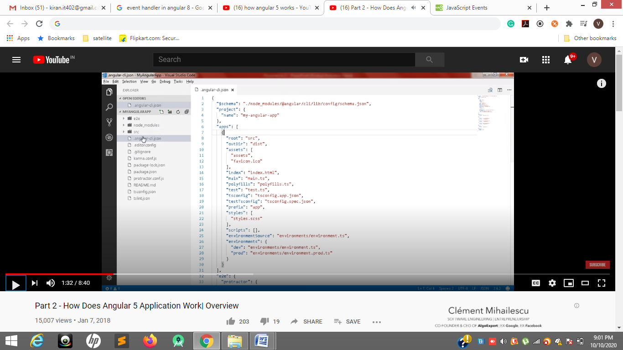

**Step 2**

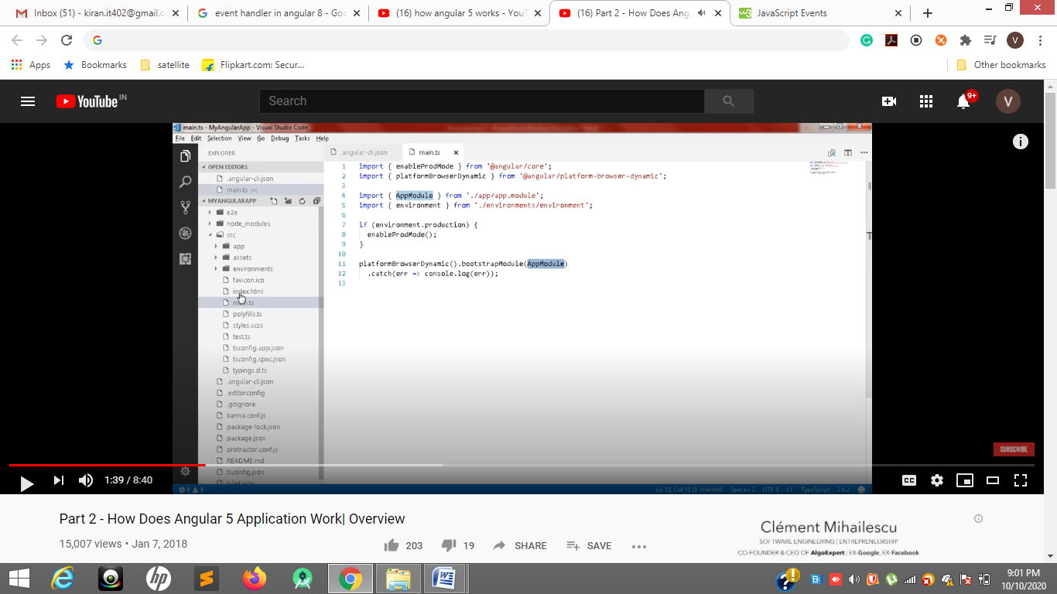

**Step 3**

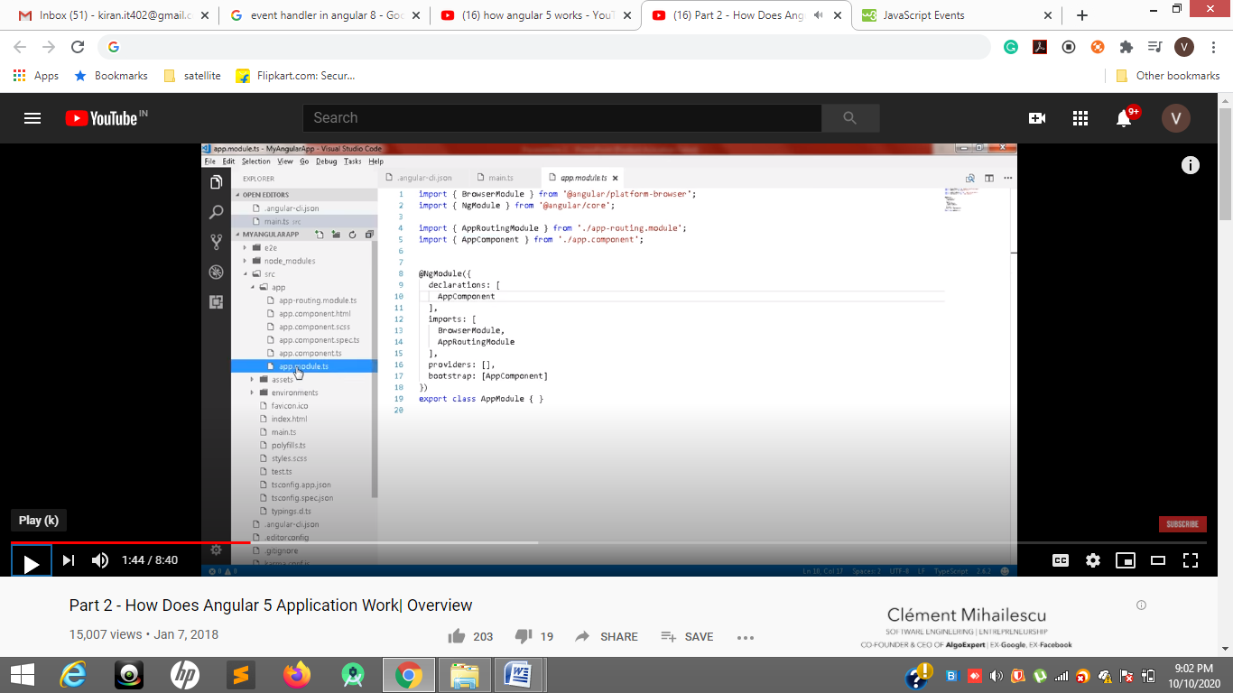

**Step4**

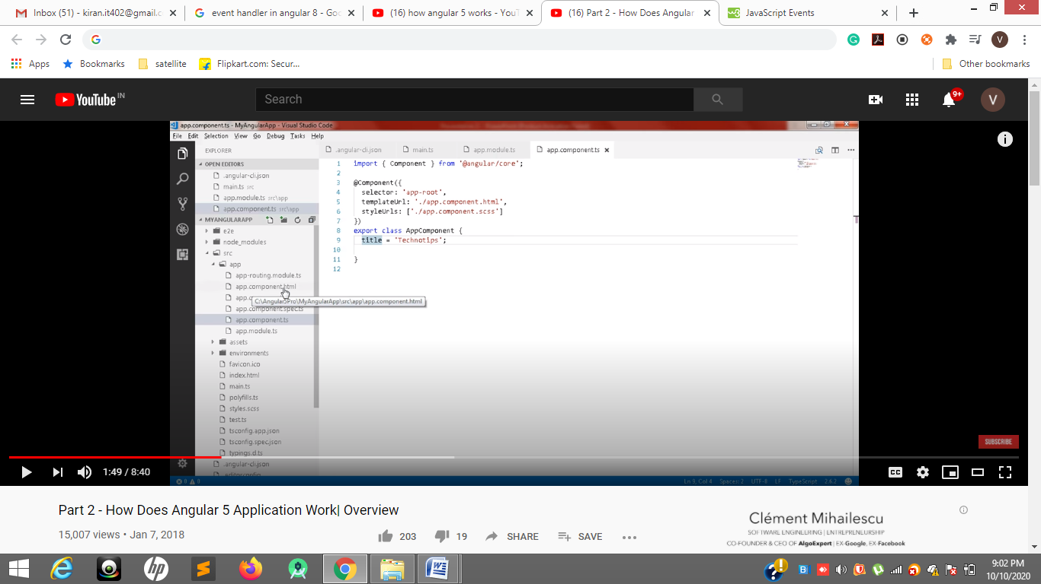

**Step 5**

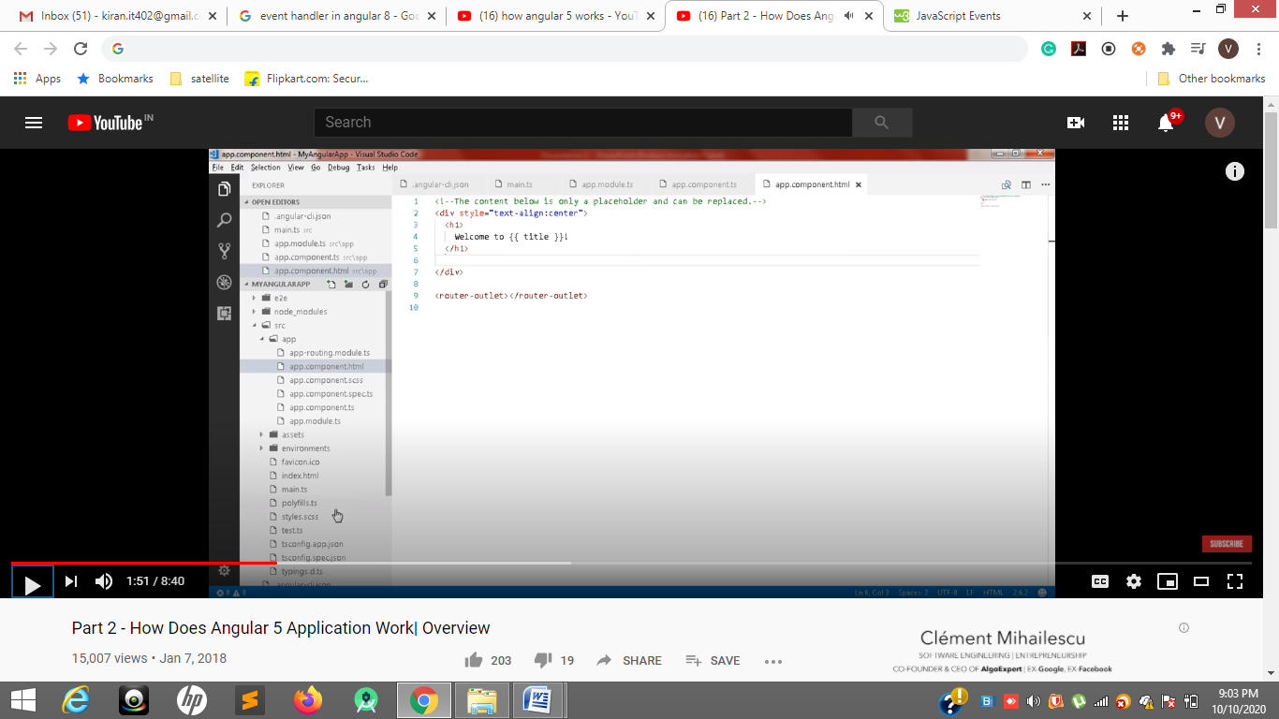

**Step 6**

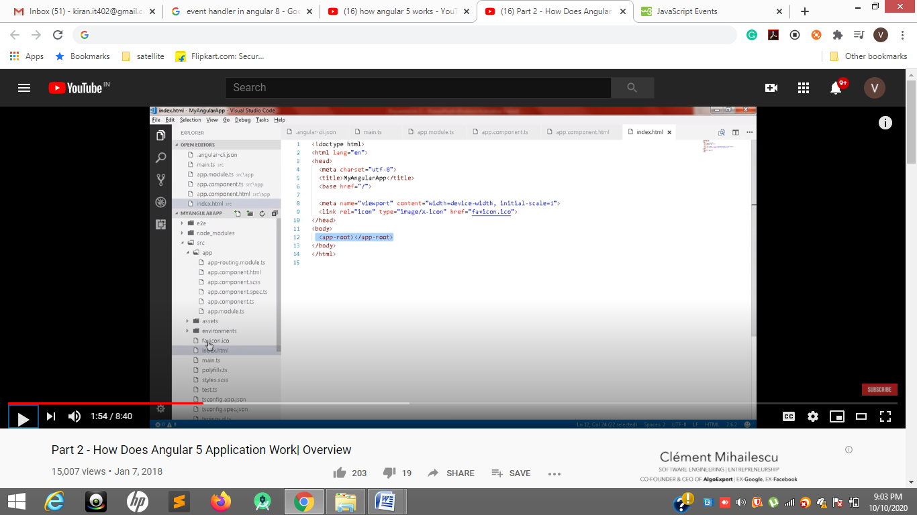

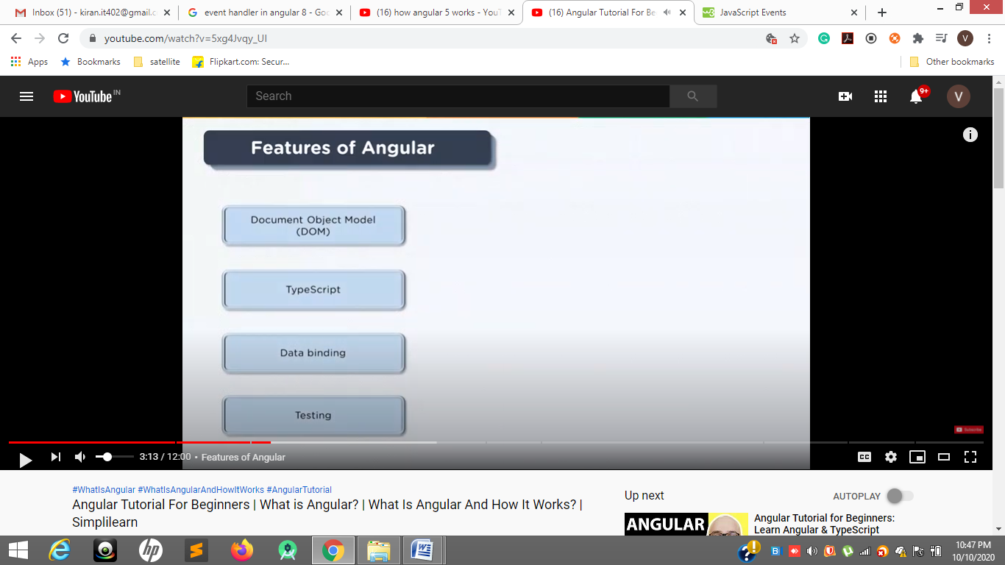

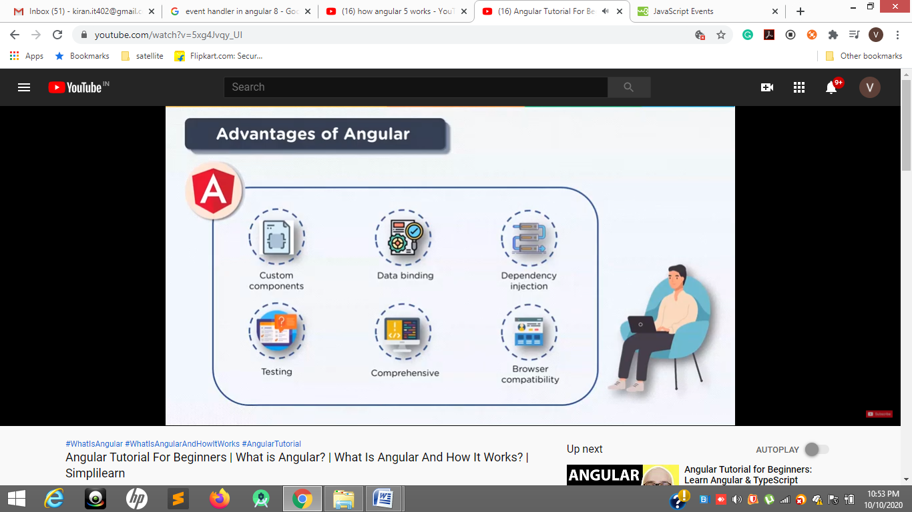

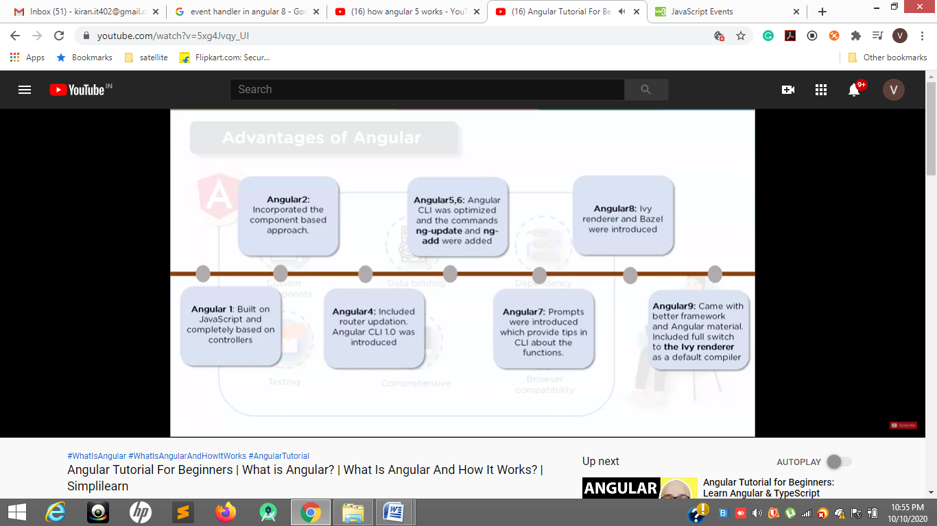

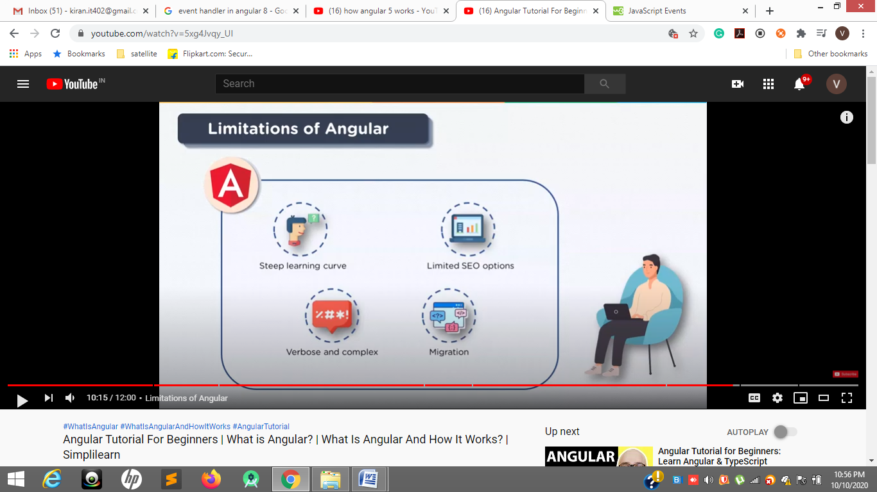

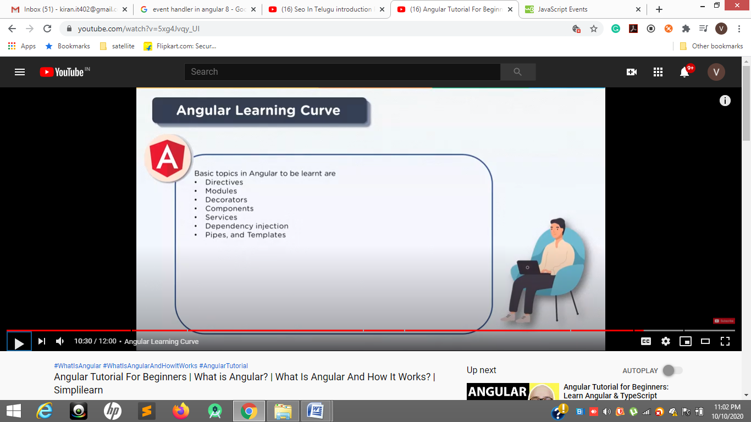

A **template** is an HTML snippet that tells **Angular** how to render the component in **angular** application. The **template** is immediately associated with a component defines that component's view.

(click)="onSave($event)"

(input)="currentItem.name=$event.target.value"

(keyup)="onKey($event)"

(keyup.enter)="onEnter(box.value)"

(focus)="myMethod()"

(blur)="myMethod()"

(submit)="myMethod()"

(scroll)="myMethod()"

(cut)="myMethod()"

(copy)="myMethod()"

(paste)="myMethod()"

(keydown)="myMethod()"

(keypress)="myMethod()"

(keyup)="myMethod()"

(mouseenter)="myMethod()"

(mousedown)="myMethod()"

(mouseup)="myMethod()"

(click)="myMethod()"

(dblclick)="myMethod()"

(drag)="myMethod()"

(dragover)="myMethod()"

(drop)="myMethod()"

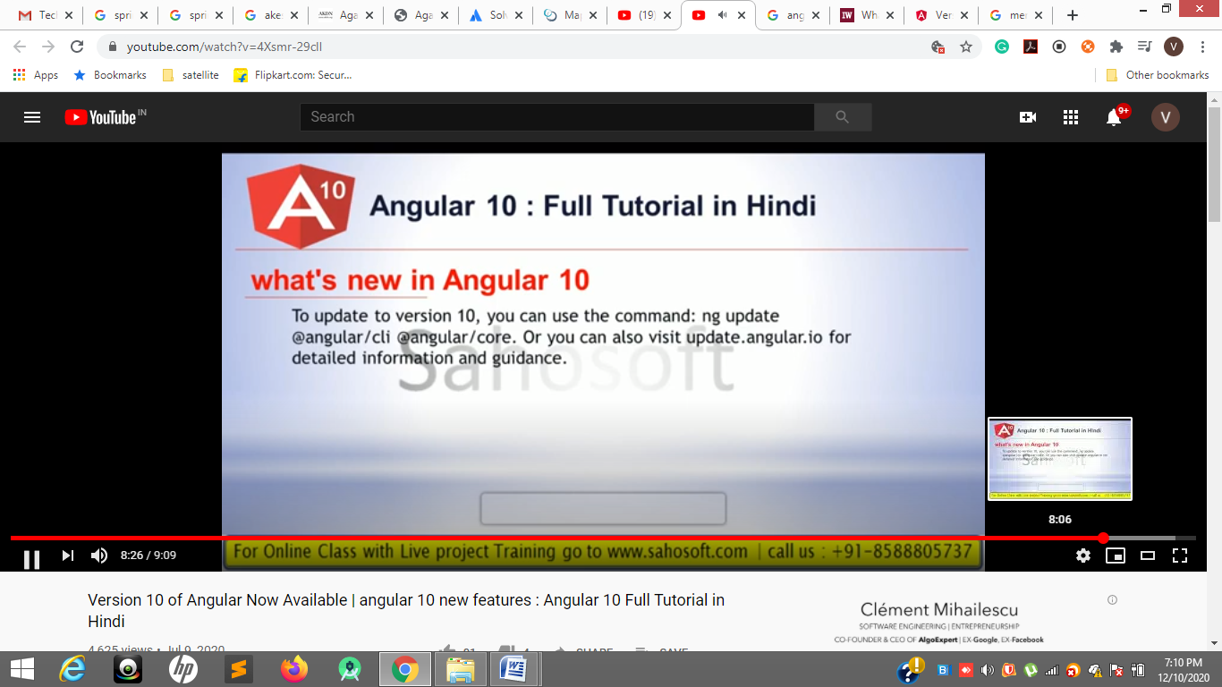

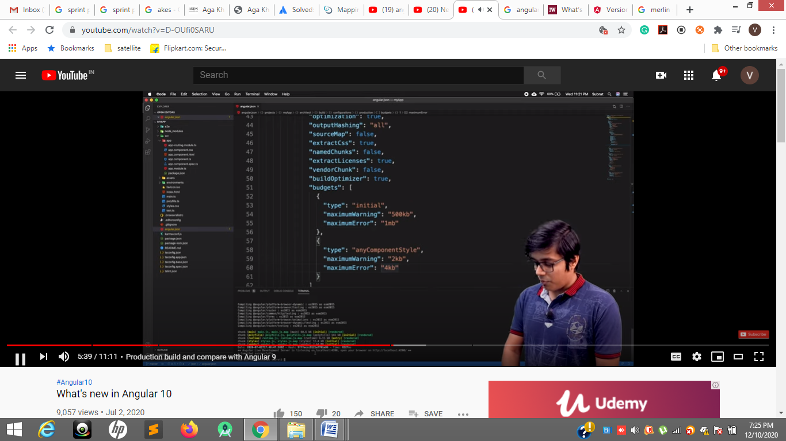

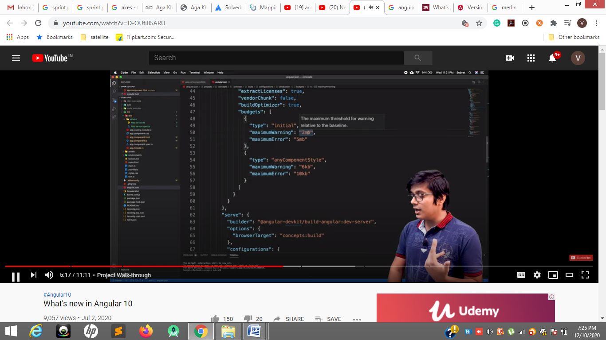

**When we build our application we 9 generate es5 and es6 but 10 only e6 file**

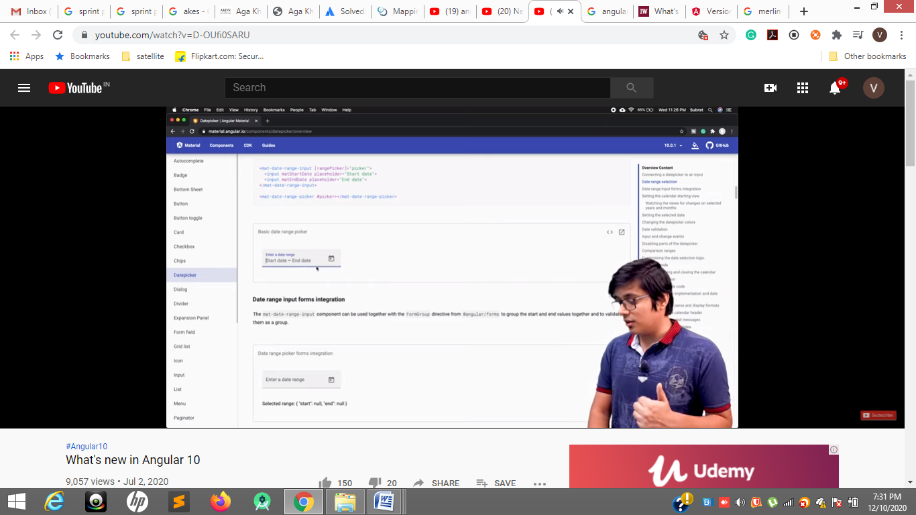

**In date picker Date range introduced like start date and end date in angular material.**

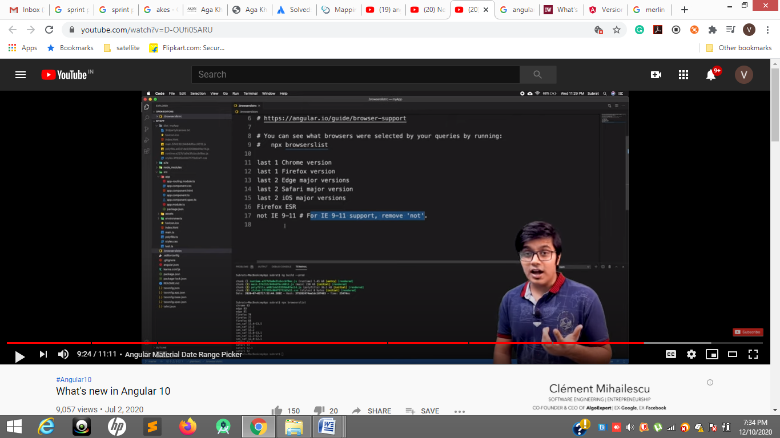

[**https://www.youtube.com/watch?v=cPNTKy1Lq9s**](https://www.youtube.com/watch?v=cPNTKy1Lq9s)

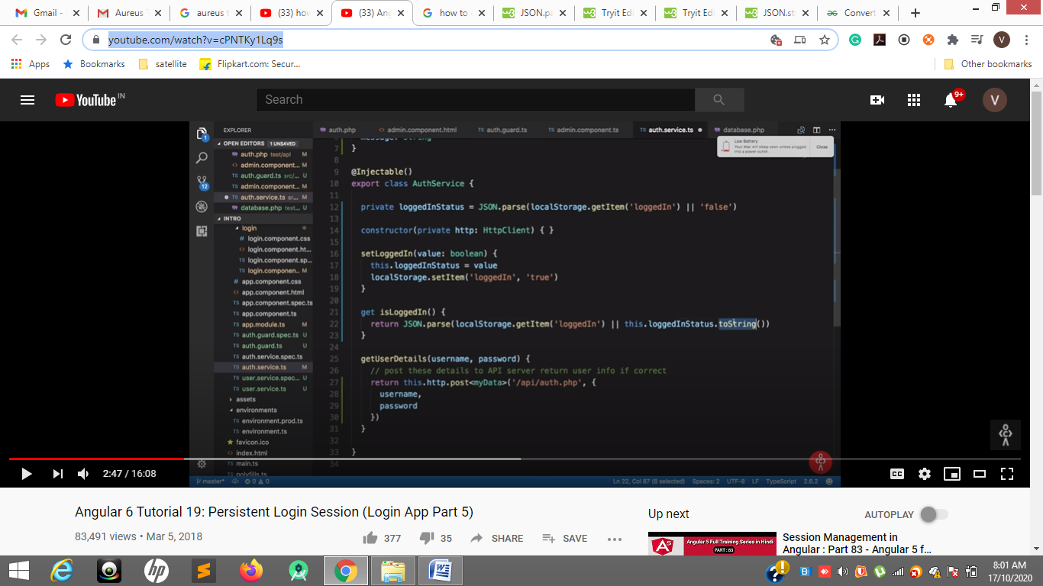

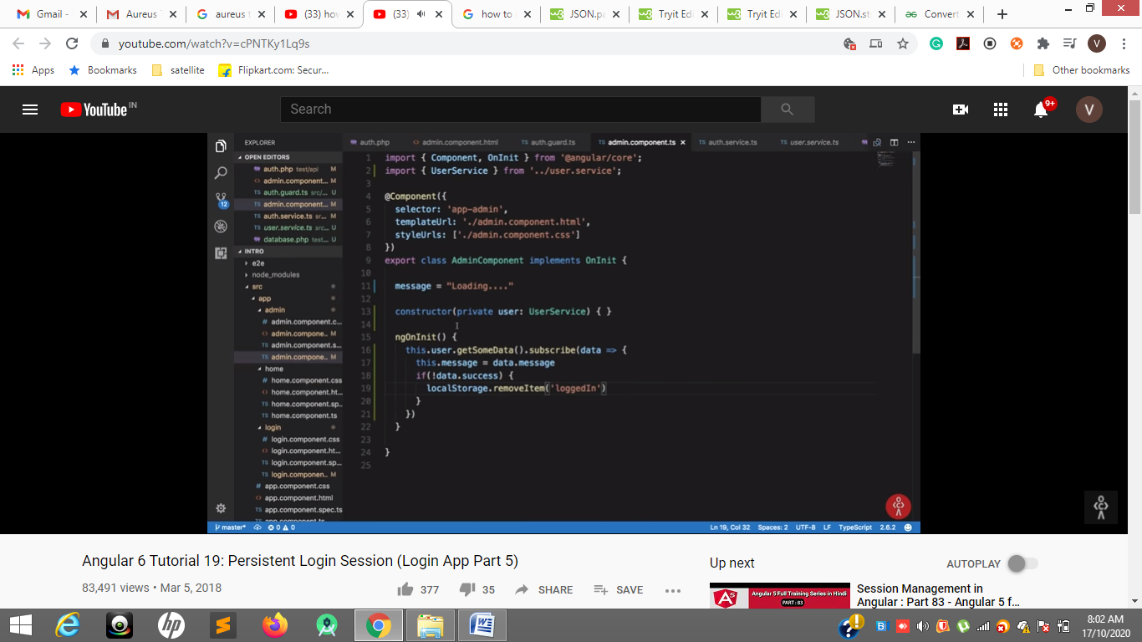

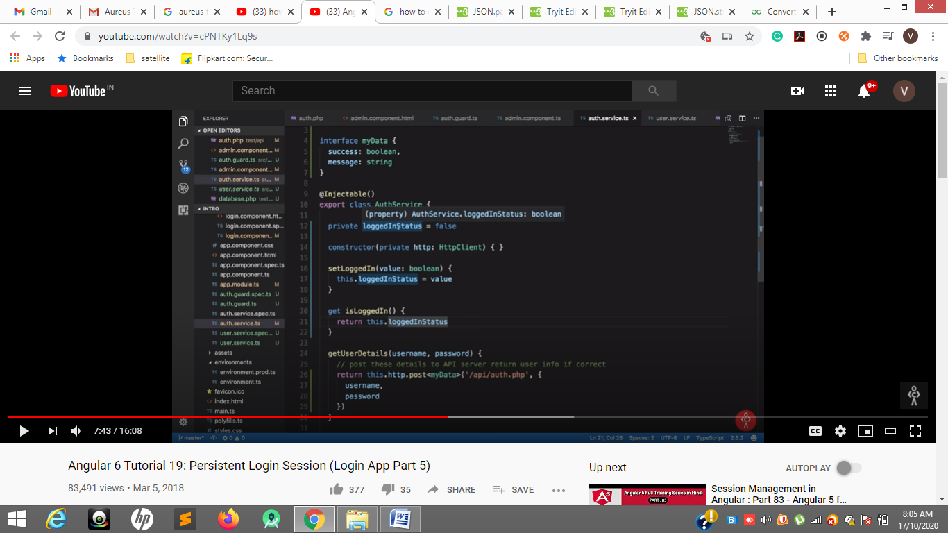

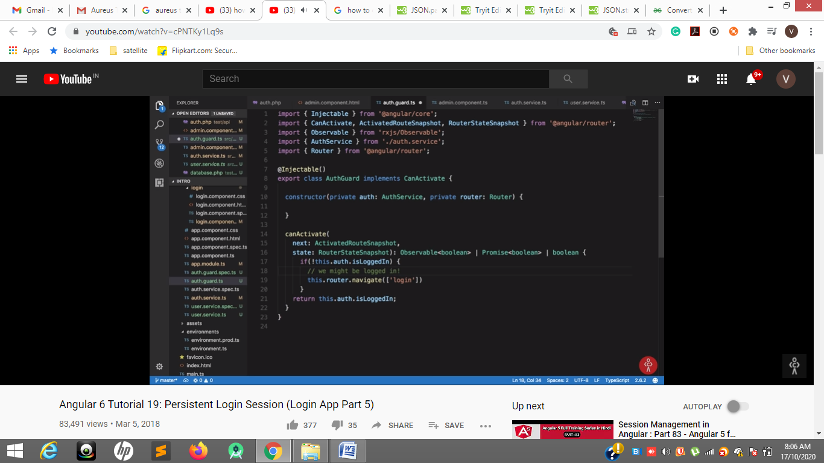

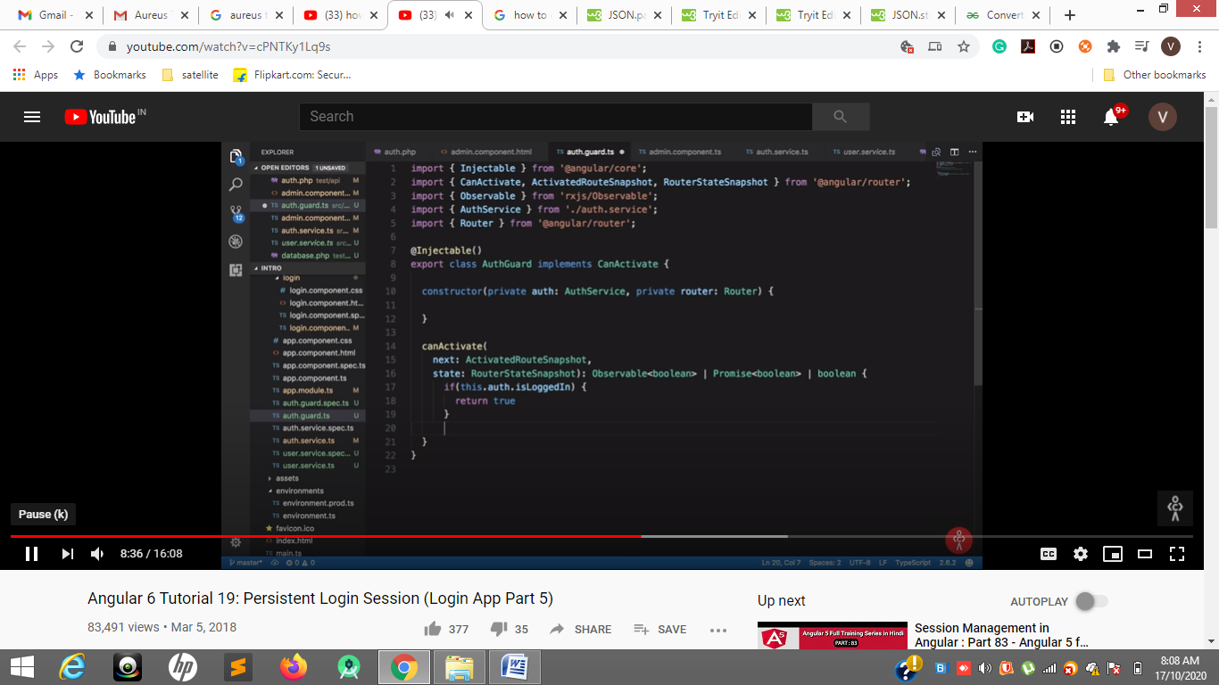

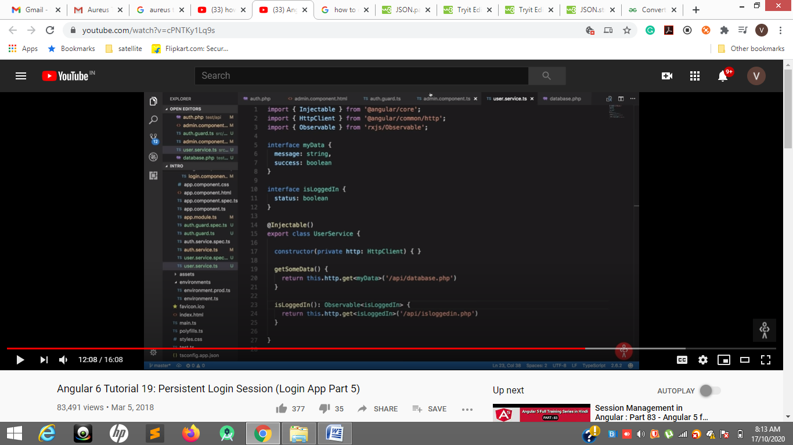

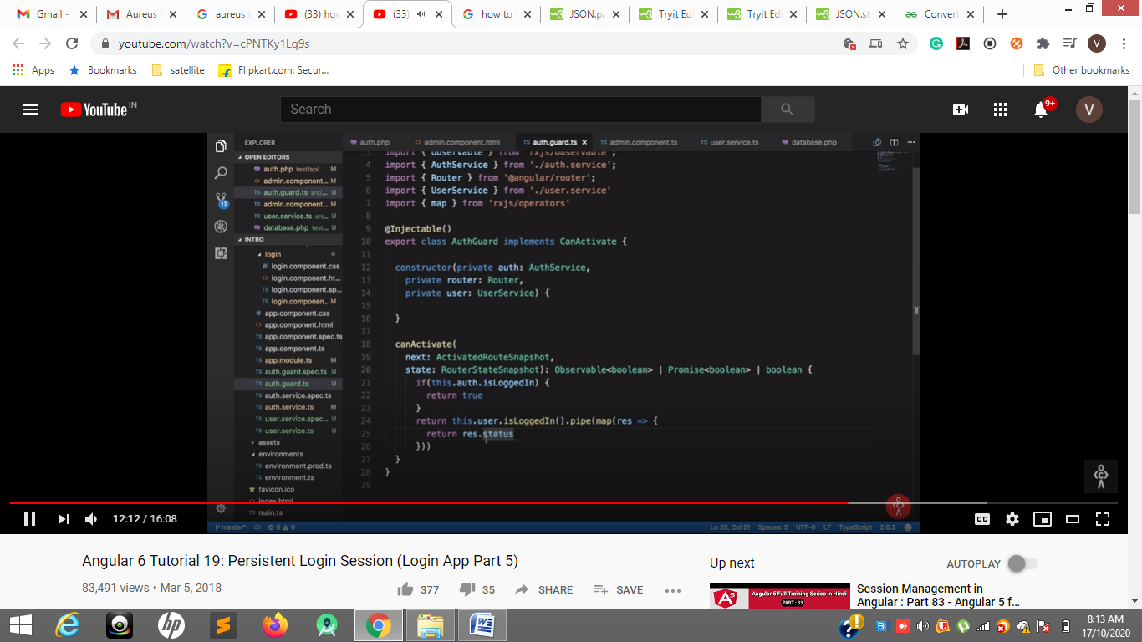

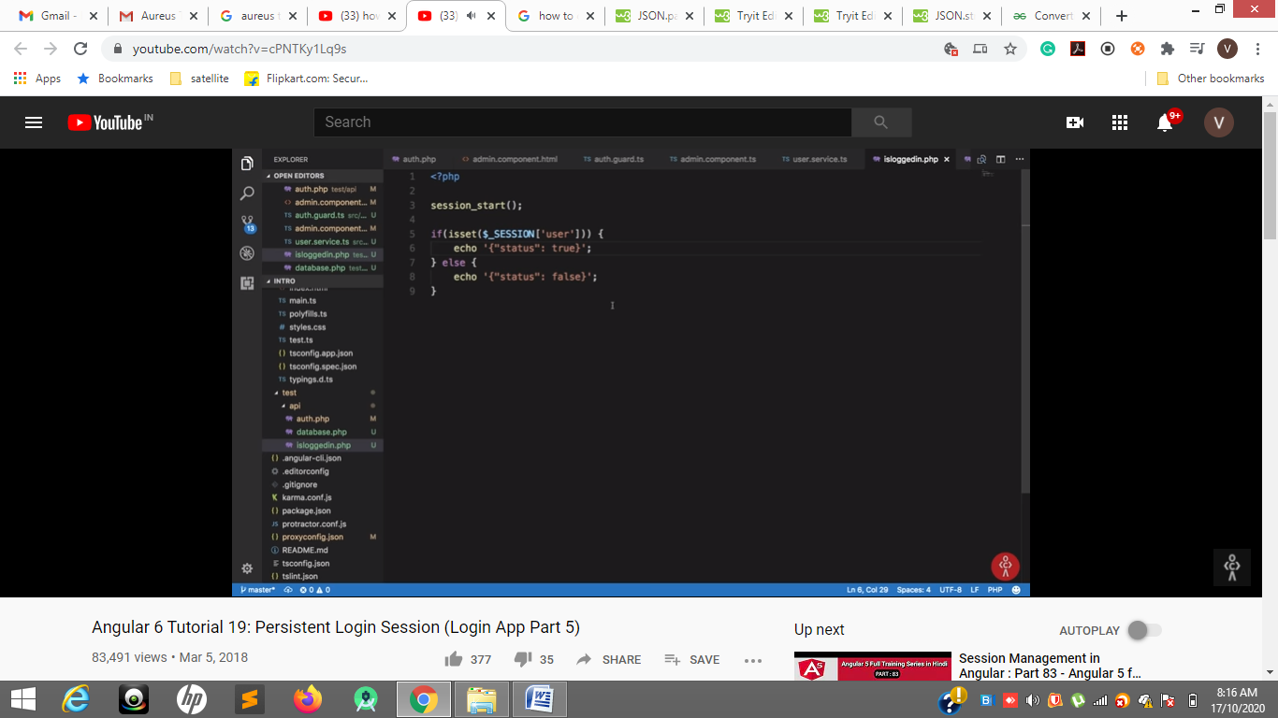

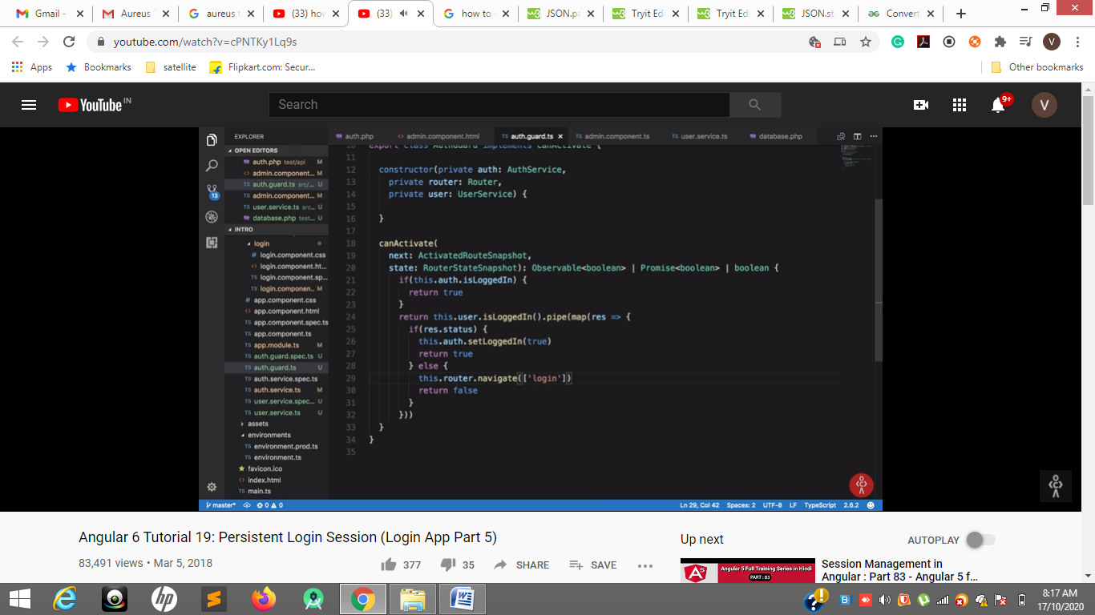

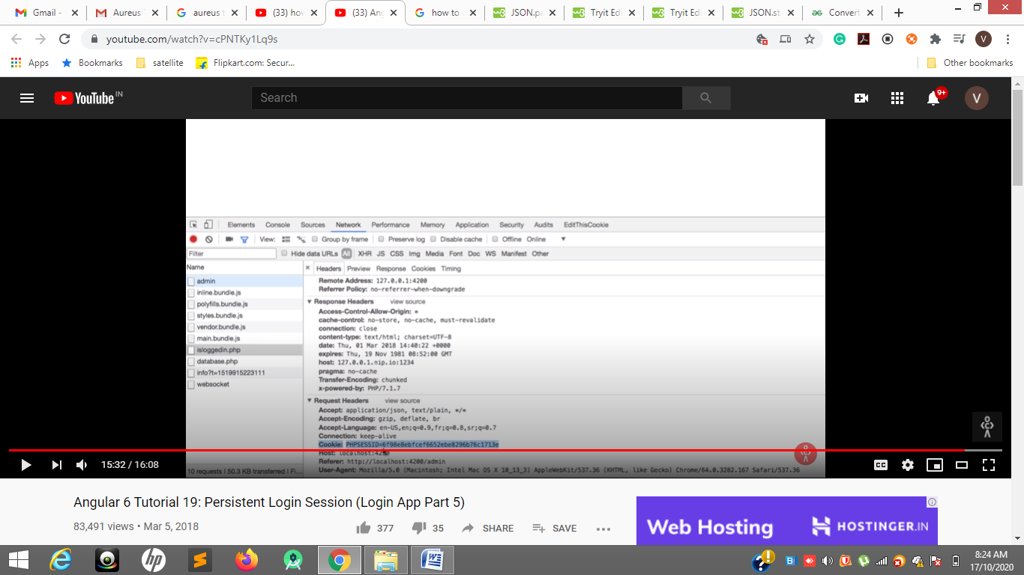

**On refresh cookie we will send to check isLogedIn or not**

